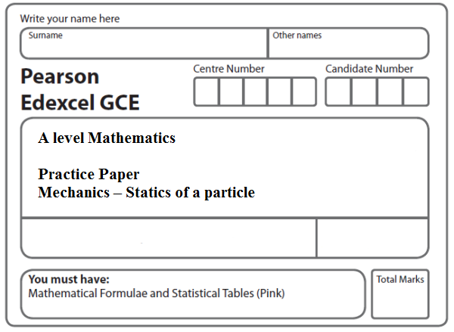
Instructions
- Use black ink or ball-point pen.
- If pencil is used for diagrams/sketches/graphs it must be dark (HB or B).
- Fill in the boxes at the top of this page with your name, centre number and candidate number.
- Answer all the questions and ensure that your answers to parts of questions are clearly labelled.
- Answer the questions in the spaces provided – there may be more space than you need.
- You should show sufficient working to make your methods clear. Answers without working may not gain full credit.
- Inexact answers should be given to three significant figures unless otherwise stated.
Information
- A booklet ‘Mathematical Formulae and Statistical Tables’ is provided.
- There are 11 questions in this question paper. The total mark for this paper is 95.
- The marks for each question are shown in brackets – use this as a guide as to how much time to spend on each question.
- Calculators must not be used for questions marked with a * sign.
Advice
• Read each question carefully before you start to answer it.
• Try to answer every question.
• Check your answers if you have time at the end.
• If you change your mind about an answer, cross it out and put your new answer and any working underneath.
1.
Figure 1

A particle P of weight W newtons is attached to one end of a light inextensible string. The other end of the string is attached to a fixed point O. A horizontal force of magnitude 5 N is applied to P. The particle P is in equilibrium with the string taut and with OP making an angle of 25° to the downward vertical, as shown in Figure 1.

Find

(a) the tension in the string,
(3)
(b) the value of W.
(3)
(Total 6 marks)
___________________________________________________________________________

2.
Figure 2

A particle of weight W newtons is attached at C to two light inextensible strings AC and BC. The other ends of the strings are attached to fixed points A and B on a horizontal ceiling. The particle hangs in equilibrium with AC and BC inclined to the horizontal at 30° and 50° respectively, as shown in Figure 2.

Given that the tension in BC is 6 N, find

(a) the tension in AC,
(3)
(b) the value of W.
(3)
(Total 6 marks)
___________________________________________________________________________

3.
Figure 3

A particle of weight 8 N is attached at C to the ends of two light inextensible strings AC and BC. The other ends, A and B, are attached to a fixed horizontal ceiling. The particle hangs at rest in equilibrium, with the strings in a vertical plane. The string AC is inclined at 35° to the horizontal and the string BC is inclined at 25° to the horizontal, as shown in Figure 3.

Find

(i) the tension in the string AC,

(ii) the tension in the string BC.
(Total 8 marks)
___________________________________________________________________________

4.

Figure 4

A non-uniform rod AB has length 3 m and mass 4.5 kg. The rod rests in equilibrium, in a horizontal position, on two smooth supports at P and at Q, where AP = 0.8 m and QB = 0.6 m, as shown in Figure 4. The centre of mass of the rod is at G. Given that the magnitude of the reaction of the support at P on the rod is twice the magnitude of the reaction of the support at Q on the rod, find

(a) the magnitude of the reaction of the support at Q on the rod,
(3)
(b) the distance AG.
(4)
(Total 7 marks)
___________________________________________________________________________

5.

Figure 5

A box of mass 2 kg is held in equilibrium on a fixed rough inclined plane by a rope. The rope lies in a vertical plane containing a line of greatest slope of the inclined plane. The rope is inclined to the plane at an angle α, where tan α = , and the plane is at an angle of 30° to the horizontal, as shown in Figure 5. The coefficient of friction between the box and the inclined plane is and the box is on the point of slipping up the plane. By modelling the box as a particle and the rope as a light inextensible string, find the tension in the rope.

(Total 8 marks)
___________________________________________________________________________
6.

Figure 6

A box of mass 5 kg lies on a rough plane inclined at 30° to the horizontal. The box is held in equilibrium by a horizontal force of magnitude 20 N, as shown in Figure 6. The force acts in a vertical plane containing a line of greatest slope of the inclined plane.

The box is in equilibrium and on the point of moving down the plane. The box is modelled as a particle.

Find

(a) the magnitude of the normal reaction of the plane on the box,
(4)
(b) the coefficient of friction between the box and the plane.
(5)
(Total 9 marks)
___________________________________________________________________________
7.

Figure 7

A particle of weight W newtons is held in equilibrium on a rough inclined plane by a horizontal force of magnitude 4 N. The force acts in a vertical plane containing a line of greatest slope of the inclined plane. The plane is inclined to the horizontal at an angle α, where tan α = as shown in Figure 7.

The coefficient of friction between the particle and the plane is .

Given that the particle is on the point of sliding down the plane,

(i) show that the magnitude of the normal reaction between the particle and the plane is 20 N,

(ii) find the value of W.
(Total 9 marks)
___________________________________________________________________________

8. Three forces F₁, F₂ and F₃ acting on a particle P are given by
F₁ = (7i – 9j) N
F₂ = (5i + 6j) N
F₃ = (pi + qj) N

where p and q are constants.

Given that P is in equilibrium,

(a) find the value of p and the value of q.
(3)
The force F₃ is now removed. The resultant of F₁ and F₂ is R. Find

(b) the magnitude of R,
(2)
(c) the angle, to the nearest degree, that the direction of R makes with j.
(3)
(Total 8 marks)
___________________________________________________________________________

9.

Figure 8

A particle P of mass 5 kg is held at rest in equilibrium on a rough inclined plane by a
horizontal force of magnitude 10 N. The plane is inclined to the horizontal at an angle α
where tan α = , as shown in Figure 8. The line of action of the force lies in the vertical
plane containing P and a line of greatest slope of the plane. The coefficient of friction
between P and the plane is μ. Given that P is on the point of sliding down the plane, find
the value of μ.
(Total 9 marks)
___________________________________________________________________________

10.
Figure 9

A particle P of mass 2 kg is held at rest in equilibrium on a rough plane by a constant force of magnitude 40 N. The direction of the force is inclined to the plane at an angle of 30°. The plane is inclined to the horizontal at an angle of 20°, as shown in Figure 9. The line of action of the force lies in the vertical plane containing P and a line of greatest slope of the plane. The coefficient of friction between P and the plane is μ.

Given that P is on the point of sliding up the plane, find the value of μ.
(Total 10 marks)
___________________________________________________________________________

11.

Figure 10

A particle of weight 120 N is placed on a fixed rough plane which is inclined at an angle α to the horizontal, where tan α = .

The coefficient of friction between the particle and the plane is .

The particle is held at rest in equilibrium by a horizontal force of magnitude 30 N, which acts in the vertical plane containing the line of greatest slope of the plane through the particle, as shown in Figure 10.

(a) Show that the normal reaction between the particle and the plane has magnitude 114 N.
(4)

Figure 11

The horizontal force is removed and replaced by a force of magnitude P newtons acting up the slope along the line of greatest slope of the plane through the particle, as shown in Figure 11. The particle remains in equilibrium.

(b) Find the greatest possible value of P.
(8)
(c) Find the magnitude and direction of the frictional force acting on the particle when P = 30.
(3)
(Total 15 marks)

TOTAL FOR PAPER: 95 MARKS

