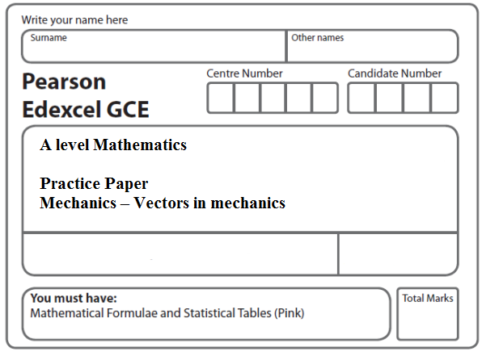
Instructions
- Use black ink or ball-point pen.
- If pencil is used for diagrams/sketches/graphs it must be dark (HB or B).
- Fill in the boxes at the top of this page with your name, centre number and candidate number.
- Answer all the questions and ensure that your answers to parts of questions are clearly labelled.
- Answer the questions in the spaces provided – there may be more space than you need.
- You should show sufficient working to make your methods clear. Answers without working may not gain full credit.
- Inexact answers should be given to three significant figures unless otherwise stated.
Information
- A booklet ‘Mathematical Formulae and Statistical Tables’ is provided.
- There are 6 questions in this question paper. The total mark for this paper is 66.
- The marks for each question are shown in brackets – use this as a guide as to how much time to spend on each question.
- Calculators must not be used for questions marked with a * sign.
Advice
• Read each question carefully before you start to answer it.
• Try to answer every question.
• Check your answers if you have time at the end.
• If you change your mind about an answer, cross it out and put your new answer and any working underneath.
1. [In this question i and j are horizontal unit vectors due east and due north respectively and position vectors are given relative to a fixed origin O.]

Two cars P and Q are moving on straight horizontal roads with constant velocities. The velocity of P is (15i + 20j) m s^{–1} and the velocity of Q is (20i – 5j) m s^{–1}

(a) Find the direction of motion of Q, giving your answer as a bearing to the nearest degree.
(3)

At time t = 0, the position vector of P is 400i metres and the position vector of Q is 800j metres. At time t seconds, the position vectors of P and Q are p metres and q metres respectively.

(b) Find an expression for

(i) p in terms of t,

(ii) q in terms of t.
(3)
(c) Find the position vector of Q when Q is due west of P.
(4)
(Total 10 marks)
___________________________________________________________________________

2. Two forces (4i – 2j) N and (2i + qj) N act on a particle P of mass 1.5 kg. The resultant of these two forces is parallel to the vector (2i + j).

(a) Find the value of q.
(4)

At time t = 0, P is moving with velocity (–2i + 4j) m s^{–1}.

(b) Find the speed of P at time t = 2 seconds.
(6)
(Total 10 marks)
___________________________________________________________________________

3. A particle P of mass 0.5 kg is moving under the action of a single force (3i – 2j) N.

(a) Show that the magnitude of the acceleration of P is 2√13m s^{–2}.
(4)

At time t = 0, the velocity of P is (i + 3j) m s^{–1}.

(b) Find the velocity of P at time t = 2 seconds.
(3)

Another particle Q moves with constant velocity v = (2i – j) m s^{–1}.

(c) Find the distance moved by Q in 2 seconds.
(2)
(d) Show that at time t = 3.5 seconds both particles are moving in the same direction.
(3)
(Total 12 marks)
___________________________________________________________________________

4.
Figure 4

Two forces P and Q act on a particle at O. The angle between the lines of action of P and Q is 120° as shown in Figure 4. The force P has magnitude 20 N and the force Q has magnitude
X newtons. The resultant of P and Q is the force R.

Given that the magnitude of R is 3X newtons, find, giving your answers to 3 significant figures,

(a) the value of X,
(5)
(b) the magnitude of (P – Q).
(4)
(Total 9 marks)
___________________________________________________________________________

5. Two forces F₁ and F₂ act on a particle P.
The force F₁ is given by F₁ = (–i + 2j) N and F₂ acts in the direction of the vector (i + j).

Given that the resultant of F₁ and F₂ acts in the direction of the vector (i + 3j),

(a) find F₂.
(7)

The acceleration of P is (3i + 9j) m s^{–2}. At time t = 0, the velocity of P is (3i – 22j) m s^{–1}.

(b) Find the speed of P when t = 3 seconds.
(4)
(Total 11 marks)
___________________________________________________________________________

6. [In this question i and j are horizontal unit vectors due east and due north respectively and
position vectors are given relative to a fixed origin O.]

Two ships, P and Q, are moving with constant velocities.
The velocity of P is (9i – 2j) km h^{–1} and the velocity of Q is (4i + 8j) km h^{–1}
(a) Find the direction of motion of P, giving your answer as a bearing to the nearest
degree.
(3)

When t = 0, the position vector of P is (9i + 10j) km and the position vector of Q is
(i + 4j) km. At time t hours, the position vectors of P and Q are p km and q km respectively.
(b) Find an expression for
(i) p in terms of t,
(ii) q in terms of t.
(3)
(c) Hence show that, at time t hours,
= (8 + 5t)i + (6 – 10t)j
(2)
(d) Find the values of t when the ships are 10 km apart.
(6)
(Total 14 marks)

TOTAL FOR PAPER: 66 MARKS

