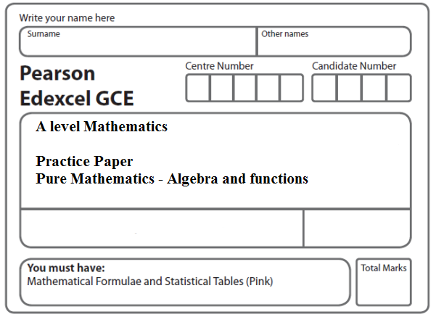
Instructions
- Use black ink or ball-point pen.
- If pencil is used for diagrams/sketches/graphs it must be dark (HB or B).
- Fill in the boxes at the top of this page with your name, centre number and candidate number.
- Answer all the questions and ensure that your answers to parts of questions are clearly labelled.
- Answer the questions in the spaces provided – there may be more space than you need.
- You should show sufficient working to make your methods clear. Answers without working may not gain full credit.
- Inexact answers should be given to three significant figures unless otherwise stated.
Information
- A booklet ‘Mathematical Formulae and Statistical Tables’ is provided.
- There are 16 questions in this question paper. The total mark for this paper is 100.
- The marks for each question are shown in brackets – use this as a guide as to how much time to spend on each question.
- Calculators must not be used for questions marked with a * sign.
Advice
• Read each question carefully before you start to answer it.
• Try to answer every question.
• Check your answers if you have time at the end.
• If you change your mind about an answer, cross it out and put your new answer and any working underneath.
1. Given that

,

find the values of the constants a, b, c, d and e.
(Total 4 marks)
___________________________________________________________________________

2. Express as a single fraction in its simplest form.
(Total 4 marks)
___________________________________________________________________________

3. Express

as a single fraction in its simplest form.
(Total 4 marks)
___________________________________________________________________________

4. Express
–
as a single fraction in its simplest form.
(Total 4 marks)
___________________________________________________________________________

5. The functions f and g are defined by

f : x → 7x – 1, x ∈ ℝ,

g : x → , x ≠ 2, x ∈ ℝ,

(a) Solve the equation fg(x) = x.
(4)
(b) Hence, or otherwise, find the largest value of a such that g(a) = f ^{–1}(a).
(1)
(Total 5 marks)
___________________________________________________________________________

6. Given that
f(x) = ln x, x > 0

sketch on separate axes the graphs of

(i) y = f(x),

(ii) y = |f(x)|,

(iii) y = –f(x – 4).

Show, on each diagram, the point where the graph meets or crosses the x-axis.
In each case, state the equation of the asymptote.
(Total 7 marks)
___________________________________________________________________________

7.

Figure 1 shows a sketch of part of the graph of y = g(x), where
g(x) = 3 + , x ⩾ –2
(a) State the range of g.
(1)
(b) Find g^{–1}(x) and state its domain.
(3)
(c) Find the exact value of x for which
g(x) = x
(4)
(d) Hence state the value of a for which
g(a) = g^{–1}(a)
(1)
(Total 9 marks)
___________________________________________________________________________
8.

Figure 2

Figure 2 shows the graph of equation y = f(x).

The points P (– 3, 0) and Q (2, – 4) are stationary points on the graph.

Sketch, on separate diagrams, the graphs of

(a) y = 3f(x + 2),
(3)
(b) y = ⏐f(x)⏐.
(3)

On each diagram, show the coordinates of any stationary points.
(Total 6 marks)
___________________________________________________________________________
9.

Figure 3

Figure 3 shows part of the curve with equation y = f(x) , x ∈ ℝ.

The curve passes through the points Q(0, 2) and P(−3, 0) as shown.

(a) Find the value of ff (−3).
(2)

On separate diagrams, sketch the curve with equation

(b) y = f ⁻¹(x),
(2)
(c) y = f(⏐x⏐) − 2,
(2)
(d) y = 2f.
(3)

Indicate clearly on each sketch the coordinates of the points at which the curve crosses or meets the axes.
(Total 9 marks)
___________________________________________________________________________

10.
Figure 4

Figure 4 shows part of the graph with equation y = f (x), .

The graph consists of two line segments that meet at the point Q(6, –1).

The graph crosses the y-axis at the point P(0, 11).

Sketch, on separate diagrams, the graphs of

(a) y = |f (x)|
(2)
(b) y = 2f (–x) + 3
(3)

On each diagram, show the coordinates of the points corresponding to P and Q.

Given that f (x) = a | x – b | – 1, where a and b are constants,

(c) state the value of a and the value of b.
(2)
(Total 7 marks)
___________________________________________________________________________

11.

Figure 5

Figure 5 shows part of the curve with equation y = f(x).
The curve passes through the points P(−1.5, 0)and Q(0, 5) as shown.

On separate diagrams, sketch the curve with equation

(a) y = |f(x)|
(2)
(b) y = f(|x|)
(2)
(c) y = 2f(3x)
(3)

Indicate clearly on each sketch the coordinates of the points at which the curve crosses or meets the axes.
(Total 7 marks)
___________________________________________________________________________

12. (a) Sketch the graph with equation

y = |4x – 3|

stating the coordinates of any points where the graph cuts or meets the axes.
(2)

Find the complete set of values of x for which

(b)
|4x – 3| > 2 – 2x
(4)
(c)
|4x – 3| > – 2x
(2)
(Total 8 marks)
___________________________________________________________________________

13. , x > 3
(a) Show that , x > 3
(4)
(b) Find the range of g.
(2)
(c) Find the exact value of a for which g(a) = g^{–1}(a).
(4)
(Total 10 marks)
___________________________________________________________________________

14. Given that a and b are positive constants,
(a) on separate diagrams, sketch the graph with equation
(i) y = |2x – a|
(ii) y = |2x – a| + b
Show, on each sketch, the coordinates of each point at which the graph crosses or meets the axes.
(4)

Given that the equation
|2x – a| + b = x + 8
has a solution at x = 0 and a solution at x = c,
(b) find c in terms of a.
(4)
(Total 8 marks)
___________________________________________________________________________

15. = + + .

Find the values of the constants A, B and C.
(Total 4 marks)
___________________________________________________________________________

16. Express in partial fractions.
(Total 4 marks)

TOTAL FOR PAPER: 100 MARKS

