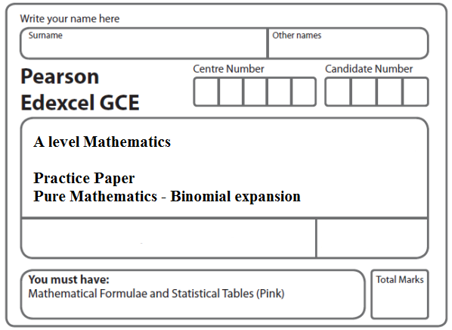
Instructions
- Use black ink or ball-point pen.
- If pencil is used for diagrams/sketches/graphs it must be dark (HB or B).
- Fill in the boxes at the top of this page with your name, centre number and candidate number.
- Answer all the questions and ensure that your answers to parts of questions are clearly labelled.
- Answer the questions in the spaces provided – there may be more space than you need.
- You should show sufficient working to make your methods clear. Answers without working may not gain full credit.
- Inexact answers should be given to three significant figures unless otherwise stated.
Information
- A booklet ‘Mathematical Formulae and Statistical Tables’ is provided.
- There are 6 questions in this question paper. The total mark for this paper is 50.
- The marks for each question are shown in brackets – use this as a guide as to how much time to spend on each question.
- Calculators must not be used for questions marked with a * sign.
Advice
• Read each question carefully before you start to answer it.
• Try to answer every question.
• Check your answers if you have time at the end.
• If you change your mind about an answer, cross it out and put your new answer and any working underneath.
1. (a) Find the binomial expansion of

,

in ascending powers of x up to and including the term in x².
Give each coefficient as a simplified fraction.
(5)
(b) Hence, or otherwise, find the expansion of

,

in ascending powers of x, up to and including the term in x².
Give each coefficient as a simplified fraction.
(3)
(Total 8 marks)
___________________________________________________________________________

2. Given that the binomial expansion of (1 + kx)^{–4}, < 1, is

1 – 6x + Ax² + …

(a) find the value of the constant k,
(2)
(b) find the value of the constant A, giving your answer in its simplest form.
(3)
(Total 5 marks)
___________________________________________________________________________

3. f (x) = , | x | < .

Find the first three non-zero terms of the binomial expansion of f(x) in ascending powers of x. Give each coefficient as a simplified fraction.

(Total 6 marks)
___________________________________________________________________________

4. f(x) = , ⏐x⏐ < .

(a) Find the binomial expansion of f(x) in ascending powers of x, up to and including the term in x³. Give each coefficient in its simplest form.
(6)

Use your answer to part (a) to find the binomial expansion in ascending powers of x, up to and including the term in x³, of

(b) g(x) = , ⏐x⏐ < ,
(1)
(c) h(x) = , ⏐x⏐ < .
(2)
(Total 9 marks)
___________________________________________________________________________

5. (a) Expand
, ⏐x⏐ < ,

in ascending powers of x, up to and including the term in x², giving each term as a simplified fraction.
(5)

Given that the binomial expansion of , ⏐x⏐ < , is

+ + Ax² + . . .,

(b) find the value of the constant k,
(2)
(c) find the value of the constant A.
(2)
(Total 9 marks)
___________________________________________________________________________

6. (a) Use the binomial theorem to expand

(2 – 3x)^{–2}, ⎜x ⎜ < ,

in ascending powers of x, up to and including the term in x³. Give each coefficient as a simplified fraction.
(5)

f(x) = , ⎜x ⎜ < , where a and b are constants.

In the binomial expansion of f(x), in ascending powers of x, the coefficient of x is 0 and the coefficient of x² is .

Find

(b) the value of a and the value of b,
(5)
(c) the coefficient of x³ , giving your answer as a simplified fraction.
(3)
(Total 13 marks)

TOTAL FOR PAPER: 50 MARKS

