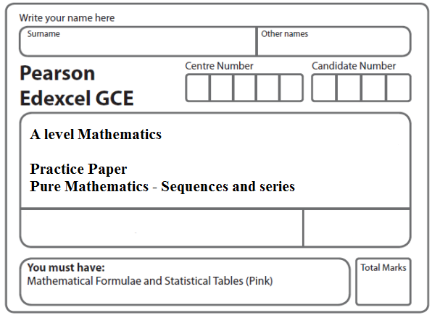
Instructions
- Use black ink or ball-point pen.
- If pencil is used for diagrams/sketches/graphs it must be dark (HB or B).
- Fill in the boxes at the top of this page with your name, centre number and candidate number.
- Answer all the questions and ensure that your answers to parts of questions are clearly labelled.
- Answer the questions in the spaces provided – there may be more space than you need.
- You should show sufficient working to make your methods clear. Answers without working may not gain full credit.
- Inexact answers should be given to three significant figures unless otherwise stated.
Information
- A booklet ‘Mathematical Formulae and Statistical Tables’ is provided.
- There are 8 questions in this question paper. The total mark for this paper is 50.
- The marks for each question are shown in brackets – use this as a guide as to how much time to spend on each question.
- Calculators must not be used for questions marked with a * sign.
Advice
• Read each question carefully before you start to answer it.
• Try to answer every question.
• Check your answers if you have time at the end.
• If you change your mind about an answer, cross it out and put your new answer and any working underneath.
1. A sequence a₁, a₂, a₃,… is defined by

a₁ = 1
n ⩾ 1
where k is a positive constant.
(a) Write down expressions for a₂ and a₃ in terms of k, giving your answers in their
simplest form.
(3)
Given that
(b) find an exact value for k.
(3)
(Total 6 marks)
___________________________________________________________________________

2. A sequence a₁, a₂, a₃,… is defined by
a_{n + 1} = 4a_{n} – 3, n ≥ 1

a₁ = k, where k is a positive integer.

(a) Write down an expression for a₂ in terms of k.
(1)
Given that = 66

(b) find the value of k.
(4)
(Total 5 marks)
___________________________________________________________________________
3. (i) A sequence U₁, U₂, U₃, ... is defined by
U_{n + 2} = 2U_{n + 1} – U_{n}, n ≥ 1,

U₁ = 4 and U₂ = 4.
Find the value of

(a) U₃,
(1)
(b) .
(2)

(ii) Another sequence V₁, V₂, V₃, ... is defined by

V_{n + 2} = 2V_{n + 1} – V_{n}, n ≥ 1,

V₁ = k and V₂ = 2k, where k is a constant.

(a) Find V₃ and V₄ in terms of k.
(2)
Given that = 165,
(b) find the value of k.
(3)
(Total 8 marks)
___________________________________________________________________________

4. A sequence , , , . . . is defined by

= 1,

= a + 5, n ≥ 1,

where a is a constant.

(a) Write down an expression for in terms of a.
(1)
(b) Show that = a² + 5a + 5.
(2)
Given that = 41

(c) find the possible values of a.
(3)
(Total 6 marks)
___________________________________________________________________________

5. A sequence of numbers a₁, a₂, a₃… is defined by

a_{n + 1} = 5a_{n} – 3, n ≥ 1.

Given that a₂ = 7,

(a) find the value of a₁.
(2)
(b) Find the value of .
(3)
(Total 5 marks)
___________________________________________________________________________

6. A sequence of numbers a₁, a₂, a₃, ... is defined by
a₁ = 3,

a_{n +1} = 2a_{n} – c, (n ≥ 1),
where c is a constant.

(a) Write down an expression, in terms of c, for a₂.
(1)
(b) Show that a₃ = 12 – 3c.
(2)
Given that ≥ 23,

(c) find the range of values of c.
(4)
(Total 7 marks)
___________________________________________________________________________

7. A sequence a₁, a₂, a₃, ... is defined by

a₁ = 4,
a_{n +1} = k(a_{n} + 2), for n ≥ 1

where k is a constant.

(a) Find an expression for a₂ in terms of k.
(1)

Given that = 2,

(b) find the two possible values of k.
(6)
(Total 7 marks)
___________________________________________________________________________

8. A sequence a₁, a₂, a₃, … is defined by

a₁ = 4,

a_{n + 1} = 5 – ka_{n}, n ≥ 1,

where k is a constant.

(a) Write down expressions for a₂ and a₃ in terms of k.
(2)
Find

(b) in terms of k, giving your answer in its simplest form,
(3)
(c) .
(1)
(Total 6 marks)

TOTAL FOR PAPER: 50 MARKS

