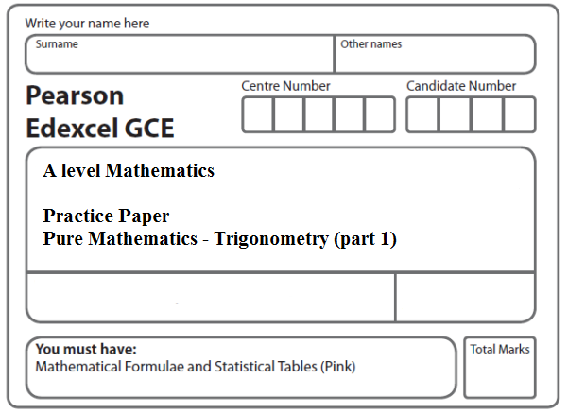
Instructions
- Use black ink or ball-point pen.
- If pencil is used for diagrams/sketches/graphs it must be dark (HB or B).
- Fill in the boxes at the top of this page with your name, centre number and candidate number.
- Answer all the questions and ensure that your answers to parts of questions are clearly labelled.
- Answer the questions in the spaces provided – there may be more space than you need.
- You should show sufficient working to make your methods clear. Answers without working may not gain full credit.
- Inexact answers should be given to three significant figures unless otherwise stated.
Information
- A booklet ‘Mathematical Formulae and Statistical Tables’ is provided.
- There are 8 questions in this question paper. The total mark for this paper is 70.
- The marks for each question are shown in brackets – use this as a guide as to how much time to spend on each question.
- Calculators must not be used for questions marked with a * sign.
Advice
• Read each question carefully before you start to answer it.
• Try to answer every question.
• Check your answers if you have time at the end.
• If you change your mind about an answer, cross it out and put your new answer and any working underneath.
1. In the triangle ABC, AB = 11 cm, BC = 7 cm and CA = 8 cm.

(a) Find the size of angle C, giving your answer in radians to 3 significant figures.
(3)
(b) Find the area of triangle ABC, giving your answer in cm² to 3 significant figures.
(3)
(Total 6 marks)
___________________________________________________________________________

2.

Figure 1

Figure 1 shows a sketch of a design for a scraper blade. The blade AOBCDA consists of an isosceles triangle COD joined along its equal sides to sectors OBC and ODA of a circle with centre O and radius 8 cm. Angles AOD and BOC are equal. AOB is a straight line and is parallel to the line DC. DC has length 7 cm.

(a) Show that the angle COD is 0.906 radians, correct to 3 significant figures.
(2)

(b) Find the perimeter of AOBCDA, giving your answer to 3 significant figures.
(3)

(c) Find the area of AOBCDA, giving your answer to 3 significant figures.
(3)

(Total 8 marks)
___________________________________________________________________________

3.

Figure 2

Figure 2 is a sketch representing the cross-section of a large tent ABCDEF.
AB and DE are line segments of equal length.
Angle FAB and angle DEF are equal.
F is the midpoint of the straight line AE and FC is perpendicular to AE.
BCD is an arc of a circle of radius 3.5 m with centre at F.
It is given that
AF = FE = 3.7 m
BF = FD = 3.5 m
angle BFD = 1.77 radians
Find
(a) the length of the arc BCD in metres to 2 decimal places,
(2)
(b) the area of the sector FBCD in m² to 2 decimal places,
(2)
(c) the total area of the cross-section of the tent in m² to 2 decimal places.
(4)
(Total 8 marks)
___________________________________________________________________________

4.
Figure 3

Figure 3 shows the shape ABCDEA which consists of a right-angled triangle BCD joined to a sector ABDEA of a circle with radius 7 cm and centre B.

A, B and C lie on a straight line with AB = 7 cm.

Given that the size of angle ABD is exactly 2.1 radians,

(a) find, in cm, the length of the arc DEA,
(2)
(b) find, in cm, the perimeter of the shape ABCDEA, giving your answer to 1 decimal place.
(4)
(Total 6 marks)
___________________________________________________________________________

5.

Figure 4

The shape ABCDEA, as shown in Figure 4, consists of a right-angled triangle EAB and a triangle DBC joined to a sector BDE of a circle with radius 5 cm and centre B.

The points A, B and C lie on a straight line with BC = 7.5 cm.

Angle EAB = radians, angle EBD = 1.4 radians and CD = 6.1 cm.

(a) Find, in cm², the area of the sector BDE.
(2)
(b) Find the size of the angle DBC, giving your answer in radians to 3 decimal places.
(2)
(c) Find, in cm², the area of the shape ABCDEA, giving your answer to 3 significant figures.
(5)
(Total 9 marks)
___________________________________________________________________________
6.

Figure 5

The triangle XYZ in Figure 1 has XY = 6 cm, YZ = 9 cm, ZX = 4 cm and angle ZXY = α.
The point W lies on the line XY.

The circular arc ZW, in Figure 5 is a major arc of the circle with centre X and radius 4 cm.

(a) Show that, to 3 significant figures, α = 2.22 radians.
(2)

(b) Find the area, in cm², of the major sector XZWX.
(3)

The region enclosed by the major arc ZW of the circle and the lines WY and YZ is shown shaded in Figure 5.

Calculate

(c) the area of this shaded region,
(3)

(d) the perimeter ZWYZ of this shaded region.
(4)

(Total 12 marks)
___________________________________________________________________________

7.

Figure 6

Figure 6 shows ABC, a sector of a circle of radius 6 cm with centre A. Given that the size of angle BAC is 0.95 radians, find

(a) the length of the arc BC,
(2)
(b) the area of the sector ABC.
(2)

The point D lies on the line AC and is such that AD = BD. The region R, shown shaded in Figure 6, is bounded by the lines CD, DB and the arc BC.

(c) Show that the length of AD is 5.16 cm to 3 significant figures.
(2)

Find

(d) the perimeter of R,
(2)
(e) the area of R, giving your answer to 2 significant figures.
(4)

(Total 12 marks)
___________________________________________________________________________

8.

Figure 7

Figure 7 shows a plan view of a garden.

The plan of the garden ABCDEA consists of a triangle ABE joined to a sector BCDE of a circle with radius 12 m and centre B.

The points A, B and C lie on a straight line with AB = 23 m and BC = 12 m.

Given that the size of angle ABE is exactly 0.64 radians, find

(a) the area of the garden, giving your answer in m², to 1 decimal place,
(4)
(b) the perimeter of the garden, giving your answer in metres, to 1 decimal place.
(5)

(Total 9 marks)

TOTAL FOR PAPER: 70 MARKS

