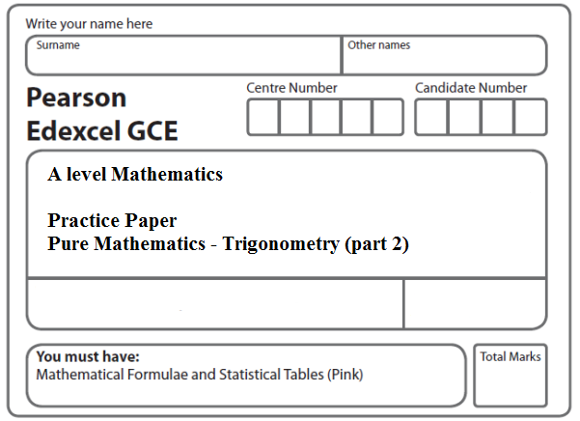
Instructions
- Use black ink or ball-point pen.
- If pencil is used for diagrams/sketches/graphs it must be dark (HB or B).
- Fill in the boxes at the top of this page with your name, centre number and candidate number.
- Answer all the questions and ensure that your answers to parts of questions are clearly labelled.
- Answer the questions in the spaces provided – there may be more space than you need.
- You should show sufficient working to make your methods clear. Answers without working may not gain full credit.
- Inexact answers should be given to three significant figures unless otherwise stated.
Information
- A booklet ‘Mathematical Formulae and Statistical Tables’ is provided.
- There are 10 questions in this question paper. The total mark for this paper is 100.
- The marks for each question are shown in brackets – use this as a guide as to how much time to spend on each question.
- Calculators must not be used for questions marked with a * sign.
Advice
• Read each question carefully before you start to answer it.
• Try to answer every question.
• Check your answers if you have time at the end.
• If you change your mind about an answer, cross it out and put your new answer and any working underneath.
1. (a) Express 2 cos θ – sin θ in the form R cos (θ + α), where R and α are constants, R > 0 and 0 < α < 90° Give the exact value of R and give the value of α to 2 decimal places.
(3)
(b) Hence solve, for 0 ≤ θ < 360°,
.

Give your answers to one decimal place.
(5)
(c) Use your solutions to parts (a) and (b) to deduce the smallest positive value of θ for which
.

Give your answer to one decimal place.
(2)
(Total 10 marks)
___________________________________________________________________________

2. g(θ ) = 4 cos 2θ + 2 sin 2θ.

Given that g(θ ) = R cos (2θ – α), where R > 0 and 0 < α < 90°,

(a) find the exact value of R and the value of α to 2 decimal places.
(3)
(b) Hence solve, for –90° < θ < 90°,

4 cos 2θ + 2 sin 2θ = 1,

giving your answers to one decimal place.
(5)

Given that k is a constant and the equation g(θ ) = k has no solutions,

(c) state the range of possible values of k.
(2)
(Total 10 marks)
___________________________________________________________________________

3. Given that

2 cos (x + 50)° = sin (x + 40)°.

(a) Show, without using a calculator, that

tan x° = tan 40°.
(4)
(b) Hence solve, for 0 ≤ θ < 360,

2 cos (2θ + 50)° = sin (2θ + 40)°,

giving your answers to 1 decimal place.
(4)
(Total 8 marks)
___________________________________________________________________________

4. Find all the solutions of

2 cos 2θ = 1 – 2 sin θ

in the interval 0 ≤ θ < 360°.
(Total 6 marks)
___________________________________________________________________________

5. (a) Write 5 cos 𝜃 – 2 sin 𝜃 in the form R cos (𝜃 + α), where R and α are constants,
R > 0 and 0 ⩽ α <
Give the exact value of R and give the value of α in radians to 3 decimal places.
(3)
(b) Show that the equation
5 cot 2x – 3 cosec 2x = 2
can be rewritten in the form
5 cos 2x – 2 sin 2x = c
where c is a positive constant to be determined.
(2)
(c) Hence or otherwise, solve, for 0 ⩽ x < π,
5 cot 2x – 3 cosec 2x = 2
giving your answers to 2 decimal places.
(Solutions based entirely on graphical or numerical methods are not acceptable.)
(4)
(Total 9 marks)
___________________________________________________________________________

6. (a) Express 6 cos θ + 8 sin θ in the form R cos (θ – α), where R > 0 and 0 < α < .
Give the value of α to 3 decimal places.
(4)
(b) p(θ ) = , 0 ≤ θ ≤ 2π.

Calculate

(i) the maximum value of p(θ ),

(ii) the value of θ at which the maximum occurs.
(4)
(Total 8 marks)
___________________________________________________________________________

7. (i) Without using a calculator, find the exact value of

(sin 22.5° + cos 22.5°)².

You must show each stage of your working.
(5)

(ii) (a) Show that cos 2θ + sin θ = 1 may be written in the form

k sin² θ – sin θ = 0, stating the value of k.
(2)
(b) Hence solve, for 0 ≤ θ < 360°, the equation

cos 2θ + sin θ = 1.
(4)
(Total 11 marks)
___________________________________________________________________________

8.
Figure 1

Figure 1 shows the curve C, with equation y = 6 cos x + 2.5 sin x for 0 ≤ x ≤ 2π.

(a) Express 6 cos x + 2.5 sin x in the form R cos(x – α), where R and α are constants with
R > 0 and 0 < α < . Give your value of α to 3 decimal places.
(3)
(b) Find the coordinates of the points on the graph where the curve C crosses the coordinate axes.
(3)

A student records the number of hours of daylight each Sunday throughout the year. She starts on the last Sunday in May with a recording of 18 hours, and continues until her final recording 52 weeks later.

She models her results with the continuous function given by

, 0 ≤ t ≤ 52

where H is the number of hours of daylight and t is the number of weeks since her first recording.

Use this function to find

(c) the maximum and minimum values of H predicted by the model,
(3)
(d) the values for t when H = 16, giving your answers to the nearest whole number.

[You must show your working. Answers based entirely on graphical or numerical methods are not acceptable.]
(6)
(Total 15 marks)
___________________________________________________________________________
9.
Figure 2

Kate crosses a road, of constant width 7 m, in order to take a photograph of a marathon runner, John, approaching at 3 m s^{–1}.

Kate is 24 m ahead of John when she starts to cross the road from the fixed point A.
John passes her as she reaches the other side of the road at a variable point B, as shown in Figure 2.

Kate’s speed is V m s^{–1} and she moves in a straight line, which makes an angle θ,
0 < θ < 150°, with the edge of the road, as shown in Figure 2.

You may assume that V is given by the formula

, 0 < θ < 150°

(a) Express 24sin θ + 7cos θ in the form R cos (θ – α), where R and α are constants and where R > 0 and 0 < α < 90°, giving the value of α to 2 decimal places.
(3)

Given that θ varies,

(b) find the minimum value of V.
(2)

Given that Kate’s speed has the value found in part (b),

(c) find the distance AB.
(3)

Given instead that Kate’s speed is 1.68 m s^{–1},

(d) find the two possible values of the angle θ, given that 0 < θ < 150°.
(6)
(Total 14 marks)
___________________________________________________________________________
10. (a) Express 2 sin θ – 4 cos θ in the form R sin(θ – α), where R and α are constants, R > 0 and 0 < α < .
Give the value of α to 3 decimal places.
(3)

H(θ) = 4 + 5(2sin 3θ – 4cos3θ)²

Find

(b) (i) the maximum value of H(θ),

(ii) the smallest value of θ, for 0 ≤ θ ≤ π, at which this maximum value occurs.
(3)

Find

(c) (i) the minimum value of H(θ),

(ii) the largest value of θ, for 0 ≤ θ ≤ π, at which this minimum value occurs.
(3)
(Total 9 marks)

TOTAL FOR PAPER: 100 MARKS

