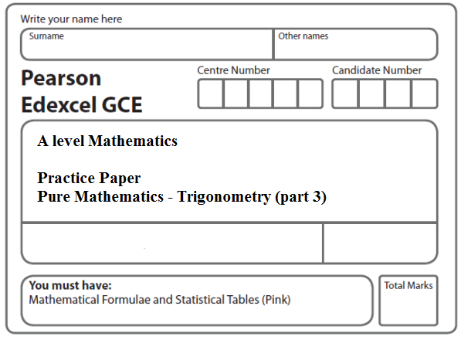
Instructions
- Use black ink or ball-point pen.
- If pencil is used for diagrams/sketches/graphs it must be dark (HB or B).
- Fill in the boxes at the top of this page with your name, centre number and candidate number.
- Answer all the questions and ensure that your answers to parts of questions are clearly labelled.
- Answer the questions in the spaces provided – there may be more space than you need.
- You should show sufficient working to make your methods clear. Answers without working may not gain full credit.
- Inexact answers should be given to three significant figures unless otherwise stated.
Information
- A booklet ‘Mathematical Formulae and Statistical Tables’ is provided.
- There are 9 questions in this question paper. The total mark for this paper is 96.
- The marks for each question are shown in brackets – use this as a guide as to how much time to spend on each question.
- Calculators must not be used for questions marked with a * sign.
Advice
• Read each question carefully before you start to answer it.
• Try to answer every question.
• Check your answers if you have time at the end.
• If you change your mind about an answer, cross it out and put your new answer and any working underneath.
1. (i) (a) Show that 2 tan x – cot x = 5 cosec x may be written in the form

a cos² x + b cos x + c = 0

stating the values of the constants a, b and c.
(4)
(b) Hence solve, for 0 ≤ x < 2π, the equation

2 tan x – cot x = 5 cosec x

giving your answers to 3 significant figures.
(4)
(ii) Show that

tan θ + cot θ ≡ λ cosec 2θ, , n ∈ ℤ

stating the value of the constant λ.
(4)
(Total 12 marks)
___________________________________________________________________________

2. (a) Express 4 cosec² 2θ − cosec² θ in terms of sin θ and cos θ.
(2)
(b) Hence show that
4 cosec² 2θ − cosec² θ = sec² θ .
(4)
(c) Hence or otherwise solve, for 0 < θ < π,

4 cosec² 2θ − cosec² θ = 4

giving your answers in terms of π.
(3)
(Total 9 marks)
___________________________________________________________________________

3. (a) Prove that
= tan θ, θ ≠ 90n°, n ∈ ℤ.
(4)
(b) Hence, or otherwise,

(i) show that tan 15° = 2 – $\sqrt{3}$,
(3)
(ii) solve, for 0 < x < 360°,

cosec 4x – cot 4x = 1.
(5)
(Total 12 marks)
___________________________________________________________________________

4. (a) Show that
cosec 2x + cot 2x = cot x, x ≠ 90n°, n ∈ ℤ
(5)
(b) Hence, or otherwise, solve, for 0 ≤ θ < 180°,

cosec (4θ + 10°) + cot (4θ + 10°) = √3

You must show your working.

(Solutions based entirely on graphical or numerical methods are not acceptable.)
(5)
(Total 10 marks)
___________________________________________________________________________

5. (a) Prove that
2 cot 2x + tan x ≡ cot x, x ≠ , n ∈ ℤ
(4)
(b) Hence, or otherwise, solve, for –π ≤ x < π,

6 cot 2x + 3 tan x = cosec² x – 2.

Give your answers to 3 decimal places.

(Solutions based entirely on graphical or numerical methods are not acceptable.)
(6)
(Total 10 marks)
___________________________________________________________________________

6. (a) Prove that
sec 2A + tan 2A ≡ , A ≠ , n ∈ℤ.
(5)
(b) Hence solve, for 0 ≤ θ < 2π,
sec 2θ + tan 2θ = .
Give your answers to 3 decimal places.
(4)
(Total 9 marks)
___________________________________________________________________________

7. f(x) = 7 cos 2x − 24 sin 2x.

Given that f(x) = R cos (2x + α), where R > 0 and 0 < α < 90°,

(a) find the value of R and the value of α.
(3)
(b) Hence solve the equation
7 cos 2x − 24 sin 2x = 12.5

for 0 ≤ x < 180°, giving your answers to 1 decimal place.
(5)
(c) Express 14 cos² x − 48 sin x cos x in the form a cos 2x + b sin 2x + c, where a, b, and c are constants to be found.
(2)
(d) Hence, using your answers to parts (a) and (c), deduce the maximum value of

14 cos² x − 48 sin x cos x.
(2)
(Total 12 marks)
___________________________________________________________________________

8. (a) Starting from the formulae for sin (A + B) and cos (A + B), prove that

tan (A + B) = $\frac{\text{tan}A+\text{tan}B}{1−\text{tan}A\text{tan}B}$.
(4)
(b) Deduce that

tan = .
(3)
(c) Hence, or otherwise, solve, for 0 ≤ θ ≤ π,

1 + √3 tan θ = (√3 − tan θ) tan (π − θ).

Give your answers as multiples of π.
(6)

(Total 13 marks)
___________________________________________________________________________
9. (a) Prove that
sin 2x – tan x tan x cos 2x, x (2n + 1)90°, n ∈ ℤ
(4)
(b) Given that x 90° and x 270°, solve, for 0 ⩽ x < 360°,
sin 2x – tan x = 3 tan x sin x
Give your answers in degrees to one decimal place where appropriate.
(Solutions based entirely on graphical or numerical methods are not acceptable.)
(5)
(Total 9 marks)

TOTAL FOR PAPER: 96 MARKS

