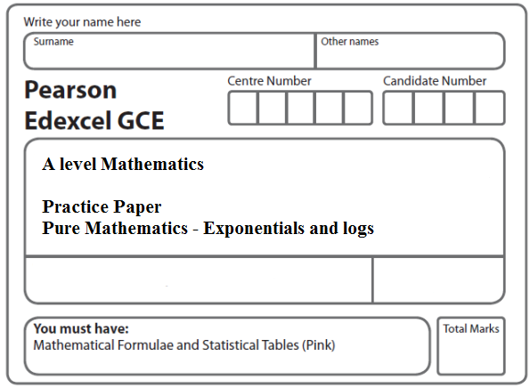
Instructions
- Use black ink or ball-point pen.
- If pencil is used for diagrams/sketches/graphs it must be dark (HB or B).
- Fill in the boxes at the top of this page with your name, centre number and candidate number.
- Answer all the questions and ensure that your answers to parts of questions are clearly labelled.
- Answer the questions in the spaces provided – there may be more space than you need.
- You should show sufficient working to make your methods clear. Answers without working may not gain full credit.
- Inexact answers should be given to three significant figures unless otherwise stated.
Information
- A booklet ‘Mathematical Formulae and Statistical Tables’ is provided.
- There are 11 questions in this question paper. The total mark for this paper is 101.
- The marks for each question are shown in brackets – use this as a guide as to how much time to spend on each question.
- Calculators must not be used for questions marked with a * sign.
Advice
• Read each question carefully before you start to answer it.
• Try to answer every question.
• Check your answers if you have time at the end.
• If you change your mind about an answer, cross it out and put your new answer and any working underneath.
1. Find the exact solutions, in their simplest form, to the equations

(a) 2 ln (2x + 1) – 10 = 0
(2)
(b) 3^{x}e^{4x} = e⁷
(4)
(Total 6 marks)
___________________________________________________________________________

2. Find algebraically the exact solutions to the equations

(a) ln (4 – 2x) + ln (9 – 3x) = 2 ln (x + 1), –1 < x < 2,
(5)
(b) 2^{x} e^{3x+1} = 10.

Give your answer to (b) in the form where a, b, c and d are integers.
(5)
(Total 10 marks)
___________________________________________________________________________

3. Given that
f(x) = 2e^{x} – 5, x ∈ ℝ,

(a) sketch, on separate diagrams, the curve with equation

(i) y = f (x),

(ii) y = |f (x)|.

On each diagram, show the coordinates of each point at which the curve meets or cuts the axes.

On each diagram state the equation of the asymptote.
(6)
(b) Deduce the set of values of x for which f (x) = |f (x)|.
(1)
(c) Find the exact solutions of the equation |f (x)| = 2.
(3)

(Total 10 marks)
___________________________________________________________________________
4. The functions f and g are defined by
f: x e^{x} + 2, x ∈ ℝ,

g : x ln x, x > 0.
(a) State the range of f.
(1)
(b) Find fg(x), giving your answer in its simplest form.
(2)
(c) Find the exact value of x for which f(2x + 3) = 6.
(4)
(d) Find f ⁻¹, the inverse function of f, stating its domain.
(3)
(e) On the same axes sketch the curves with equation y = f(x) and y = f⁻¹(x), giving the coordinates of all the points where the curves cross the axes.
(4)
(Total 14 marks)
___________________________________________________________________________

5. The function f is defined by
f : , x ∈ ℝ, k is a positive constant.

(a) State the range of f.
(1)
(b) Find f ^{–1} and state its domain.
(3)
The function g is defined by
g : , x > 0

(c) Solve the equation
g(x) + g(x²) + g(x³) = 6

giving your answer in its simplest form.
(4)
(d) Find fg(x), giving your answer in its simplest form.
(2)
(e) Find, in terms of the constant k, the solution of the equation

fg(x) = 2k²
(2)
(Total 12 marks)
___________________________________________________________________________
6. The area, A mm², of a bacterial culture growing in milk, t hours after midday, is given by

A = 20e^{1.5t}, t ≥ 0.

(a) Write down the area of the culture at midday.
(1)
(b) Find the time at which the area of the culture is twice its area at midday. Give your answer to the nearest minute.
(5)
(Total 6 marks)
___________________________________________________________________________

7. Water is being heated in an electric kettle. The temperature, θ °C, of the water t seconds after the kettle is switched on, is modelled by the equation

θ = 120 – 100e^{–λt}, 0 ≤ t ≤ T.

(a) State the value of θ when t = 0.
(1)

Given that the temperature of the water in the kettle is 70 °C when t = 40,

(b) find the exact value of λ, giving your answer in the form , where a and b are integers.
(4)

When t = T, the temperature of the water reaches 100 °C and the kettle switches off.

(c) Calculate the value of T to the nearest whole number.
(2)
(Total 7 marks)
___________________________________________________________________________

8. The first term of a geometric series is 20 and the common ratio is . The sum to infinity of the series is S∞.

(a) Find the value of S∞.
(2)

The sum to N terms of the series is S_{N}.

(b) Find, to 1 decimal place, the value of S₁₂.
(2)
(c) Find the smallest value of N, for which S∞ – S_{N} < 0.5.
(4)

(Total 8 marks)
___________________________________________________________________________

9. (i) All the terms of a geometric series are positive. The sum of the first two terms is 34 and the sum to infinity is 162.

Find

(a) the common ratio,
(4)

(b) the first term.
(2)

(ii) A different geometric series has a first term of 42 and a common ratio of .
Find the smallest value of n for which the sum of the first n terms of the series exceeds 290.
(4)
(Total 10 marks)
___________________________________________________________________________

10. The value of Bob’s car can be calculated from the formula
V = 17000e^{−0.25t} + 2000e^{−0.5t} + 500.

where V is the value of the car in pounds (£) and t is the age in years.

(a) Find the value of the car when t = 0.
(1)
(b) Calculate the exact value of t when V = 9500.
(4)
(c) Find the rate at which the value of the car is decreasing at the instant when t = 8.
Give your answer in pounds per year to the nearest pound.
(4)
(Total 9 marks)
___________________________________________________________________________

11. The amount of an antibiotic in the bloodstream, from a given dose, is modelled by the formula
x = De^{–0.2t},

where x is the amount of the antibiotic in the bloodstream in milligrams, D is the dose given in milligrams and t is the time in hours after the antibiotic has been given.

A first dose of 15 mg of the antibiotic is given.

(a) Use the model to find the amount of the antibiotic in the bloodstream 4 hours after the dose is given. Give your answer in mg to 3 decimal places.
(2)

A second dose of 15 mg is given 5 hours after the first dose has been given. Using the same model for the second dose,

(b) show that the total amount of the antibiotic in the bloodstream 2 hours after the second dose is given is 13.754 mg to 3 decimal places.
(2)

No more doses of the antibiotic are given. At time T hours after the second dose is given, the total amount of the antibiotic in the bloodstream is 7.5 mg.

(c) Show that T = a ln $\left(b+\frac{b}{e}\right)$, where a and b are integers to be determined.
(4)
(Total 8 marks)

TOTAL FOR PAPER: 101 MARKS

