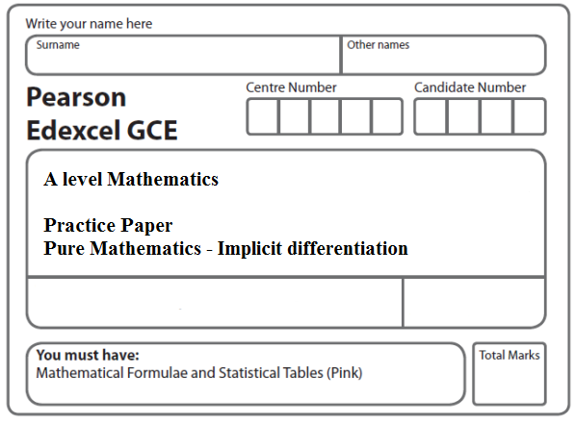
Instructions
- Use black ink or ball-point pen.
- If pencil is used for diagrams/sketches/graphs it must be dark (HB or B).
- Fill in the boxes at the top of this page with your name, centre number and candidate number.
- Answer all the questions and ensure that your answers to parts of questions are clearly labelled.
- Answer the questions in the spaces provided – there may be more space than you need.
- You should show sufficient working to make your methods clear. Answers without working may not gain full credit.
- Inexact answers should be given to three significant figures unless otherwise stated.
Information
- A booklet ‘Mathematical Formulae and Statistical Tables’ is provided.
- There are 7 questions in this question paper. The total mark for this paper is 66.
- The marks for each question are shown in brackets – use this as a guide as to how much time to spend on each question.
- Calculators must not be used for questions marked with a * sign.
Advice
• Read each question carefully before you start to answer it.
• Try to answer every question.
• Check your answers if you have time at the end.
• If you change your mind about an answer, cross it out and put your new answer and any working underneath.
1. A curve C has the equation
x³ + 2xy – x – y³ – 20 = 0
(a) Find in terms of x and y.
(5)
(b) Find an equation of the tangent to C at the point (3, –2), giving your answer in the form ax + by + c = 0, where a, b and c are integers.
(2)
(Total 7 marks)
___________________________________________________________________________

2. The curve C has the equation 2x + 3y² + 3x² y = 4x².

The point P on the curve has coordinates (–1, 1).

(a) Find the gradient of the curve at P.
(5)
(b) Hence find the equation of the normal to C at P, giving your answer in the form ax + by + c = 0, where a, b and c are integers.
(3)
(Total 8 marks)
___________________________________________________________________________

3. The curve C has equation
x² – 3xy – 4y² + 64 = 0.
(a) Find $\frac{dy}{dx}$ in terms of x and y.
(5)
(b) Find the coordinates of the points on C where $\frac{dy}{dx}$ = 0.
(Solutions based entirely on graphical or numerical methods are not acceptable.)
(6)
(Total 11 marks)
___________________________________________________________________________

4. x² + y² + 10x + 2y – 4xy = 10
(a) Find in terms of x and y, fully simplifying your answer.
(5)
(b) Find the values of y for which .
(5)
(Total 10 marks)
___________________________________________________________________________

5. The curve C has equation

2x²y + 2x + 4y – cos (πy) = 17.

(a) Use implicit differentiation to find in terms of x and y.
(5)
The point P with coordinates lies on C.
The normal to C at P meets the x-axis at the point A.

(b) Find the x coordinate of A, giving your answer in the form , where a, b, c and d are integers to be determined.
(4)
(Total 9 marks)
___________________________________________________________________________
6. The curve C has equation
4x² – y³ – 4xy + 2^{y} = 0
The point P with coordinates (–2, 4) lies on C.
(a) Find the exact value of at the point P.
(6)

The normal to C at P meets the y-axis at the point A.
(b) Find the y coordinate of A, giving your answer in the form p + qln2, where p and q
are constants to be determined.
(3)
(Total 9 marks)
___________________________________________________________________________

7. The curve C has equation

16y³ + 9x²y − 54x = 0.

(a) Find in terms of x and y.
(5)
(b) Find the coordinates of the points on C where = 0.
(7)
(Total 12 marks)

TOTAL FOR PAPER: 66 MARKS

