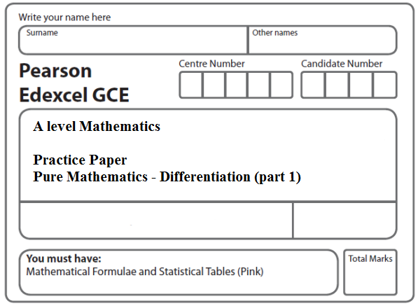
Instructions
- Use black ink or ball-point pen.
- If pencil is used for diagrams/sketches/graphs it must be dark (HB or B).
- Fill in the boxes at the top of this page with your name, centre number and candidate number.
- Answer all the questions and ensure that your answers to parts of questions are clearly labelled.
- Answer the questions in the spaces provided – there may be more space than you need.
- You should show sufficient working to make your methods clear. Answers without working may not gain full credit.
- Inexact answers should be given to three significant figures unless otherwise stated.
Information
- A booklet ‘Mathematical Formulae and Statistical Tables’ is provided.
- There are 11 questions in this question paper. The total mark for this paper is 100.
- The marks for each question are shown in brackets – use this as a guide as to how much time to spend on each question.
- Calculators must not be used for questions marked with a * sign.
Advice
• Read each question carefully before you start to answer it.
• Try to answer every question.
• Check your answers if you have time at the end.
• If you change your mind about an answer, cross it out and put your new answer and any working underneath.
1. Differentiate with respect to x, giving your answer in its simplest form,

(a) x² ln (3x),
(4)
(b) .
(5)
(Total 9 marks)
___________________________________________________________________________

2. Differentiate with respect to x

(a) ln (x² + 3x + 5),
(2)
(b) .
(3)
(Total 5 marks)
___________________________________________________________________________

3. (a) Express
–

as a single fraction in its simplest form.
(4)

Given that
f(x) = – – 2, x > 1,

(b) show that
f(x) = .
(2)
(c) Hence differentiate f(x) and find f ′(2).
(3)
(Total 9 marks)
___________________________________________________________________________

4. Given that
x = sec² 3y, 0 < y <

(a) find in terms of y.
(2)
(b) Hence show that
(4)
(c) Find an expression for in terms of x. Give your answer in its simplest form.
(4)
(Total 10 marks)
___________________________________________________________________________

5.

Figure 1

Figure 1 shows a sketch of the curve C which has equation

y = e^{x√3} sin 3x, − ≤ x ≤ .

(a) Find the x-coordinate of the turning point P on C, for which x > 0.
Give your answer as a multiple of π.
(6)
(b) Find an equation of the normal to C at the point where x = 0.
(3)
(Total 9 marks)
___________________________________________________________________________

6. Find the gradient of the curve with equation

ln y = 2x ln x, x > 0, y > 0,

at the point on the curve where x = 2. Give your answer as an exact value.

(Total 7 marks)
___________________________________________________________________________
7. (i) Differentiate with respect to x

(a) y = x³ ln 2x,

(b) y = (x + sin 2x)³.
(6)

Given that x = cot y,

(ii) show that = .
(5)
(Total 11 marks)
___________________________________________________________________________

8. (a) Differentiate with respect to x,

(i) ln (3x),

(ii) , giving your answer in its simplest form.
(6)
(b) Given that x = 3 tan 2y find in terms of x.
(5)
(Total 11 marks)
___________________________________________________________________________
9. h(x) = + – , x ≥ 0.
(a) Show that h(x) = .
(4)
(b) Hence, or otherwise, find h′(x) in its simplest form.
(3)
Figure 2

Figure 2 shows a graph of the curve with equation y = h(x).

(c) Calculate the range of h(x) .
(5)
(Total 12 marks)
___________________________________________________________________________
10. The curve C has equation
y = .

(a) Show that
=
(4)
(b) Find an equation of the tangent to C at the point on C where x = .

Write your answer in the form y = ax + b, where a and b are exact constants.
(4)
(Total 8 marks)
___________________________________________________________________________

11. Given that
(cos x) = –sin x,

(a) show that (sec x) = sec x tan x.
(3)

Given that
x = sec 2y,

(b) find in terms of y.
(2)

(c) Hence find in terms of x.
(4)

(Total 9 marks)

TOTAL FOR PAPER: 100 MARKS

