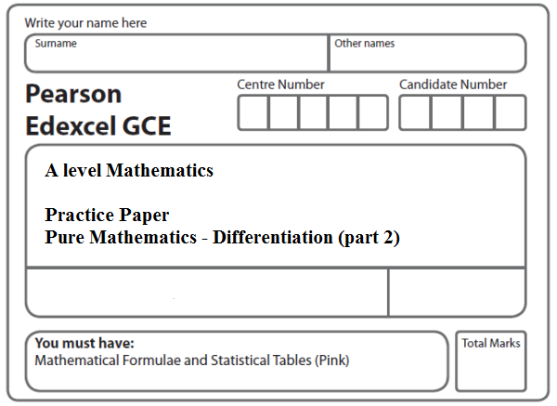
Instructions
- Use black ink or ball-point pen.
- If pencil is used for diagrams/sketches/graphs it must be dark (HB or B).
- Fill in the boxes at the top of this page with your name, centre number and candidate number.
- Answer all the questions and ensure that your answers to parts of questions are clearly labelled.
- Answer the questions in the spaces provided – there may be more space than you need.
- You should show sufficient working to make your methods clear. Answers without working may not gain full credit.
- Inexact answers should be given to three significant figures unless otherwise stated.
Information
- A booklet ‘Mathematical Formulae and Statistical Tables’ is provided.
- There are 11 questions in this question paper. The total mark for this paper is 100.
- The marks for each question are shown in brackets – use this as a guide as to how much time to spend on each question.
- Calculators must not be used for questions marked with a * sign.
Advice
• Read each question carefully before you start to answer it.
• Try to answer every question.
• Check your answers if you have time at the end.
• If you change your mind about an answer, cross it out and put your new answer and any working underneath.
1. The curve C has equation y = f (x) where
,
(a) Show that
(3)
Given that P is a point on C such that f ʹ(x) = –1,
(b) find the coordinates of P.
(3)
(Total 6 marks)
___________________________________________________________________________

2. The curve C has equation
y = (2x − 3)⁵
The point P lies on C and has coordinates (w, –32).
Find
(a) the value of w,
(2)
(b) the equation of the tangent to C at the point P in the form y = mx + c , where m and c are constants.
(5)
(Total 7 marks)
___________________________________________________________________________

3. The curve C has equation x = 8y tan 2y.
The point P has coordinates .
(a) Verify that P lies on C.
(1)
(b) Find the equation of the tangent to C at P in the form ay = x + b, where the constants
a and b are to be found in terms of π.
(7)
(Total 8 marks)
___________________________________________________________________________

4. (i) Given that ,
show that
(4)
(ii) Given that
find the exact value of at , giving your answer in its simplest form.
(5)
(iii) Given that ,
show that ,
where g(x) is an expression to be found.
(3)
(Total 12 marks)
___________________________________________________________________________

5. The point P lies on the curve with equation
x = (4y – sin 2y)².
Given that P has (x, y) coordinates $\left(p, \frac{π}{2}\right)$, where p is a constant,
(a) find the exact value of p.
(1)
The tangent to the curve at P cuts the y-axis at the point A.
(b) Use calculus to find the coordinates of A.
(6)
(Total 7 marks)
___________________________________________________________________________

6. (i) Find, using calculus, the x coordinate of the turning point of the curve with equation
y = e^{3x} cos 4x, .

Give your answer to 4 decimal places.
(5)
(ii) Given x = sin² 2y, 0 < y < , find as a function of y.

Write your answer in the form

= p cosec(qy), 0 < y < ,

where p and q are constants to be determined.
(5)
(Total 10 marks)
___________________________________________________________________________

7. (i) Given y = 2x(x² – 1)⁵, show that
(a) = g(x)(x² – 1)⁴ where g(x) is a function to be determined.
(4)
(b) Hence find the set of values of x for which ⩾ 0
(2)
(ii) Given
x = ln(sec2y), 0 < y <
find as a function of x in its simplest form.
(4)
(Total 10 marks)
___________________________________________________________________________

8. f(x) = – , x ≠ ±3, x ≠ –.

(a) Show that
f(x) = .
(5)

The curve C has equation y = f (x). The point P lies on C.

(b) Find an equation of the normal to C at P.
(8)
(Total 13 marks)
___________________________________________________________________________
9.
Figure 1

Figure 1 shows a sketch of part of the curve with equation

g(x) = x²(1 – x)e^{–2x}, x ≥ 0.

(a) Show that g' (x) = f(x)e^{–2x}, where f(x) is a cubic function to be found.
(3)
(b) Hence find the range of g.
(6)
(c) State a reason why the function g^{–1}(x) does not exist.
(1)
(Total 10 marks)
___________________________________________________________________________

10. Given that k is a negative constant and that the function f(x) is defined by
f (x) = 2 – $\frac{(x−5k)(x−k)}{x^{2}−3\text{kx}+2k^{2}}$, x ≥ 0,
(a) show that f (x) = $\frac{x+k}{x−2k}$.
(3)
(b) Hence find f ' (x), giving your answer in its simplest form.
(3)
(c) State, with a reason, whether f (x) is an increasing or a decreasing function.
Justify your answer.
(2)
(Total 8 marks)
___________________________________________________________________________

11. f(x) = $\frac{x^{4}+x^{3}−3x^{2}+7x−6}{x^{2}+x−6}$, x > 2, x ∈ ℝ.

(a) Given that
,

find the values of the constants A and B.
(4)
(b) Hence or otherwise, using calculus, find an equation of the normal to the curve with equation y = f(x) at the point where x = 3.
(5)
(Total 9 marks)

TOTAL FOR PAPER: 100 MARKS

