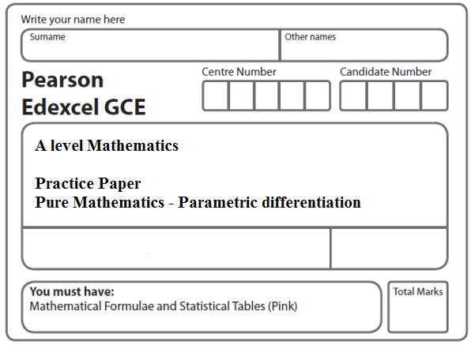
Instructions
- Use black ink or ball-point pen.
- If pencil is used for diagrams/sketches/graphs it must be dark (HB or B).
- Fill in the boxes at the top of this page with your name, centre number and candidate number.
- Answer all the questions and ensure that your answers to parts of questions are clearly labelled.
- Answer the questions in the spaces provided – there may be more space than you need.
- You should show sufficient working to make your methods clear. Answers without working may not gain full credit.
- Inexact answers should be given to three significant figures unless otherwise stated.
Information
- A booklet ‘Mathematical Formulae and Statistical Tables’ is provided.
- There are 5 questions in this question paper. The total mark for this paper is 40.
- The marks for each question are shown in brackets – use this as a guide as to how much time to spend on each question.
- Calculators must not be used for questions marked with a * sign.
Advice
• Read each question carefully before you start to answer it.
• Try to answer every question.
• Check your answers if you have time at the end.
• If you change your mind about an answer, cross it out and put your new answer and any working underneath.
1.

Figure 1

Figure 1 shows a sketch of the curve C with parametric equations

x = 4 tan t, y = 5sin2t, 0 ≤ t < .

The point P lies on C and has coordinates .

(a) Find the exact value of at the point P.
Give your answer as a simplified surd.
(4)
The point Q lies on the curve C, where = 0.

(b) Find the exact coordinates of the point Q.
(2)
(Total 6 marks)
___________________________________________________________________________

2. The curve C has parametric equations
x = 3t – 4, y = 5 – , t > 0
(a) Find in terms of t
(2)

The point P lies on C where t =
(b) Find the equation of the tangent to C at the point P. Give your answer in the form
y = px + q, where p and q are integers to be determined.
(3)
(c) Show that the cartesian equation for C can be written in the form
x > –4
where a and b are integers to be determined.
(3)
(Total 8 marks)
___________________________________________________________________________

3. A curve C has parametric equations
x = 4t + 3, y = 4t + 8 + $\frac{5}{2t}$, t ≠ 0.
(a) Find the value of $\frac{dy}{dx}$ at the point on C where t = 2, giving your answer as a fraction in its simplest form.
(3)
(b) Show that the cartesian equation of the curve C can be written in the form
y = $\frac{x^{2}+\text{ax}+b}{x−3}$, x ≠ 3,
where a and b are integers to be determined.
(3)
(Total 6 marks)
___________________________________________________________________________

4.

Figure 2

Figure 2 shows a sketch of the curve C with parametric equations

x = √3 sin 2t, y = 4 cos² t, 0 ≤ t ≤ π.

(a) Show that = k√3 tan 2t, where k is a constant to be determined.
(5)
(b) Find an equation of the tangent to C at the point where t = .

Give your answer in the form y = ax + b, where a and b are constants.
(4)
(c) Find a cartesian equation of C.
(3)
(Total 12 marks)
___________________________________________________________________________
5.

Figure 3

Figure 3 shows a sketch of the curve C with parametric equations

x = 4 sin , y = 3 cos 2t, 0 ≤ t < 2π.

(a) Find an expression for in terms of t.
(3)
(b) Find the coordinates of all the points on C where = 0.
(5)
(Total 8 marks)

TOTAL FOR PAPER: 40 MARKS

