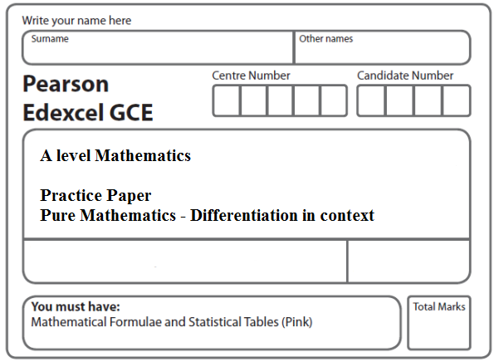
Instructions
- Use black ink or ball-point pen.
- If pencil is used for diagrams/sketches/graphs it must be dark (HB or B).
- Fill in the boxes at the top of this page with your name, centre number and candidate number.
- Answer all the questions and ensure that your answers to parts of questions are clearly labelled.
- Answer the questions in the spaces provided – there may be more space than you need.
- You should show sufficient working to make your methods clear. Answers without working may not gain full credit.
- Inexact answers should be given to three significant figures unless otherwise stated.
Information
- A booklet ‘Mathematical Formulae and Statistical Tables’ is provided.
- There are 9 questions in this question paper. The total mark for this paper is 82.
- The marks for each question are shown in brackets – use this as a guide as to how much time to spend on each question.
- Calculators must not be used for questions marked with a * sign.
Advice
• Read each question carefully before you start to answer it.
• Try to answer every question.
• Check your answers if you have time at the end.
• If you change your mind about an answer, cross it out and put your new answer and any working underneath.
1.

Figure 1 Figure 2
Figure 1 shows a closed letter box ABFEHGCD, which is made to be attached to a wall of a house.
The letter box is a right prism of length y cm as shown in Figure 1. The base ABFE of the prism is a rectangle. The total surface area of the six faces of the prism is S cm².
The cross section ABCD of the letter box is a trapezium with edges of lengths DA = 9x cm, AB = 4x cm, BC = 6x cm and CD = 5x cm as shown in Figure 2.
The angle DAB = 90° and the angle ABC = 90°. The volume of the letter box is 9600 cm³.
(a) Show that y = $\frac{\text{320}}{x^{2}}$.
(2)
(b) Hence show that the surface area of the letter box, S cm², is given by S = 60x² + $\frac{\text{7680}}{x}$.
(4)
(c) Use calculus to find the minimum value of S.
(6)
(d) Justify, by further differentiation, that the value of S you have found is a minimum.
(2)
(Total 14 marks)
___________________________________________________________________________
2.
Figure 3

Figure 3 shows a plan view of a sheep enclosure.
The enclosure ABCDEA, as shown in Figure 4, consists of a rectangle BCDE joined to an equilateral triangle BFA and a sector FEA of a circle with radius x metres and centre F.
The points B, F and E lie on a straight line with FE = x metres and 10 ≤ x ≤ 25.
(a) Find, in m², the exact area of the sector FEA, giving your answer in terms of x, in its simplest form.
(2)
Given that BC = y metres, where y > 0, and the area of the enclosure is 1000 m²,
(b) show that
.
(3)
(c) Hence show that the perimeter P metres of the enclosure is given by
.
(3)
(d) Use calculus to find the minimum value of P, giving your answer to the nearest metre.
(5)
(e) Justify, by further differentiation, that the value of P you have found is a minimum.
(2)
(Total 15 marks)
___________________________________________________________________________
3.

Figure 4

A cuboid has a rectangular cross-section where the length of the rectangle is equal to twice its width, x cm, as shown in Figure 4.

The volume of the cuboid is 81 cubic centimetres.

(a) Show that the total length, L cm, of the twelve edges of the cuboid is given by

L = 12x + .
(3)
(b) Use calculus to find the minimum value of L.
(6)
(c) Justify, by further differentiation, that the value of L that you have found is a minimum.
(2)
(Total 11 marks)
___________________________________________________________________________

4.
Figure 5

A vase with a circular cross-section is shown in Figure 5. Water is flowing into the vase.
When the depth of the water is h cm, the volume of water V cm³ is given by

V = 4 πh(h + 4), 0 ≤ h ≤ 25

Water flows into the vase at a constant rate of 80π cm³ s^{–1}.
Find the rate of change of the depth of the water, in cm s^{–1}, when h = 6.
(Total 5 marks)
___________________________________________________________________________

5. A rare species of primrose is being studied. The population, P, of primroses at time t years after the study started is modelled by the equation

, t ≥ 0,

(a) Calculate the number of primroses at the start of the study.
(2)
(b) Find the exact value of t when P = 250, giving your answer in the form a ln(b) where
a and b are integers.
(4)
(c) Find the exact value of when t =10. Give your answer in its simplest form.
(4)
(d) Explain why the population of primroses can never be 270.
(1)
(Total 11 marks)
___________________________________________________________________________

6.
Figure 6

The number of rabbits on an island is modelled by the equation
t ∈ ℝ, t ⩾ 0
where P is the number of rabbits, t years after they were introduced onto the island.
A sketch of the graph of P against t is shown in Figure 6.
(a) Calculate the number of rabbits that were introduced onto the island.
(1)
(b) Find
(3)

The number of rabbits initially increases, reaching a maximum value P_{T} when t = T
(c) Using your answer from part (b), calculate
(i) the value of T to 2 decimal places,
(ii) the value of P_{T} to the nearest integer.
(Solutions based entirely on graphical or numerical methods are not acceptable.)
(4)

For t > T, the number of rabbits decreases, as shown in Figure 6, but never falls below k,
where k is a positive constant.
(d) Use the model to state the maximum value of k.
(1)
(Total 9 marks)
___________________________________________________________________________

7. The current, I amps, in an electric circuit at time t seconds is given by

I = 16 – 16(0.5)^{t}, t ≥ 0.

Use differentiation to find the value of when t = 3 .
Give your answer in the form ln a, where a is a constant.
(Total 5 marks)
___________________________________________________________________________

8.

Figure 7

Figure 7 shows a metal cube which is expanding uniformly as it is heated.

At time t seconds, the length of each edge of the cube is x cm, and the volume of the cube is V cm³.

(a) Show that = 3x².
(1)

Given that the volume, V cm³, increases at a constant rate of 0.048 cm³ s^{–1},

(b) find when x = 8,
(2)
(c) find the rate of increase of the total surface area of the cube, in cm² s^{–1}, when x = 8.
(3)
(Total 6 marks)
___________________________________________________________________________
9.

Figure 8

A hollow hemispherical bowl is shown in Figure 8. Water is flowing into the bowl.

When the depth of the water is h m, the volume V m³ is given by

V = π h²(3 – 4h), 0 ≤ h ≤ 0.25.

(a) Find, in terms of π, when h = 0.1.
(4)

Water flows into the bowl at a rate of m³ s^{–1}.

(b) Find the rate of change of h, in m s^{–1}, when h = 0.1.
(2)
(Total 6 marks)

TOTAL FOR PAPER: 82 MARKS

