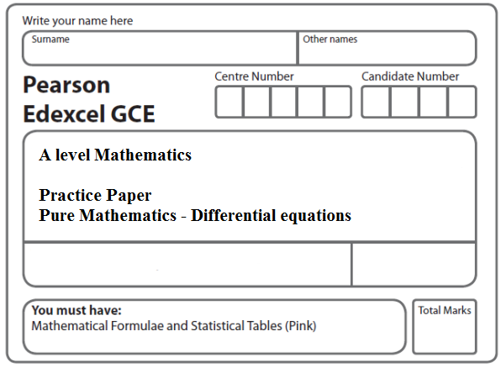
Instructions
- Use black ink or ball-point pen.
- If pencil is used for diagrams/sketches/graphs it must be dark (HB or B).
- Fill in the boxes at the top of this page with your name, centre number and candidate number.
- Answer all the questions and ensure that your answers to parts of questions are clearly labelled.
- Answer the questions in the spaces provided – there may be more space than you need.
- You should show sufficient working to make your methods clear. Answers without working may not gain full credit.
- Inexact answers should be given to three significant figures unless otherwise stated.
Information
- A booklet ‘Mathematical Formulae and Statistical Tables’ is provided.
- There are 9 questions in this question paper. The total mark for this paper is 83.
- The marks for each question are shown in brackets – use this as a guide as to how much time to spend on each question.
- Calculators must not be used for questions marked with a * sign.
Advice
• Read each question carefully before you start to answer it.
• Try to answer every question.
• Check your answers if you have time at the end.
• If you change your mind about an answer, cross it out and put your new answer and any working underneath.
1. Given that y = 2 at x = , solve the differential equation
= .
(Total 5 marks)
___________________________________________________________________________

2. (i) Find
(3)
(ii) Find
, x >
(2)
(iii) Given that at x = 0, solve the differential equation
(7)
(Total 12 marks)
___________________________________________________________________________

3. The rate of decay of the mass of a particular substance is modelled by the differential equation

,

where x is the mass of the substance measured in grams and t is the time measured in days.

Given that x = 60 when t = 0,

(a) solve the differential equation, giving x in terms of t. You should show all steps in your working and give your answer in its simplest form.
(4)
(b) Find the time taken for the mass of the substance to decay from 60 grams to 20 grams.
Give your answer to the nearest minute.
(3)
(Total 7 marks)
___________________________________________________________________________

4.

Figure 1

Figure 1 shows a vertical cylindrical tank of height 200 cm containing water.
Water is leaking from a hole P on the side of the tank.
At time t minutes after the leaking starts, the height of water in the tank is h cm.
The height h cm of the water in the tank satisfies the differential equation
9 < h ⩽ 200
where k is a constant.
Given that, when h = 130, the height of the water is falling at a rate of 1.1 cm per minute,
(a) find the value of k.
(2)

Given that the tank was full of water when the leaking started,
(b) solve the differential equation with your value of k, to find the value of t when h = 50
(6)
(Total 8 marks)
___________________________________________________________________________
5. (a) Express in partial fractions.
(3)

A team of biologists is studying a population of a particular species of animal.

The population is modelled by the differential equation

= P(P – 2) cos 2t, t ≥ 0,

where P is the population in thousands, and t is the time measured in years since the start of the study.

Given that P = 3 when t = 0,

(b) solve this differential equation to show that
P =
(7)
(c) find the time taken for the population to reach 4000 for the first time.
Give your answer in years to 3 significant figures.
(3)
(Total 13 marks)
___________________________________________________________________________
6. The rate of increase of the number, N, of fish in a lake is modelled by the differential equation

, t > 0, 0 < N < 5000

In the given equation, the time t is measured in years from the start of January 2000 and k is a positive constant.

(a) By solving the differential equation, show that

N = 5000 – Ate^{–kt}

where A is a positive constant.
(5)

After one year, at the start of January 2001, there are 1200 fish in the lake.

After two years, at the start of January 2002, there are 1800 fish in the lake.

(b) Find the exact value of the constant A and the exact value of the constant k.
(4)
(c) Hence find the number of fish in the lake after five years. Give your answer to the nearest hundred fish.
(1)
(Total 10 marks)
___________________________________________________________________________

7. (a) Find .
(2)
(b) Given that y =1.5 at x = – 2, solve the differential equation

= ,

giving your answer in the form y = f(x).
(6)
(Total 8 marks)
___________________________________________________________________________

8. Water is being heated in a kettle. At time t seconds, the temperature of the water is θ°C.
The rate of increase of the temperature of the water at any time t is modelled by the differential equation
= λ(120 – θ), θ ≤ 100
where λ is a positive constant.

Given that θ = 20 when t = 0,

(a) solve this differential equation to show that

θ = 120 – 100e^{–λt}
(8)
When the temperature of the water reaches 100°C, the kettle switches off.

(b) Given that λ = 0.01, find the time, to the nearest second, when the kettle switches off.
(3)
(Total 11 marks)
___________________________________________________________________________

9. A bottle of water is put into a refrigerator. The temperature inside the refrigerator remains constant at 3 °C and t minutes after the bottle is placed in the refrigerator the temperature of the water in the bottle is θ °C.

The rate of change of the temperature of the water in the bottle is modelled by the differential equation
= .

(a) By solving the differential equation, show that

θ = Ae^{–0.008t} + 3,
where A is a constant.
(4)

Given that the temperature of the water in the bottle when it was put in the refrigerator was 16 °C,

(b) find the time taken for the temperature of the water in the bottle to fall to 10 °C, giving your answer to the nearest minute.
(5)
(Total 9 marks)

TOTAL FOR PAPER: 83 MARKS

