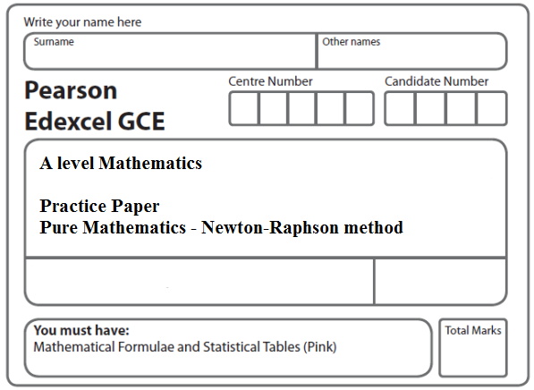
Instructions
- Use black ink or ball-point pen.
- If pencil is used for diagrams/sketches/graphs it must be dark (HB or B).
- Fill in the boxes at the top of this page with your name, centre number and candidate number.
- Answer all the questions and ensure that your answers to parts of questions are clearly labelled.
- Answer the questions in the spaces provided – there may be more space than you need.
- You should show sufficient working to make your methods clear. Answers without working may not gain full credit.
- Inexact answers should be given to three significant figures unless otherwise stated.
Information
- A booklet ‘Mathematical Formulae and Statistical Tables’ is provided.
- There are 4 questions in this question paper. The total mark for this paper is 25.
- The marks for each question are shown in brackets – use this as a guide as to how much time to spend on each question.
- Calculators must not be used for questions marked with a * sign.
Advice
• Read each question carefully before you start to answer it.
• Try to answer every question.
• Check your answers if you have time at the end.
• If you change your mind about an answer, cross it out and put your new answer and any working underneath.
1. f(x) = + − 5, x > 0.
(a) Find f ′(x).
(2)
The equation f(x) = 0 has a root α in the interval [4.5, 5.5].

(b) Using x₀ = 5 as a first approximation to α, apply the Newton-Raphson procedure once to f(x) to find a second approximation to α, giving your answer to 3 significant figures.
(4)
(Total 6 marks)
___________________________________________________________________________
2. f(x) = x² + – 3x – 1, x ≠ 0.
(a) Use differentiation to find f ′(x).
(2)
The root α of the equation f(x) = 0 lies in the interval [0.7, 0.9].

(b) Taking 0.8 as a first approximation to α, apply the Newton-Raphson process once to f(x) to obtain a second approximation to α. Give your answer to 3 decimal places.
(4)
(Total 6 marks)
___________________________________________________________________________
3. f(x) = x² + – 3x – 7, x > 0.
A root α of the equation f(x) = 0 lies in the interval [3, 5].

Taking 4 as a first approximation to α, apply the Newton-Raphson process once to f(x) to obtain a second approximation to α . Give your answer to 2 decimal places.
(Total 6 marks)
___________________________________________________________________________
4. , x > 0
(a) Show that the equation f(x) = 0 has a root α in the interval [1.1, 1.5].
(2)
(b) Find f ʹ(x).
(2)
(c) Using x₀ = 1.1 as a first approximation to α, apply the Newton-Raphson procedure once to f(x) to find a second approximation to α, giving your answer to 3 decimal places.
(3)
(Total 7 marks)

TOTAL FOR PAPER: 25 MARKS

