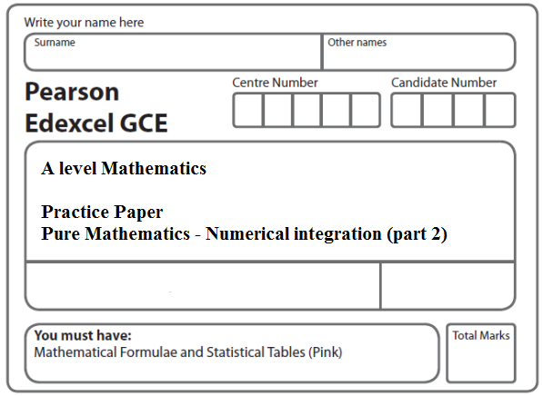
Instructions
- Use black ink or ball-point pen.
- If pencil is used for diagrams/sketches/graphs it must be dark (HB or B).
- Fill in the boxes at the top of this page with your name, centre number and candidate number.
- Answer all the questions and ensure that your answers to parts of questions are clearly labelled.
- Answer the questions in the spaces provided – there may be more space than you need.
- You should show sufficient working to make your methods clear. Answers without working may not gain full credit.
- Inexact answers should be given to three significant figures unless otherwise stated.
Information
- A booklet ‘Mathematical Formulae and Statistical Tables’ is provided.
- There are 8 questions in this question paper. The total mark for this paper is 90.
- The marks for each question are shown in brackets – use this as a guide as to how much time to spend on each question.
- Calculators must not be used for questions marked with a * sign.
Advice
• Read each question carefully before you start to answer it.
• Try to answer every question.
• Check your answers if you have time at the end.
• If you change your mind about an answer, cross it out and put your new answer and any working underneath.
1.

Figure 1

Figure 1 shows the graph of the curve with equation
y = + 1, x > 0.

The finite region R, bounded by the lines x = 1, the x-axis and the curve, is shown shaded in Figure 1. The curve crosses the x-axis at the point (4, 0).

(a) Complete the table with the values of y corresponding to x = 2 and 2.5.
x | 1 | 1.5 | 2 | 2.5 | 3 | 3.5 | 4
y | 16.5 | 7.361 |  |  | 1.278 | 0.556 | 0
(2)
(b) Use the trapezium rule with all the values in the completed table to find an approximate value for the area of R, giving your answer to 2 decimal places.
(4)
(c) Use integration to find the exact value for the area of R.
(5)
(Total 11 marks)
___________________________________________________________________________

2. y =

(a) Copy and complete the table below, giving the values of y to 2 decimal places.

x | 2 | 2.25 | 2.5 | 2.75 | 3
y | 0.5 | 0.38 |  |  | 0.2
(2)
(b) Use the trapezium rule, with all the values of y from your table, to find an approximate value for .
(4)

Figure 2

Figure 2 shows a sketch of part of the curve with equation y = $\frac{5}{3x^{2}−2}$, x > 1.

At the points A and B on the curve, x = 2 and x = 3 respectively.

The region S is bounded by the curve, the straight line through B and (2, 0), and the line through A parallel to the y-axis. The region S is shown shaded in Figure 2.

(c) Use your answer to part (b) to find an approximate value for the area of S.
(3)
(Total 9 marks)
___________________________________________________________________________

3. y = $\sqrt{\left(3^{x}+x\right)}$

(a) Complete the table below, giving the values of y to 3 decimal places.

x | 0 | 0.25 | 0.5 | 0.75 | 1
y | 1 | 1.251 |  |  | 2

(2)
(b) Use the trapezium rule with all the values of y from your table to find an approximation for the value of
$$\int{\sqrt{(3^{x}+x)}\begin{matrix} \\ dx\end{matrix}}$$
You must show clearly how you obtained your answer.
(4)
(Total 6 marks)
___________________________________________________________________________
4.

Figure 3

The finite region R, as shown in Figure 3, is bounded by the x-axis and the curve with equation

y = 27 − 2x − 9√x − , x > 0.

The curve crosses the x-axis at the points (1, 0) and (4, 0).

(a) Copy and complete the table below, by giving your values of y to 3 decimal places.

x | 1 | 1.5 | 2 | 2.5 | 3 | 3.5 | 4
y | 0 | 5.866 |  | 5.210 |  | 1.856 | 0
(2)

(b) Use the trapezium rule with all the values in the completed table to find an approximate value for the area of R, giving your answer to 2 decimal places.
(4)

(c) Use integration to find the exact value for the area of R.
(6)
(Total 12 marks)
___________________________________________________________________________

5.

Figure 4

Figure 4 shows a sketch of the curve with equation y = x³ ln (x² + 2), x ≥ 0.

The finite region R, shown shaded in Figure 4, is bounded by the curve, the x-axis and the line x = √2.

The table below shows corresponding values of x and y for y = x³ ln (x² + 2).

x | 0 |  |  |  | √2
y | 0 |  | 0.3240 |  | 3.9210

(a) Complete the table above giving the missing values of y to 4 decimal places.
(2)
(b) Use the trapezium rule, with all the values of y in the completed table, to obtain an estimate for the area of R, giving your answer to 2 decimal places.
(3)
(c) Use the substitution u = x² + 2 to show that the area of R is

.
(4)
(d) Hence, or otherwise, find the exact area of R.
(6)

(Total 15 marks)
___________________________________________________________________________
6.
Figure 5
Figure 5 shows a sketch of the curve with equation y = , 0 ≤ x ≤ .
The finite region R, shown shaded in Figure 5, is bounded by the curve and the x-axis.
The table below shows corresponding values of x and y for y = .

x | 0
y | 0 |  | 1.17157 | 1.02280 | 0

(a) Complete the table above giving the missing value of y to 5 decimal places.
(1)
(b) Use the trapezium rule, with all the values of y in the completed table, to obtain an estimate for the area of R, giving your answer to 4 decimal places.
(3)
(c) Using the substitution u = 1 + cos x, or otherwise, show that
= 4 ln (1 + cos x) – 4 cos x + k,
where k is a constant.
(5)
(d) Hence calculate the error of the estimate in part (b), giving your answer to 2 significant figures.
(3)
(Total 12 marks)
___________________________________________________________________________
7.

Figure 6

Figure 6 shows a sketch of part of the curve with equation y = ln 2x.

The finite region R, shown shaded in Figure 6, is bounded by the curve, the x-axis and the lines x = 1 and x = 4.

(a) Use the trapezium rule, with 3 strips of equal width, to find an estimate for the area of R, giving your answer to 2 decimal places.
(4)
(b) Find .
(4)
(c) Hence find the exact area of R, giving your answer in the form a ln 2 + b, where a and b are exact constants.
(3)
(Total 11 marks)
___________________________________________________________________________
8. I = .

(a) Given that y = , copy and complete the table below with values of y corresponding to x = 3 and x = 5 . Give your values to 4 decimal places.

x | 2 | 3 | 4 | 5
y | 0.2 |  | 0.1745
(2)

(b) Use the trapezium rule, with all of the values of y in the completed table, to obtain an estimate of I, giving your answer to 3 decimal places.
(4)
(c) Using the substitution x = (u − 4)² + 1, or otherwise, and integrating, find the exact value of I.
(8)
(Total 14 marks)

TOTAL FOR PAPER: 90 MARKS

