Astronomical telescope consisting of two converging lenses

This simple telescope uses two converging lenses - an objective lens and an eyepiece lens. The lenses are arranged such that the focal points of the two lenses coincide. The separation between the lenses is therefore equal to the sum of their focal lengths. Light from a point on a distant object – at infinity – sends parallel rays to the objective lens, which forms an image at its focal point. This image is real, and acts as the object for the second eyepiece lens. All the rays from a given point on this ‘image-object’ will give parallel rays leaving the eyepiece (the reverse of the image formation by the objective). The image seen through the eyepiece is thus virtual and seen at infinity. The direction of these rays can be found by drawing a construction line from the top of the ‘image-object’ that passes through the centre of the eyepiece lens undeviated and drawing the other lines parallel to it.

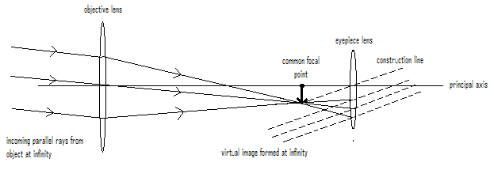

Note that:

The rays coming from the object at infinity are parallel.
The ray passing through the centre of the objective lens does not bend.
The rays do not bend as they pass the image at the common focal point.
The rays leave the eyepiece parallel to the construction line and to each other.

Subtended Angles

θ
a
b
c

If the angle between sides a and b of the right-angled triangle is very small then the sides can be considered to be the same length. This will be true when side c is very much smaller than the other two sides. For small angles such as these sin θ ≅ θ when θ is in radians.

Consider a very distant object of height, h, a distance, d, away

angle subtended

h
θ

d

The angle in radians subtended by the object is given by:

sin θ = h ≅ θ
d

We can calculate the angles subtended by the Moon and the Sun at the Earth.

Mean distance to the Moon = 380 000 km
Mean diameter of the Moon = 3500 km
Mean distance to the Sun = 150 000 000 km
Mean diameter of the Sun = 1 400 000 km

Angle subtended by the Moon = 3500 km = 9.21 x 10⁻³ rad
380 000 km

Angle subtended by the Moon = 1 400 000 km = 9.33 x 10⁻³ rad
150 000 000 km
Magnification of the telescope
If we look at the ray diagram for the telescope and simplify it by considering only the incoming ray that passes through the centre of the objective lens we can work out the angular magnification.

Angular magnification, M = angle subtended by image
angle subtended by object at the unaided eye
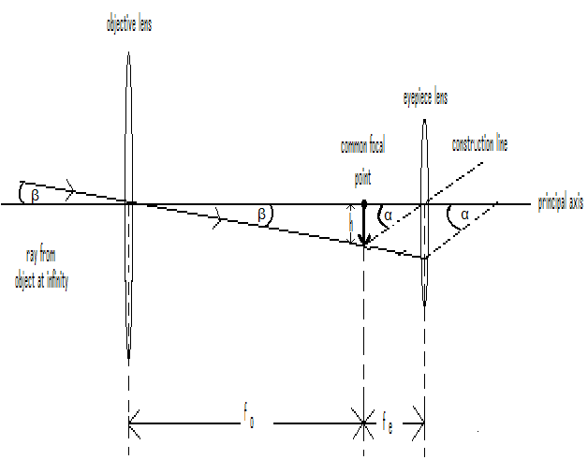Looking at this diagram, the angular magnification is α
β

sinα = h ≅ α
f_{e}

and sinβ = h ≅ β
f_{o}

hence α = h ÷ h
β f_{e} f_{o}

= h × f_{o}
f_{e} h

= f_{o}
f_{e}

Thus a high magnification telescope requires a long objective lens focal length and a short eyepiece focal length.

The equations M = f_{o} and objective to eyepiece distance = f_{o} + f_{e} can
f_{e}
be used to design particular telescopes.

