CLASSIFICATION OF STARS

Classification by luminosity

A brief look at the night sky would show that some stars look brighter than others. About 2000 years ago the Greek astronomer Hipparchus produced a catalogue of over 1000 stars and their relative brightness. He used a 6 point scale, with 1 being the brightest and 6 the dimmest. As this scale is concerned with how bright different stars appear to be, these magnitudes are an apparent magnitude scale. In simple qualitative terms this is the brightness of the star as seen from Earth. It should be stressed that what you see with the naked eye is the visible luminosity. (This is to avoid problems with the non-visible parts of the spectrum which should not be included in this simpler definition. So terms like luminosity or intensity should not be used. Luminosity is the total power radiated by a star, and the intensity is the power per unit area at the observer).

A star’s luminosity is in fact its total power output at all wavelengths and it is often referred to as the bolumetric luminosity. Obviously, it would not be helpful to catalogue a star’s bolumetric luminosity for observers to use with optical telescopes.

The fact that some stars appear brighter than others can be due to two reasons:
- it could be closer
- it could be emitting more power at visible wavelengths.

The brightest star in The Plough, for example, happens to be the furthest away.

Apparent magnitude, m

With modern measuring techniques (eg photography, CCD cameras) a more quantitative approach to apparent magnitude can be made. The devices allow the intensity of the light from a star to be measured. The apparent magnitude scale now takes on a more precise meaning. The branch of astronomy that deals with this is called photometry.

Magnitude 1 stars are now defined to be 100 times brighter than magnitude 6 stars. From magnitude 6 to magnitude 1 is a change of 5 magnitudes, so if a factor of x gives a change of one magnitude then x⁵ gives a change of 5 magnitudes.

x⁵ = 100 so x = 2.512

Because of the way light is perceived by an observer, equal intervals in brightness are actually equal ratios of light intensity received, the scale is logarithmic. This scale allows the brightest stars to have negative apparent magnitudes, the brightest star having an apparent magnitude of -26.
This scale allows the intensity, I, measured to be converted to a numerical apparent magnitude

m = - 2.51 log (I/2.56 x 10⁻⁶)

Where 2.56 × 10.6 lux is the intensity for a magnitude 0 star, and the log is to base 10.

Questions will not be set on this equation, but the following features are of note:
- the negative relationship between intensity and apparent magnitude
- the 2.51 ratio for a difference in apparent magnitude of 1 and therefore the log scale used for apparent magnitudes.

Tables such as the one below are easy to obtain using sources on the internet.

Absolute magnitude, M

Units of distance
It is clear that apparent magnitude tells you very little about the properties of the star itself, unless you know how far away it is. Although astrophysicists use S.I. they also use other units. Astronomical distances are extremely big and several different units of distance exist to make the numbers smaller and more manageable.

When the solar system was first mapped a model was tested against observations of the motions of the planets so that a map with distances relative to the A.U. (astronomical unit) – the mean distance of the Earth from the Sun – was produced. To calibrate the map one of the distances needed to be determined. Today we can do this by bouncing an E-M pulse off Venus. The A.U. has a value of 1.5 × 10¹¹ m.

To find distances for the stars is trickier. The only inarguable technique for finding stellar distances is the parallax method. This involves measuring how the apparent position of a star against the much more distant background stars changes as the Earth goes around the Sun. The longest baseline we can use is the opposite extremities of the Earth’s orbit around the sun.
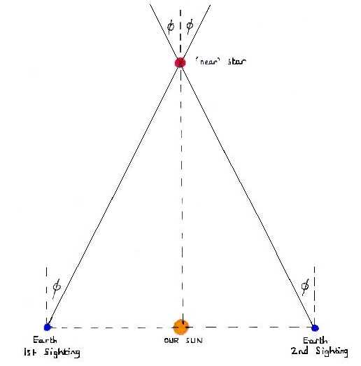

The star is observed from Earth. Six months later the same star is observed again. The Earth- Sun distance is known and hence the distance from the Earth to the star can be calculated from that and the measured angle φ.

The parallax method has a distance limitation of about 9.25 × 10¹⁷ m. Beyond this the angles become too small to be measured reliably.
ALL other methods are open to argument, they all depend on assumptions and the further out we go the more dependent we are on the links between them. If all the links are correct to within 15%, the total error can be as much as 40%.

The parsec, pc, is the distance from which 1 AU subtends an angle of 1 arc second (1/3600th of a degree). Diagrammatically this means that a star is one parsec distant when the angle φ is 1 arcsecond or 1/3600 °

1 A.U.
1 parsec
φ = 1 arcsecond
=1/3600 °

The parsec is an important unit because of the measurement of distances using trigonometrical parallax.
1 pc is approximately 3.26 light year.

The light year, ly, is the distance travelled by light in a vacuum in one year. It can be easily converted into metres by multiplying the speed of light in a vacuum (3 × 10⁸ ms⁻¹) by the number of seconds in a year (365 × 24 × 3600) to get 9.46 × 10¹⁵ m.

Definition of absolute magnitude, M
The absolute magnitude of a star is the apparent magnitude it would have at a distance of 10 pc from an observer. It is a measure of a star’s inherent brightness. This means that absolute and apparent magnitudes are measured on the same logarithmic scale.
As light intensity reduces in proportion to the inverse square of the distance, the relationship between apparent and absolute magnitude can be related to distance, d, by the equation:
m −M = 5log (d/10)

d. is measured in parsec, and the log is to base 10. A quick glance shows that
- Stars which are closer than 10 pc (about 33 light years) have a brighter (more negative) apparent magnitude than absolute magnitude, m-M < 0
- Stars further than 10 pc have a dimmer (more positive) apparent magnitude than absolute magnitude, m-M > 0
- If m = M, the star must be 10 pc away.

Care must be taken comparing magnitudes – does a bigger magnitude mean brighter (greater intensity) or dimmer (bigger number). It is safer to talk about brighter or dimmer magnitudes.

