LENSES AND RAY DIAGRAMS

Lenses come in many different shapes. We will only be concerned with those of the first three shapes which are all convex lenses.

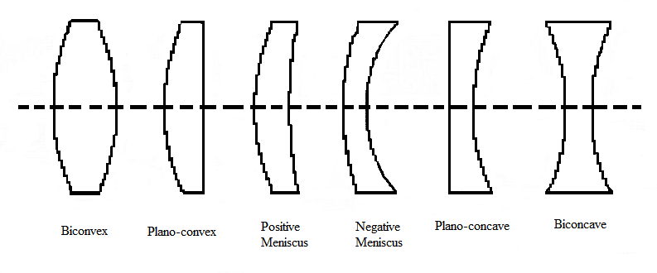

Convex or converging lenses are useful because they can form real images, i.e. ones that form on a screen.

When light enters a lens it is refracted and when it leaves a lens it is refracted again. A convex lens is designed so as to bring parallel rays of light to a point focus.

Terms to remember:

Principal Axis
The line of symmetry running through the middle of a lens is called the principal axis.
Principal Focus, F
The point on the principal axis where all the incoming rays parallel to the principal axis cross the axis after refraction is called the principal focus.
Focal length, f
The distance from the centre of the lens to the principal focus is called the focal length.
2F
This is the point that is twice the focal length from the lens

Ray Diagrams
When drawing a ray diagram for a converging lens various rules are used to simplify the process.
- The lens is assumed to be very thin so the ray is shown bending only once at the centre of the lens
- A ray of light passing through the centre of the lens is undeviated so its path can be drawn as a straight line.

These two ideas can be used to draw diagrams showing the formation of an image.

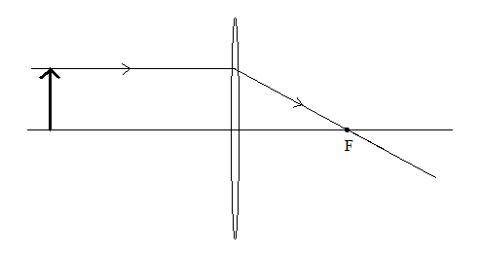
A ray parallel to the principal axis is drawn from the top of the object:

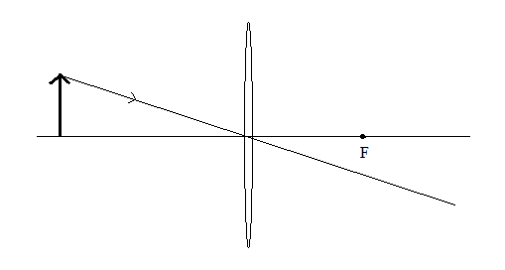
Another ray is drawn from the top of the object that passes through the centre of the lens:

The two together establish the position of the top of the image:
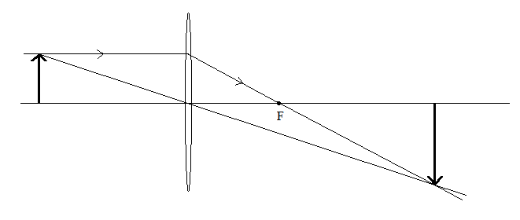
The size and position of the image depends on where the object is placed.
Steps for a good ray diagram:

- Use a ruler and pencil.
- Draw in the principal axis.
- Draw the lens as a very thin ellipse.
- Mark the foci on both sides of the lens (i.e. before and after it).
- Draw an object – an arrow – sitting on the principal axis.
- Draw a ray of light from the top of the object parallel to the principal axis that then passes through the focal point on the other side of the lens.
- Draw a ray of light from the top of the object passing through the centre of the lens.
- The point where these two rays cross gives the position of the top of the image. If necessary extend them with dotted lines to find the point they appear to cross at. (This point is then not on the other side of the lens from the object).
- The bottom of the image will be on the principal axis.
- Draw in the image arrow.

Terms to remember:

An image is real if the rays that pass through the lens actually meet on the far side of the lens from the object.

An image is diminished if it is smaller than the object

An image is enlarged if it is larger than the object.

An image is inverted if it is upside down compared to the object.

