Single Dish Radio Telescope
Ground-based observations are severely affected by the atmosphere for most of the electromagnetic spectrum. Two of the least affected areas are visible, dealt with earlier, and radio waves

The design of a single dish radio telescope is very similar to that of a reflecting optical telescope. The parabolic metal surface (reflecting dish) reflects the radio waves to an aerial without any spherical aberration. There is no need for a secondary reflector as the aerial can be placed at the focal point. Information is then transmitted for analysis.
A simple calculation would show that, despite their large size, the resolving power of radio telescopes tends to be quite poor. In the early 1960s lunar occultation was used to identify sources of radio waves, and this led to the identification of the first quasar, 3C-273. Man-made interference can cause a big problem for radio astronomy. Radio transmissions, mobile phones, radar systems, global navigation satellites, satellite TV and even microwave ovens all contribute to making the detection of extra-terrestrial objects difficult. It is difficult to deal with interference from orbiting satellites, but the effect of microwave ovens is minimised by building radio telescopes away from centres of population. Linking telescopes together also helps, as local interference can be removed from individual detectors, enhancing the common signal from the distant sources. One aspect of the design of radio telescopes is worth pointing out. Because the wavelengths of the radio waves are relatively long, the reflecting dish of the telescope can be made from mesh rather than solid metal, decreasing the weight and cost. Provided the mesh size is smaller than λ/20, radio waves are reflected rather than diffracted through the mesh. As well as improving the resolving power of the telescope, increasing the dish diameter also increases the collecting power i.e. the rate at which energy can be collected by the telescope. This clearly depends on the intensity of the incident radiation and the area of the dish. The area of the dish is proportional to the square of the diameter, so doubling the diameter increases the collecting power by a factor of 4. Ground based telescopes are largely restricted to the visible and radio regions of the electromagnetic spectrum.

I-R, U-V and X-ray telescopes

It is easy to assume that the atmosphere is transparent because we can see the Sun during the day and the stars at night. However, the atmosphere is not transparent at all wavelengths and is opaque to many regions of the electromagnetic spectrum. The absorption of different wavelengths is the result of the presence of different types of molecules in the atmosphere.

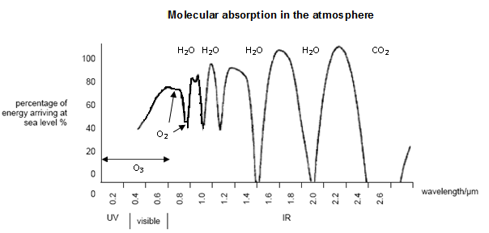

This graph shows the effect that water vapour – H₂O, carbon dioxide – CO₂, oxygen – O₂ and ozone – O₃ have on the IR, visible and UV spectrum as the radiation passes through the atmosphere. The absorption is the result of resonance – the frequency of the incoming photon matches a natural frequency of vibration of the molecule.

This explains why telescopes detecting these parts of the electromagnetic spectrum are placed on balloons, in orbit, at the top of high mountains or in very dry areas, such as the Atacama Desert. Perhaps surprisingly, X-rays and Gamma rays are also absorbed by the atmosphere. Some of the earliest satellites were used to carry X-ray and Gamma ray detectors. Detection of these high-energy photons allows analysis of some of the most violent and exotic phenomena in the Universe, and may provide data about its composition, age and expansion rate.

