Reflecting Telescope

You should all be familiar with the simple law of reflection:
i
r

angle of incidence = angle of reflection

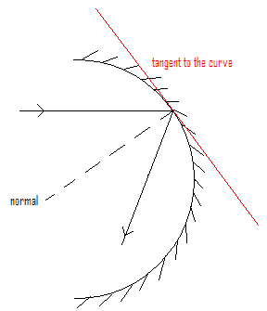

This can be applied to curved surfaces as well as plane surfaces.

This would suggest that for a concave mirror a set of parallel rays would be brought to a single focus at half the distance to the centre of curvature of the mirror.

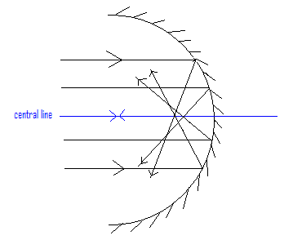

Unfortunately a simple circular cross-section (spherical) mirror is not this well behaved. Rays at different distances from the centre are brought to a focus at different points. The resulting image is blurred. This is known as spherical aberration.

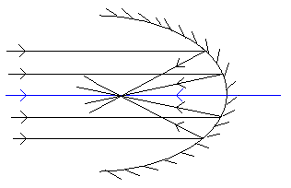

This can be overcome by using a parabolic mirror.

There are a number of different designs of reflecting telescopes. One type is the Cassegrain arrangement.
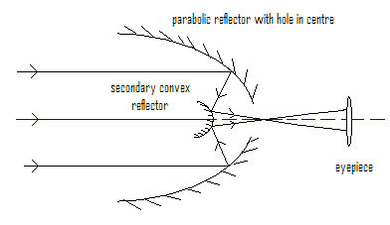

Although it looks like this would produce a ‘hole’ in the image because the axial ray is blocked by the secondary convex reflector, this is not so. All the incoming parallel rays are coming from the same point on the object, so light from the object always appears in the image.

The Hubble telescope uses a Cassegrain arrangement.

