Reflecting Telescopes versus Refracting Telescopes

The larger the telescope, the better it is. The largest and hence best telescopes are reflecting telescopes. There are a number of reasons why reflecting telescopes i.e. those using mirrors dominate.

Reflecting telescopes can be made much large than refracting telescopes because a mirror can be supported from behind i.e. over more of it, whereas a lens has to be supported by the edge only. A large lens is also likely to break under its own weight.

Although the secondary mirror in a reflecting telescope blocks light it does not result in a bit of the image being missing. This is because light from a distant source is parallel so that even light from a source on the axis of the mirror will still hit the secondary and be collected.

Size matters because

A larger objective – either lens or mirror – means more light can be collected because the area is greater. This in turn means that much fainter objects can be seen.

The larger the diameter of the aperture the greater the resolving power of the telescope i.e. the more detail can be seen in the image.

Mirrors are superior because

Mirrors do not refract light and therefore do not suffer from chromatic aberration. The different coloured wavelengths are refracted slightly differently by the edges of a lens where its shape is close to that of a triangular prism. White light is thus dispersed and this results in different focal points for the different colours. The blue focus is closer to the lens than the red focus.

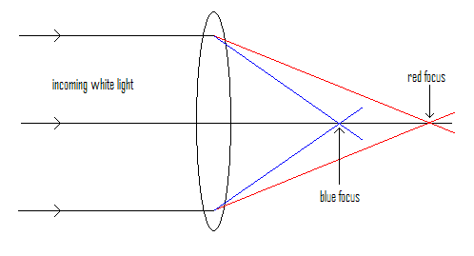

Whilst both spherical mirrors and spherical lenses suffer from spherical aberration, using a parabolic mirror eliminates this problem.

Reflecting telescope problems

The secondary mirror and the ‘spider’ that holds it in place will both diffract the light as it passes. This reduces the image quality.

The light passes, eventually, through an eyepiece lens. This means the light is refracted before the final image is produced, which means that problems associated with refraction are not entirely eliminated.

The objective mirror is ‘exposed’ but an objective lens is protected.

