THE LENS FORMULA

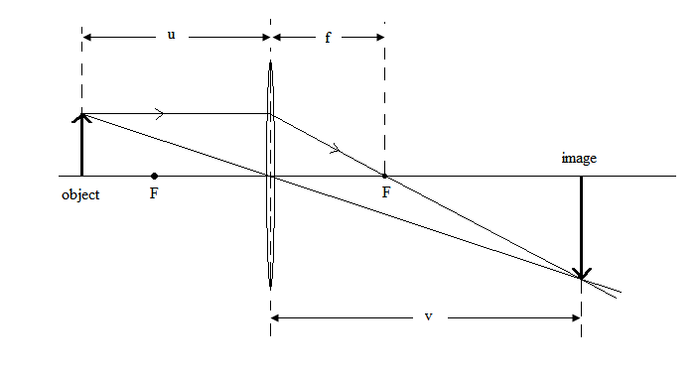
Although scale diagrams can be used to work out the position of an object it is more convenient to use the lens formula.
f is the focal length of the lens – the distance from the centre of the lens to the focal point

u is the distance from the centre of the lens to the object

v is the distance from the centre of the lens to the image

The lens formula is:

1 = 1 + 1
f u v

For this equation to be used correctly you must remember the following points.
- Converging lenses have positive focal lengths – this is the only kind you will be asked about.
(Diverging lenses have negative focal lengths)

- Distances to real images are positive, distances to virtual images are negative.

E.g.
1. An object is placed 40 cm in front of a converging lens of focal length 30 cm. Where is the image?

1 = 1 + 1
f u v

1 = 1 - 1
v f u

1 = 1 - 1
v 30 40

1 = 4 - 3
v 120 120

1 = 1
v 120

v = 120cm

As the object was placed between 2F and F it will be real, inverted and magnified.

2. An object is placed 15 cm in front of a converging lens of focal length 30 cm. Where is the image?

1 = 1 + 1
f u v

1 = 1 - 1
v f u

1 = 1 - 1
v 30 15

1 = 1 - 2
v 30 30

1 = - 1
v 30

v = - 30cm

As the object was placed between F and the lens it will be virtual, upright and magnified.

