Analyse the characteristics of the main characters from Casablanca. Consider:
- Why the gender/character is stereotypical of this era?
- How the representation reflects society at the time the film was made?

 | TASK 1: Character traits  Add screen grabs from key scenes to exemplify their character traits. | TASK 2: Film Form  Use film form to analyse how your chosen scene  represents gender. | TASK 3: Context  What happened in society during the 1940s which would influence the representation of gender?
Rick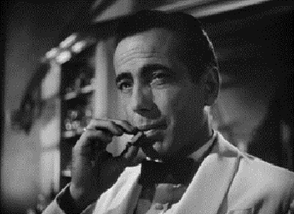

 | TASK 1: Character traits  Add screen grabs from key scenes to exemplify their character traits. | TASK 2: Film Form  Use film form to analyse how your chosen scene  represents gender. | TASK 3: Context  What happened in society during the 1940s which would influence the representation of gender?
Ilsa
