The Tower of London 

The Tower of London is located on the north bank of the River Thames, it is a manmade heritage attraction (originally a castle, and still in use by the Royal Family, but now predominantly a visitor attractions) and brings in millions of people per year, well over 2 million people come and pay to see this attraction due to its beautiful architecture and history. Open all but four days of the year between 9 – 5:30, these four days are the 24th, 25th ,26th of December and the 1st of January, it’s very well-known but is it meeting diverse expectations?

**Who are the typical visitors to Tower of London and what requirements do they have?**

International, it is an international scale as it’s a largely known building, people from all over the world come to visit with 47% of visitors being from overseas, the Tower of London brings people from all over the world in due to its rich history and beautiful building. How well are the overseas guests being treated?

When looking or booking online the website can be adjusted to any language in the settings area which is good as it doesn’t put international tourists off before they even read through the website, it’s the first feeling of inclusiveness for them. If they need additional help with the language barrier they have access to leaflets, announcements and tour guides all in different languages. Also, for people who speak different languages they can access the audio guides, they are available in English, Dutch, French, German, Italian, Japanese, Korean, Chinese Mandarin, Portuguese, Russian and Spanish. Unfortunately, the plaques on the walls are only in English, all the shows and re-enactments are in only English as well as the brochures, the audio guide is the only way for overseas visitors to be able to understand the castle this is a great bit of technology as it makes the Tower more inclusive, its helps grow understanding and is more welcoming.

On days where there’s limited tours available this is a great alternative that won’t push people away as an international guest may feel it’s a wasted journey to see the Tower of London without a tour guide but then after finding out they can access an audio guide they may then decide to visit and use that instead of not coming at all. If the oversea visitor is deaf or hard of hearing, then the Tower of London gives nothing to help them understand the role plays, there are no sign language enactments, this could be a good thing to put into place on the day the sign language tours are on.

The audio guides make the attraction more accessible to overseas visitors as they can join in on the day and understand what they are seeing. It is one of the top UK attractions, so it is important to be accessible for a range of languages.

Costs are clearly signposted to the overseas visitors – both on the website and at the ticket centre on the day, as there is also a currency exchange this will meet their expectations as they can change money if they don’t have money converted into GBP.

Rules are clearly signposted in a number of languages and therefore their safety and security aren’t compromised. If the Tower needs to do announcements, then the tannoy is given in a number of different languages so that everyone is aware that there is an emergency or a problem. Without this not everyone may understand, and panic may be caused.

People with specific needs, Extra support with the facilities and with getting the relevant information, this can be found on the Tower of London website there is information all about the accessibility guide, this tells people how exactly they can get around and what they can and can’t access for example it tells you how many steps each tower has and how difficult it may be to access. This is also useful for pregnant visitors or those with children who may worry about them going up the steps in the various towers.

For visitor whom are deaf, or hearing impaired the Tower of London offers Induction loops at the ticket boxes and Welcome Centre where a video of someone signing a welcome and explain the activities you can do whilst at the tower, you can Switch your hearing aid to the ‘T’ setting to be able to listen to the loops shown and can even book a place for a British Sign Language tour however its only British sign language on the tour and spaces and dates are not very often.

For blind or partially sighted there are handling points, this is in the basement of the White Tower, information given here is in Braille and tactile format. For people with hearing difficulties then the link to the hearing aids is a great idea and they can then tune in to hear the guides and information, this makes the experience more enjoyable and inclusive. The sign language tour is quite difficult to get so they could do a clip for each part of the tour on a tablet and it could be a video of someone signing the facts, this would bring more hearing-impaired people in.

If there are emergencies additional help is available for those that may need it e.g. different exits are available, and guidance is provided for those who may be deaf or blind.

Disabled ticket prices are also reduced this is to allow for the reduced experience that disabled visitors may experience whilst they are visiting e.g. not being able to get into Towers that don’t have disabled access. This is fair for the disabled visitor and means that they aren’t disadvantaged on their visit.

Accessible services are available through the site (as further detailed in the services section) this enables visitors to feel included and it increases their experience whilst they are there as they aren’t worried about missing out of the education or about simpler things such as finding a toilet.

There are toilets which are fully accessible for those that need them, these are behind the Jewel House. 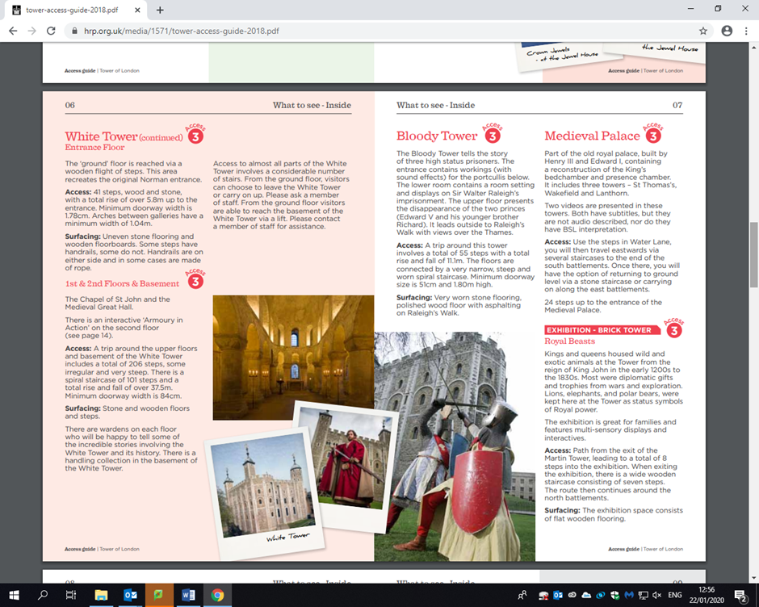

Individuals, a solo traveller may need a map and a bit of guidance but physically they should be able to make their way around the tower, if they have any food requirements then they cater to all allergies and dietary needs. They have merchandise in all different size clothes, so they are inclusive in that sense. Other than this the visitor should be able to enjoy the facilities of the tower of London with little to no assistance. They do have access to all the technology around the building for example the interactive screens and props with sound effects, this is a great way to get people to engage.

The Tower of London is fully accessible for individuals and ticket prices are clearly indicated, and they are available online and at the gate. Buying tickets online is easy and convenient and there is a 10% discount on the online tickets. It is also convenient to buy tickets online as the code can be shown on the day and tickets don’t need to be printed – which would be useful for people who decide to go and visit on the day whilst perhaps visiting other attractions in London.

Families, Buggy accessibility and safe walkways are important if children are around, making sure the children are included and safe is the key need of a family. At the tower of London families may struggle with buggies due to the bumpy terrain and the number of stairs throughout the attraction. However, with young children under-fives go free and you can get family deals this deal includes children over five going for only £11.70 and two adults and two children going for £44.40. If babies are drinking bottles of milk, then the restaurant will not warm them up for them due to kitchen hygiene but other than this they are very inclusive of families and do kids meals. There are areas where prams can be left – but this is at owner’s risk. Buggies can be parked next to the middle drawbridge and at the entrance of the white tower.

They put on shows and plays to show the history in a fun way to help children stay involved and entertained. This is a great way to have different levels of education as its proven the children will respond more to the roleplays than to speeches and leaflets, it has assessable education that reaches all ages. Around the area is props with sound effects and interactive screens this is open to all and is great for keeping children entertained and adding to the enjoyment to their day.

Baby changing facilities are available throughout the Tower of London, so you have a choice of changing facilities to choose from. There is also a lost children area and wristbands are available for children from the Welcome Centre.

School groups

Schools need extra space for all the children, they need assembly points, places for lunch, an area to talk and teach. For schools visiting they get special offers and deals on tickets, which is great as it makes it more inclusive for less fortunate who may struggle to pay full price, and it’s cheaper for the school, as the teachers are also included in this discount , due to availability they try to give a room for schools to regroup in , have lunch in and learn in. They also advise schools to come on their quietest day so it’s easier and safer for them, security is on watch always, so the kids should be safe whilst at the facility.

Tour guides are available to schools as well as hand outs and extra help from staff, the kitchen will do school deals with meals and sandwich boxes however hot meals are still normal prices, they also allow students to bring home meals. Schools have the same access to technology as families and individuals but if the schools are given a room to base in for the day there is access to a computer and projector.

Here is the link for schools <https://www.hrp.org.uk/tower-of-london/schools/#gs.tif7ak>

Resources are also provided online before the trip to help with teacher planning and risk assessments.

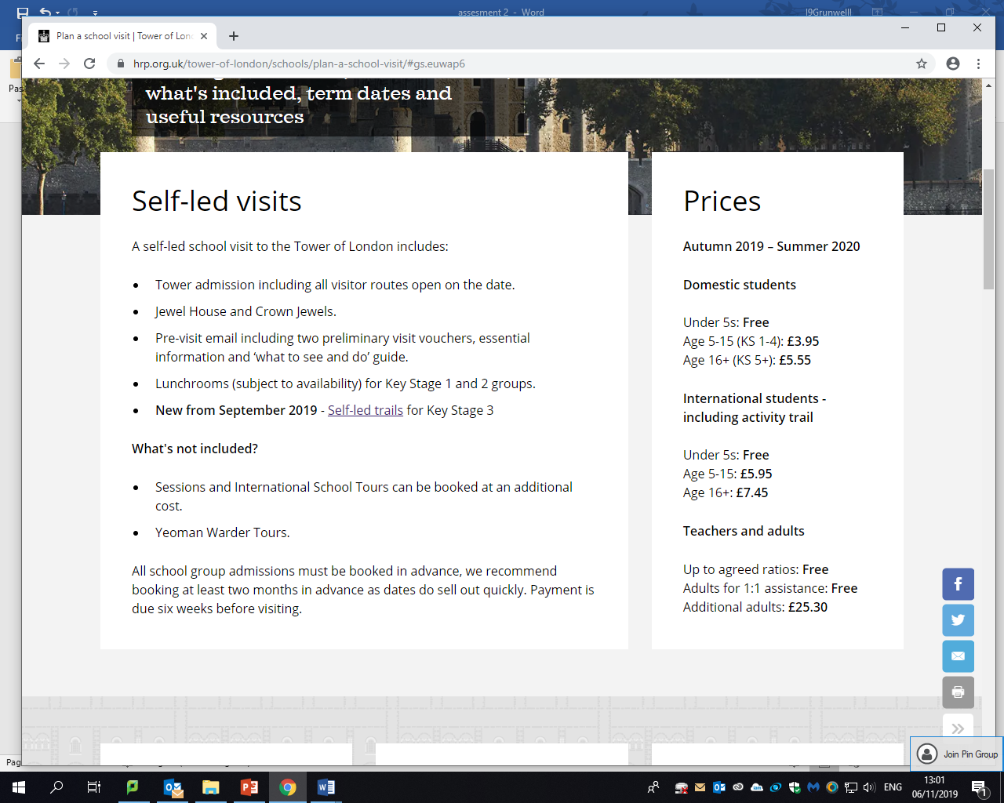



**How does the Tower of London provide products and services to meet diverse visitor expectations?**

The key primary spend opportunity is the tickets for entry to the Tower of London. An adult gate price ticket is £28.90, a child ticket is £14.40, and a concession ticket is £23.10. Family saver tickets are also available for either £43.30 or £72.20 depending on how many children there are. A secondary spend opportunity of membership to the Tower of London is available for £55 a year – this means that you can go to the Tower of London unlimited times for 1 year. If you live in the Tower Hamlets area and you have a library card you can visit the Tower of London for £1.

Another primary spend opportunity is buying additional tickets to the Exclusive Members Viewing of the Crown Jewels – this is only available for members. Usually to see the crown jewels you must go on a conveyor belt and cannot stop to look at them properly.

There are always exhibitions on throughout the Tower of London and the majority of these are available within the main ticket price. Sometimes there are special exhibits such as the wire animals which were an art installation – and are now a permanent feature.

There are other ticketed opportunities at the Tower of London such as “The Fallen Angel with Tracy Borman” these require you to book a separate ticket alongside your main ticket price. This is additional income for the Tower of London and brings in new audiences to the Tower.

They have gift shops selling merchandise which brings in a large amount of money from people wanting souvenirs, the clothing size ranges meaning it is inclusive and no size should feel left out, they sell leaflets and they also do tours which are more expensive than finding your own way around however for people needing a guide or a translator prices do drop. The gift shop is an example of a secondary spend opportunity. There are 5 shops and they each have a theme. The 5 shops are Tower of London, Beefeater, White Tower, Jewel House and Ravens House. Having 5 shopping opportunities maximises the revenue from the Tower of London and gives visitors lots of opportunities to buy souvenirs. This would meet the needs of the visitors as it enables them to visit shops to suit their needs and find somewhere else to go if the other shops are busy. The Beefeater shop is also just inside the entrance of the Tower of London, so visitors can buy a guidebook or an audio guide. It is easy to find so tourists needs are met as soon as they arrive within the Tower of London – they don’t need to search the whole site to find an Audio Guide. The Ravens shop is a children’s shop – therefore parents know where to buy their children souvenirs such as dressing up outfits and toys. Again, this meets the needs of customers as they know exactly where to go to find what they need. It will also be appealing to young people visiting the store – and will help to maximise revenue as children will encourage their parents to buy them a souvenir.

The gift shops are important as not only do they provide an income they also provide somewhere for visitors to buy memories from their day such as postcards, magnets and books. Educational books can also be purchased that may not be available elsewhere and this is important to internal customers such as authors who may put their books into the Tower of London gift shops. They would rely on the shops as part of their income.

They have cafes, food and drinks shops around the venue which they also gain revenue from this are all filled with options such as, pescatarian, dairy free, gluten free, vegan, vegetarian, the food means they should be able to cater to everyone. The doorways into the cafes are all wheelchair accessible and the tills a fair height to be considered wheelchair friendly. The staff are more than happy to read the menu out to anyone who needs help and will also explain gifts in the gift shops to people with issues with their vision. If they had a list of foods that could be listened to by audio, then this would make it easier for the staff who must dedicate a lot of time to reading out the menus if its busy. The cafes are examples of secondary spend opportunities. The cafes on site are the New Armouries Café, Ravens Café and The Wharf Kiosk.

The cafes are important as they provide food and drink to external visitors, but also provide jobs for internal customers. Some families will also include the café as part of their day out so they will want food to be provided. Also, for overseas customers they may not have had a chance to purchase food before their visit, so they would rely on food whilst they are there. However, some families would rather take a picnic with them and therefore wouldn’t spend any money in the cafes as they can sometimes be quite expensive.

Venue Hire is possible at the Tower of London for Corporate Events, Weddings and Conferences. This is another secondary spend opportunity. Private tours are also available, and this is another secondary spend opportunity.

The service of translating or foreign speaking tour guides is a great and diverse service as then international guests can have a fluent enjoyable tour, the audio is also a special product when it comes to meeting needs as it makes peoples experiences more rememberable and enjoyable as they leave with facts and knowledge instead of just looking around uninformed. And the connecting hearing aids is a great service for hearing impaired.

Language translation is important as it opens up the Tower of London to a wide range of other customers and their spend is important as part of the UKs tourism income. They are likely to buy the audio guides – which provides further income for the Tower of London and they are likely to purchase one for each member of their family. The guides are £5 each and they are very popular for tourists. Without the audio guides many overseas visitors may not understand their visit and therefore would not recommend the Tower to their friends. Everyday thousands of overseas visitors come to the Tower of London and therefore their spending is very important. It also makes the experience more enjoyable for those tourists as they further understand the rich history of the Tower of London – which could be quite complicated without the audio guide.

Currency exchange is available at the ticket centre, this is useful for overseas tourists as they will easily be able to convert their money to GBP rather than their own currency. It is in a good location for them as it is easily accessible. Currency Exchange is important as not all tourists may have enough in GBP and may want to exchange their money somewhere where they know is safe. This will also create a job for someone.

There is an information centre for tourists where leaflets and maps can be picked up. This is outside the entrance of the Tower of London. This is useful for customers as they can also find out information about the local area e.g. transport connections. Secondary spend opportunities are available here e.g. buying small souvenirs, audio guides, guidebooks and refreshments such as bottles of water. This is an important service as visitors can ask questions about the Tower of London and buy the necessities the need before entering the Tower – reducing individual tourists queuing time later on. The visitor centre also provides jobs for internal customers.

They don’t have any rides which an inviting feature for children could be, with no rides they are losing out on money and potential customers new and returning. They also don’t have a car park which makes sense due to the busy area and there is no space to make one in the future however it would entice more people in as to get there it takes most people at least one train and a taxi, so a car park would have been a great selling point. However, the Tower of London is close to Tower Hill underground station and signs are provided from the underground station to the Tower itself to help visitors who may be unfamiliar with the local area.

They have first aiders on site and have security and cleaners, so the site has good facilities and is run well with rules put in place such as orderly ques to get into the attraction and exhibitions, they make sure it’s a relaxed and smooth-running attraction so that people do not leave stressed. They do sell skip the queue passes which allows people to not have to que which for exhibitions such as the crown jewels which normally has a que time of 45 minutes a skip the que pass is a great product. <https://www.getyourguide.com/-l2708/?cmp=ga&campaign_id=2087749618&adgroup_id=75978248599&target_id=kwd-744296262142&loc_physical_ms=1006959&match_type=b&ad_id=395567337276&keyword=%2Btower%20%2Bof%20%2Blondon%20%2Bqueue&ad_position=1t1&feed_item_id=&placement=&partner_id=CD951&gclid=EAIaIQobChMI0PbEqfub5wIVF-DtCh0vLwm5EAAYASAAEgJbavD_BwE> – link to skip the que pass. First Aid, Security and Cleaners are an important service because they keep visitors safe and reduce emergencies. Without First Aiders on site the emergency services may need to be called and this might worry other visitors. In the summer it is very important to have first aiders as well especially as queues can be long and there isn’t anywhere to sit in the queues and they may get heatstroke.

Park and Ride and Transfer Shuttles are not necessary for the Tower of London as it is easily accessible on the London Underground and the London Bus Service. There is also no parking available for the Tower of London.

Toilets are available across the site, this includes baby change facilities and accessible toilets. These are regularly cleaned with a clear cleaning schedule inside. All toilets are clearly signposted within the Tower of London and on the map. Baby change is important as many visitors do visit with their children – especially as under 5 tickets are free. Without specific baby change facilities parents maybe wouldn’t visit or would have to change their baby publicly or on the floor of a normal toilet. Having baby change facilities puts a parent’s mind at rest and would make them more likely to visit as they know there is somewhere to go. Also, as there is more than one baby change this would also be welcoming to a parent as they know that they have lots of options to choose from so they wouldn’t worry.

There is no creche at the Tower of London. Parents are responsible for their children throughout the visit.

Clear signposts are visible throughout the Tower of London, these signpost the various exhibits, shops and toilets that are in place throughout the Tower of London. These are important to help tourists find their way around the site. The Yeoman Warders are also very visible in their distinctive uniforms and they can provide help and guidance such as instructions on how to find certain areas, first aid and historical question answering. The signposts are important because people who are visiting for the first time might worry that they have missed something or may not be able to find something. The signposts make it clear for visitors – especially if they are worried about asking for directions or if the Tower is very busy.

There is no accommodation available at the Tower of London as it is home to the Yeoman Warders and various members of the armed services. There are plenty of hotels around the Tower of London.

Bags cannot be left at the Tower of London as it is a security risk. All bags must be carried around or left at a luggage storage location somewhere else in London. This may not be appealing to Tourists as they be carrying around suitcases etc if they are flying home – however there are many luggage storage areas nearby. Whilst this may not be useful for all customer types it does help to look after the safety of all customers within the Tower of London and therefore visitors should appreciate these rules as without them people may bring things into the Tower of London which are forbidden – there is a list of forbidden items on the Tower of London website.

**Meeting and Exceeding Visitor Expectations**

Appeal of Location and Environment

The Tower of London environment has changed very little since it was built. It is in central London, right next to Tower Bridge, meaning that it is easily accessible. It is also close to other attractions. As it is a historic building the Towers can only be maintained rather than new buildings being built. The environment is very clean, and everything is easily signposted. The Yeoman Warders keep the location clean and safe. There is some wildlife such as the Ravens and these are looked after by the Yeoman. As it is clean, tidy and easy to find your way around this would meet the needs of visitors as they won’t get lost nor worry about the cleanliness or hygiene of the location. It also exceeds customer expectations as there is so much to see – especially when the poppy display is in the moat. Visitors come from far and wide to see the Tower of London poppies. It is a very iconic building in British History and when people see it they are awe-struck by its size, history and the stories it tells, and a lot of this you can see without even paying an entrance fee to the Tower. None of the Tower is in disrepair, despite its age (parts were built in 1066!).

Accessibility and quality of existing products and services

Due to the age of the Tower of London not all areas are accessible, however this is reflected in the price of disabled visitors. An accessible map has been produced to make it clear what is and what isn’t accessible for visitors. When tickets are booked at the ticket office it is also made clear what is accessible. The staff at the Tower of London will go the extra mile to ensure that the visit is still spectacular regardless of whether you can access the towers or not. They will sit and tell stories to those who cannot access, and photographs are available to view if you cannot enter. This meets and exceeds visitor expectations as they can still see a lot of the Tower without worrying that they are missing out.

Development of new products/services.

As previously mentioned due to the age of the Tower of London it is difficult to develop new products/services as there are restrictions on building and the site cannot be expanded due to its location and the walls and moat. Also, it is right next to the River Thames. However, new exhibits and activities frequently open such as the Easter Family Activities where you travel back in time to 1671 and try to steal the Crown Jewels and Meet the King. There are activities throughout the day to provide further entertainment for families – this would appeal to them and encourage more visitors. As this is an additional fun activity this would exceed the needs of customers as it is something additional they will get in their original ticket prices and it will help to entertain their children as it is hands on and immersive – rather than just walking around to see the exhibits.

There are a lot of exhibits included in the standard visitor price therefore each visitor gets a lot for their money. As part of the restoration works at the Tower of London there are often new parts opening and these will also add to the products and services available at the Tower of London.

The BSL tours are also a more recent feature, these do get booked up quickly, but they will exceed the needs of customers who are deaf as the stories of the past will be opened to visitors who may otherwise not get to learn them.

Diversification of facilities and amenities

One way that the Tower of London has diversified is through their conference and wedding bookings. This would be an amazing venue for a wedding and would more than exceed the needs of customers due to the prestige and honour of the Tower of London and the stories of its past inhabitants. The Tower of London is limited in its diversification, but the addition of the restaurants and a range of shops will meet and exceed the needs of customers as they have choice in what they are choosing from and the range will appeal to a wide range of customer types.

Image, Brand and Promotional Offers

There is free Wi-Fi access across the Tower of London site – this would meet the needs of all customers as they could find out additional information about the site, translate words if they are from overseas or find out about onwards travel information. They could also post to social media to share their experience and therefore offer free advertising for the Tower of London. Group discounts and advance purchase discount are available. Advance purchase is 10% off, this exceeds the needs of customers as everyone likes to receive money off their entry, also this means you don’t have to queue up twice – which would appeal to a lot of customers. London 2for1 tickets are available and again this reduces the price when you get the train to London – it is also another form of advertising for the Tower of London as they appear in the 2 for 1 ticket brochure for train providers such as Great North Western and Anglia Trains.

**Technology**

The Tower of London uses Technology to exceed guest’s expectations by having audio tours in English, Dutch, French, German, Italian, Japanese, Korean, Chinese Mandarin, Portuguese, Russian and Spanish. This allows overseas visitors to enjoy and understand their tours, making the experience not only more educational but more enjoyable. However, it has been noted that the audio guides are a little dated, and perhaps if a blind visitor wanted to use them that the buttons are a little worn down so perhaps they couldn’t be used well by them. <https://web.wpi.edu/Pubs/E-project/Available/E-project-042718-081257/unrestricted/Tower_Report_Final.pdf>

They also have their own snapchat filters for younger visitors which are a fun interactive feature which also gives them publicity. Management systems are important as they cannot be too full legally, this is assisted by technology heavily staff use walkie talkies in order to communicate with each other, there are turn styles that count how many turns are being done to know how many people are passing through this information then goes to a data base and allows staff to know when to not anyone else in.

Entry to the Tower of London is technologically controlled as there are voucher/ticket scanners so you can’t access without having a ticket. This is an additional security measure – also the number of guests can be counted so that the Tower isn’t overcrowded.

Within the Crown Jewels area there is a moving walkway so that you cannot stop and touch the exhibition. Technology is also used to protect the Crown Jewels from theft. Cameras and monitors are used throughout the exhibit.

The key area of technology for the Tower of London is the website. You can also use QR codes on your phone to gain access to the Tower of London, so paper tickets don’t need to be carried around. This is useful for customers who do not have access to a printer whilst they are on holiday.

Around the venue there are interactive screens for children and adults to learn more and guide them round the tower. Other than this there is no technology and so I think they should use virtual reality goggles to paint a picture of what once happened in the tower and use them for tours to wheelchair users who can’t get up the stairs. The website is a main platform for booking and it has lots of information on however they do not have an app. The lack of an app is shocking as apps are huge nowadays and could potentially bring in more people, if you could see how busy it is and book on an app this would be easier than the website, also if they charge for the app this is a great way of new income. Even with no app you can still book online on the website and this website can be accessed from phones and on the go, which is very convenient for people.

Free WIFI is available throughout the Tower of London and visitors are encouraged to share their photos with the hashtag #PalacePhoto on their social media through Twitter and Instagram. Visitors can also view up to date information on social media as well.

Special effects generally aren’t used unless there are enactments on, but these don’t happen unless there is a special event. As the Tower of London is very central in London they are quite limited to special effects due to the location and the historic surroundings.

**The importance of technology for the Tower of London**

Some of the technology available helps to improve the quality of products and services offered e.g. the audio guides enable overseas visitors to have the same access to the attraction as UK visitors. However there isn’t sufficient technology available for disabled visitors and it does not add to a disabled visitors experience of the Tower of London – as detailed in this report <https://web.wpi.edu/Pubs/E-project/Available/E-project-042718-081257/unrestricted/Tower_Report_Final.pdf>.

However, technology as reduced queuing times in non-peak season. The Tower of London is one of the busiest attractions in London and always has queues, however by pre-booking tickets visitors only need to queue once, which is much better for the tourist experience than having to queue in two long queues. Over 50% of tickets are pre-booked (this includes school groups), however a lot of overseas tourists still choose to book on the day, this is possibly because they decide on the day what they want to visit.

Technology in some ways has reduced operating costs because they can install cameras instead of having lots of staff on security – however due to the nature of the Tower of London it does need to be staffed and continually maintained as some parts of the site are from 1066.

Technology is important for enhancing the image of the Tower of London – through their social media they can raise the profile of the visitor attraction. They have twitter and Instagram, and this would open the Tower to lots of young people. Also, other people can search for the Tower and see recent photographs and videos about the Tower as well as reading important news easily through something they use every day – rather than a website that they might not visit. The website is easy to navigate – however there is some confusion in that it isn’t just the Tower of London website – it is the Royal Historic Palaces website – this could be confusing for overseas visitors who may not realise that they have gone onto a different palace’s website as this is easy to do.

Currently there are no virtual tours available, this is a shame because it would increase the appeal to school groups and families who may want to see what it is like before they go. Although there is no virtual tour there is a lot of information and photographs available online to show the tower and it has been in several TV programmes, so the history of the castle is quite well known.

With or without technology the Tower of London is one of the top visitor attractions in the UK and there are often queues around the block to visit it. People go to the Tower because they want to see the history and learn about the prisoners of the past, they also want to see the crown jewels. They don’t generally go to see the technology available. Technology could be used to increase the appeal – but it isn’t a main part of the Tower of London and I don’t think it should be either.



**What are the positive and negative aspects of these products and services provided by the Tower of London?** 

The gift shops are positive as it’s a good income for the Tower and it is size inclusive meaning no one should feel left out however products are fairly expensive so a negative aspect is it’s not fully price inclusive, tours are great for English speaking customers and people who need more guidance however for overseas customers tours are not always available in other languages they are hard to have on often.

The foods are very inclusive and depending on which café you go to the prices vary so there should be an inclusive place for everyone, and with staff willing to help anyone who needs extra help the only negative is they may be busy and have the person waiting around for assistance. <https://www.hrp.org.uk/tower-of-london/visit/eating/#gs.uhfsw1>

The hearing aid, tours, screens are all great uses of technology and help make it more inclusive, however they are only for hearing impaired people, there is less available for visually impaired people and people who struggle with mobility, these both need to be worked on. The skip the que pass is a great product as some people don’t like waiting or get wound up waiting and they now have an alternative to that, and they also are dedicated to making sure they have always got a new exhibition being worked on.

Tours could be provided in multiple languages by a real guide instead of an audio guide, this would enable visitors to ask questions in their own language and therefore find the visit more educational than they might without being able to answer questions.

**How suitable is the Tower of London in meeting and exceeding the diverse visitor expectations?**

The Tower of London makes sure that all of the main world languages are included so that overseas visitors can have the best experience and take in the maximum amount of information whilst at the attraction, I believe that overseas visitors are very well catered to however with the lack of spaces for the overseas tour guides this could be improved to make sure that every oversea guest is satisfied instead of just the people who are lucky enough to go on a day where there are tours being held.

When it comes to being inclusive of food and clothes I struggle to fault them, all dietary requirements, vegan, gluten free, diary free, pescatarian, vegetarian and more all are catered for even including kid’s meals that are smaller and cheaper for families, pack lunches for schools can also be made. The choices and prices of food are very impressive. In the gift store it’s understandable that it’s a secondary income to the attraction however it is quite expensive which may be an issue for some, the clothes they do range from XXS to XXXL, all body shapes and sizes are included and catered to.

Educationally the Tower of London is very inclusive to schools as they encourage them with group deals and teacher discounts as well as allowing them to have a room to use for the day, they also have educational leaflets, plates on the walls , interactive displays and role plays to make sure however you like to learn and whatever age you are you can learn and enjoy the day. This leads me to entertainment as well as the roleplays and interactive areas they do many events throughout the year all just as accessible as a day there, they do mainly however do the roleplays and events in English meaning this is a less inclusive area for overseas visitors which is disappointing but in London the majority of event goers are English speaking. Suitability of products and services for visitors is good, there are many needs being catered to by The Tower of London’s efforts and they are all effective for the people they have been put in for but not everyone can be catered to. The T channel and audio guides work extremely well, and products put in place are suitable however the Tower of London is still not suitable for all visitors as people with mobility issues and wheelchairs cannot go upstairs in the building and can actually see very little of the tower, however this is due to the history of the building and the fact they cannot put in lifts etc. So the accessibility of the Tower of London is an issue that cannot be made more accessible, filled with narrow halls and tricky stairs it’s not accessible for wheelchair users or people who may struggle with their balance or sight, the cobbled path that greets you at the entrance is tricky for buggies and wheelchairs but is manageable, due to lack of change they can make on the inside they have made outside very accessible with ramps into the restaurants but not into the Tower.

The convenience of the travel to the Tower of London depend on where you are coming from but trains from all around England go to London, once in London there are coaches that drop people there as well as taxis and signs to direct people. Due to scale of it is largely recognised and so its location is on maps and should be easily found. If these coaches could be seen or ordered on a app then this would encourage people to get the app. At <https://www.londontoolkit.com/whattodo/london_travelcard_2for1.html> it offers special deals to people visiting the tower of London, you can get free train tickets to the tower of London if you buy your tickets with this deal, this is a great incentive to get people to come and it attracts new visitors.

The technology is okay but it’s not as good as it could be, no app means everyone must use a website when a survey recently taken by the sun showed 85% of people preferred an app to a website, this could open up a whole new customer range, also for visitors with hearing aids there is a channel they can connect to, for those whom have little English or hearing there is tours, screens are for all guests as well as the moving props as they help make it more inclusive, however there is still a gap in the market, there is less available for visually impaired people and people who struggle with mobility, these both need to be worked on.

**What conclusions can be made and what recommendations should be implemented?**

The Tower does not have Permission to change the inside of the Tower so unfortunately it will most likely never be wheelchair accessible however with technology today I would suggest a Virtual reality experience of a tour of the tower, I would also suggest that they continue with the audio guides and leaflets in other languages but would suggest that they have more tours available as over two million of their visitors are overseas visitors so it would definitely be used and profitable. The issue with a virtual tour is that it would need to be constantly updated and this could be costly – it also wouldn’t be useful for a blind tourist as they wouldn’t be able to access the virtual tour. An app would also be a good idea as this is easier to update and most people use smart phones. Apps are generally easy to use, and they could provide a range of services to visitors such as a map, free audio guide, QR codes and offers on food and souvenirs.

I believe the food is brilliant and should just continue to change with the times, I think the sizes of clothes are great but the prices are less inclusive and if the Tower of London could lower some prices whilst still making profits then they should on at least a few items for people such as parents with multiple children where it may be too expensive to buy multiple gifts. Travel to and education at the attraction are great and I don’t believe any improvements are needed as travel is convenient and education is encouraged and helped. Teachers have a whole education dedicated to providing the best experience to schools that visit and they provide all information to help plan trips – this is very helpful. Perhaps teachers could be given free tickets to go to the Tower before the trip so that they can make further plans or worksheets that would be more suitable for their class e.g. a GCSE History class. Statistics show many people return to the tower of London after being there a first time which must mean people’s expectations are being met. Return visitors only tend to happen if they feel that their needs have been met so this is very positive. ;’

To help improve the technology used to support people I would suggest other than the virtual reality they should give out tablets that talk through the tour in sign so hearing-impaired people don’t have to wait for a sign tour to become available as these are limited, with a tablet and a clip for different places around the tower they could be getting all the information without having to wait weeks for an available tour. Although this may be costly to set up this could be good for attractions all over the country and could make the attraction more accessible. It may not need changing frequently for somewhere like the Tower of London because they can’t expand, and they are limited on what they can include for new features. For example, at some attractions the audio guide is also a video guide with subtitles. They also need to get an app to encourage more people to come and stay updated on what’s going on at the Tower of London.

They do not have any rides or play areas which could be a put off for some parents and could be an enticing new facility that could bring more visitors in. They don’t use any QR codes which are a great way for people to interact using their own technology, a code is scanned on a mobile and then videos images and music can appear, this would be a great way to get people to interact with their technology. Different parts of the tower could have different codes which showed what it would have been like, almost like Pokémon go, you could see the animals running around that use to live on the grounds and the people and knights who once lived there. This would be exciting for young children and wouldn’t need frequently updating. Also the Tower wouldn’t need to provide smart phones for this and they already have the WIFI in place for the app to work.

Overall the Tower of London meets and exceeds the needs of many different customer types through their products, facilities and services. Whilst technology could be good to include it wouldn’t change why people visit the Tower and would only add a small amount to the visits themselves. The Tower of London is a very suitable attraction and has many suitable products and services. It meets the diverse needs of customers daily and it wouldn’t be one of the most popular attractions in the UK if it didn’t do this. It is a unique and fascinating tourist attraction and the only place you will get close to the Crown Jewels.