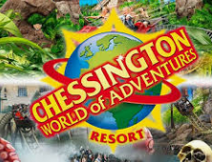

**ARTICLE HEADING HERE PLEASE, MAKE SURE YOU ADD IN THE NAME OF YOUR ORGANISATION**

Put in your attraction’s logo here!

**Introduction – What is your organisation, is it P/P/V, manmade/event/natural? , where are they located, how many people visit per year, hat are their opening hours?**

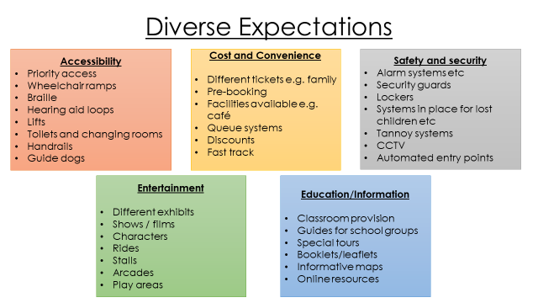

**Who are the typical visitors to (enter your attraction), what requirements do they have and how does (enter name of attraction) meet these needs?**

In this section, you need to identify who the organisations typical customers are, explain what the specific needs of these customer types are, why they are a need and then tell me how the organisation meets these needs. To help you work out what their needs could be refer to the list above and try and give me details from each heading for each type of customer you discuss.

**How does (name your attraction) provide products and services to meet diverse visitor expectations (actual products and services, support services and primary/secondary spending opportunities? Why are they important to (name your attraction)?**

What are the primary spending opportunities at your attraction? Give me a detailed overview of the range of tickets available to different types of customers, prices, additional exhibitions which have an entrance cost (can you just do this part?), special events which are not part of the usual entrance cost and happen at an alternative time of day?? (e.g. Proms in the Park at Wisley Gardens, Ice skating at the NHM, Ministry of Sound night at Thorpe Park). Why is primary spending important to the organisation? How does this meet the needs of different types of visitors? Could you make any recommendations for improvement?

What are the secondary spending opportunities at your attraction? (e.g. shops, merchandise, catering and accommodation, guided tours, visitor centres, events during normal opening hours , upgrades, annual passes, passes for entry to a range of attractions, photo passes, fast track, (you must research your organisations fully)

Make a list of all the secondary spending opportunities at your attraction, then one by one, explain what they are, what the price is, what it includes, which customer type is it aimed at, how it meets their needs and assess why this revenue is important to the organisation. Are there any opportunities that they are missing out on? Make recommendations for improvement.

What other main products and services does your organisation have? (e.g. rides, exhibits, landscapes, information centres, maps, conference facilities, educational talks etc. You must research your organisations fully).

Make a list of all the other main products and services your organisation has and then one by one, explain what they are, which customer types they are aimed at, how it meets their needs, and assess why it is important for the organisation to have these products and services. Are there any opportunities that they are missing out on? Make recommendations for improvement.

What support services does your organisation offer? (e.g. Visitor information centres, parking, park and ride facilities, transfer shuttles, toilets and restrooms, first aid, creche and children’s facilities, signage, security, cleaning, changing places, bins (which types?) etc. You must research your organisations fully).

Make a list of all the support services your organisation has and then one by one, explain what they are, which customer types they are aimed at, how it meets their needs, and assess why it is important for the organisation to have these products and services. Are there any opportunities that they are missing out on? Make recommendations for improvement.