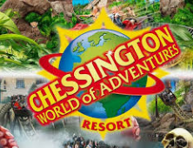

**ARTICLE HEADING HERE PLEASE, MAKE SURE YOU ADD IN THE NAME OF YOUR ORGANISATION**

Put in your attraction’s logo here!

**Introduction – What is your organisation, is it P/P/V, manmade/event/natural? , where are they located, how many people visit per year, hat are their opening hours?**

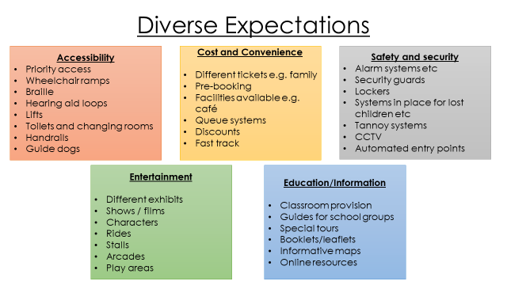

**Who are the typical visitors to (enter your attraction), what requirements do they have and how does (enter name of attraction) meet these needs?**

In this section, you need to identify who the organisations typical customers are, explain what the specific needs of these customer types are, why they are a need and then tell me how the organisation meets these needs. To help you work out what their needs could be refer to the list above and try and give me details from each heading for each type of customer you discuss.

**How does (name your attraction) provide products and services to meet diverse visitor expectations (actual products and services, support services and primary/secondary spending opportunities? Why are they important to (name your attraction)?**

What are the primary spending opportunities at your attraction? Give me a detailed overview of the range of tickets available to different types of customers, prices, additional exhibitions which have an entrance cost (can you just do this part?), special events which are not part of the usual entrance cost and happen at an alternative time of day?? (e.g. Proms in the Park at Wisley Gardens, Ice skating at the NHM, Ministry of Sound night at Thorpe Park). Why is primary spending important to the organisation? How does this meet the needs of different types of visitors? Could you make any recommendations for improvement?

What are the secondary spending opportunities at your attraction? (e.g. shops, merchandise, catering and accommodation, guided tours, visitor centres, events during normal opening hours , upgrades, annual passes, passes for entry to a range of attractions, photo passes, fast track, (you must research your organisations fully)

Make a list of all the secondary spending opportunities at your attraction, then one by one, explain what they are, what the price is, what it includes, which customer type is it aimed at, how it meets their needs and assess why this revenue is important to the organisation. Are there any opportunities that they are missing out on? Make recommendations for improvement.

What other main products and services does your organisation have? (e.g. rides, exhibits, landscapes, information centres, maps, conference facilities, educational talks etc. You must research your organisations fully).

Make a list of all the other main products and services your organisation has and then one by one, explain what they are, which customer types they are aimed at, how it meets their needs, and assess why it is important for the organisation to have these products and services. Are there any opportunities that they are missing out on? Make recommendations for improvement.

What support services does your organisation offer? (e.g. Visitor information centres, parking, park and ride facilities, transfer shuttles, toilets and restrooms, first aid, creche and children’s facilities, signage, security, cleaning, changing places, bins (which types?) etc. You must research your organisations fully).

Make a list of all the support services your organisation has and then one by one, explain what they are, which customer types they are aimed at, how it meets their needs, and assess why it is important for the organisation to have these products and services. Are there any opportunities that they are missing out on? Make recommendations for improvement.

**How does (name your attraction) meet and exceed their visitor expectations?**

**Appeal of location and environment**

Is the location in an appealing environment? Where exactly is it based? What methods of transport can you use to get there? Is it located to any main roads? Is it well sign posted? Does its location cause any traffic congestion and accessibility issues? Analyse the impact (look on Trip Advisor). Assess all the advantages and disadvantages of its location and environment. What recommendations for improvement would you make?

**Accessibility and quality of existing products and services**

Is the attraction accessible for all different types of customers? What are the current product and services like? Are they appealing to the customer or could they be improved? Are they current and up to date or are there any areas that could be improved or replaced? Assess all the advantages and disadvantages of its accessibility and the quality of its existing products and services. Analyse in detail and make recommendations for improvement.

**Development of new products**

Have they developed any new products and services recently? What exactly have they done? What have they replaced and why? Has this in your opinion increased their customer appeal and return factor of their existing customers? Analyse in detail and make recommendations for improvement.

**Diversification of facilities and amenities**

Do they have a diverse range of different products and services at the attraction which meets the needs of a wide range of different customers? What could they do to improve this? Have they diversified into any other business areas (accommodation, partnerships with other attractions, conference facilities, visiting exhibitors, Evening special events, venue hire?) Why do you think they have done this? Is it good for their business? Could they diversify in any other way in your opinion? what are the advantages and disadvantages of diversifying their product offering at the attraction? Analyse in detail and make recommendations for improvement.

**Image, branding and promotional offers**

Do they have a recognisable image/brand? Place is a copy of their logo, is it instantly recognisable? How important is their brand/image to their organisation? Does this help them gain new customers? Where do they promote themselves? What promotional offers do they currently have? Are these enticing? What other organisations are they working with to promote their products? Analyse if you think this is beneficial to them and justify your reasons why. Do they have any sponsors at their attraction? If so who and why do they do this? What are the advantages and disadvantages of their image, branding and working with other organisations? Analyse all in detail and make recommendations for improvement.

**How does (name your attraction) use technology and explain why is it so important to them?**

**Explain all the different types of technology that your organisation uses, analyse why they use it, is it effective,** **how does it help raise the profile of the organisation,** **how does it meet the needs of the customers and could they improve in any areas? Consider the following area:**

**Pre-Visit - analyse why they use it, how does it help them as an organisation, is it effective, how does it help raise the profile of the organisation, how does it meet the needs of the customers and could they improve in any areas?**

e.g. Website, online booking systems, online chat function, online shop, newsletter sign up, mobile app, social media links and pages, video footage, email.

**During Visit - analyse why they use it,** **how does it help them as an organisation, is it effective, how does it help raise the profile of the organisation, how does it meet the needs of the customers and could they improve in any areas?**

e.g. Visitor Number Plate Recognition entry to car parks, car park ticket entry systems, car park payment systems (contactless?), online ticket collection points, automated /ticket scan turnstile entry, x-ray scanning for bag/people searches, contactless payment, paperless tickets, rides/attraction itself, interactive displays & exhibitions, VR tours, audio tours (app?), video screenings, 4D cinema, online guidebooks, electronic information boards, Mobile App, special effects, lighting, music, customer feedback/complaints, social media posts.

**Post Visit - analyse why they use it, how does it help them as an organisation, is it effective, how does it help raise the profile of the organisation, how does it meet the needs of the customers and could they improve in any areas?**

e.g. email mailing lists (discounts/offers/priority booking service), online customer feedback surveys, social media posts,

**Conclusion**

Evaluate the suitability of all the products and services which are provided by the organisation and the use of technology in meeting the diverse expectations of its visitors. Summarise all the recommendations for improvement made throughout the piece of work, justifying your reasons.