Statement of Financial Position

# Transfer the data on to the Balance sheet for this sole trader business for 2012 and calculate the net worth of the business

(Into the yellow boxes write the individual items, in to the green boxes write the totals, and into the blue boxes write the final totals, which should be the same value).

Refer to the 2011 example for help.

Joanna was spending her Sunday preparing her accounts. Yesterday she completed the Profit and Loss account and today her goal was to update the 2011 Balance sheet with the 2012 results.

She had been advised that her car now had a value of £8,000 and Fixtures and fittings had depreciated by £900 since 2011. Some of her decisions on Stock purchases had not worked out and she had £35,000 of cash tied up. On the other hand Debtors and prepayments from clients totalled £5,000, while her Cash-in-hand was £1,000 and Bank account £4,000.

Jo owed £25,000 to creditors and in other charges.

Her opening capital had risen by £10,400, and during the year she had paid herself £65,000 from the business (Drawings). At the end of the 2012 trading year Jo had transferred £59,600 Net profit from the Profit and Loss account.

(HJR U44)

|  |  |  |  |  |  |  |  |  |  |  |  |  |  |  |  |  |  |  |  |  |  |  |  |  |  |  |  |  |  |  |  |  |  |  |  |  |  |  |  |  |  |  |  |  |  |  |  |  |  |  |  |  |  |  |  |  |  |  |  |  |  |  |  |  |  |  |  |  |  |  |  |  |  |  |  |  |  |  |  |  |  |  |  |  |  |  |  |  |  |  |  |  |  |  |  |  |  |  |  |  |  |  |  |  |  |  |  |  |  |  |  |  |  |  |  |  |  |  |  |  |  |  |
| --- | --- | --- | --- | --- | --- | --- | --- | --- | --- | --- | --- | --- | --- | --- | --- | --- | --- | --- | --- | --- | --- | --- | --- | --- | --- | --- | --- | --- | --- | --- | --- | --- | --- | --- | --- | --- | --- | --- | --- | --- | --- | --- | --- | --- | --- | --- | --- | --- | --- | --- | --- | --- | --- | --- | --- | --- | --- | --- | --- | --- | --- | --- | --- | --- | --- | --- | --- | --- | --- | --- | --- | --- | --- | --- | --- | --- | --- | --- | --- | --- | --- | --- | --- | --- | --- | --- | --- | --- | --- | --- | --- | --- | --- | --- | --- | --- | --- | --- | --- | --- | --- | --- | --- | --- | --- | --- | --- | --- | --- | --- | --- | --- | --- | --- | --- | --- | --- | --- | --- | --- | --- | --- |
| |  |  |  |  | | --- | --- | --- | --- | | **2011** |  | **2012** | | | £ |  | £ | £ | |  | **Non-current assets** |  |  | | 10,000 | Car |  |  | | 7,900 | Fixtures and fittings |  |  | | **17,900** | **Non-current assets** |  |  | |  |  |  |  | |  | **Current assets** |  |  | | 30,000 | Stocks |  |  | | 4,000 | Debtors and prepayments |  |  | | 3,000 | Bank account |  |  | | 1,000 | Cash-in-hand |  |  | | **38,000** | **Total current assets** |  |  | |  |  |  |  | |  | **Current liabilities** |  |  | | 20,000 | Creditors and accrued charges |  |  | | 20,000 | **Total current liabilities** |  |  | |  |  |  |  | | **18,000** | **Net current assets/liabilities** (working capital) |  |  | |  |  |  |  | | **35,900** | **Net assets** |  |  | |  |  |  |  | |  | **Financed by** |  |  | | 30,000 | Owners’ capital |  |  | | 48,100 | Net profit |  |  | |  |  |  |  | | 42,200 | Drawings |  |  | |  |  |  |  | | **35,900** | **Total capital employed** |  |  | |  |  |  |  | |  |  |

# 

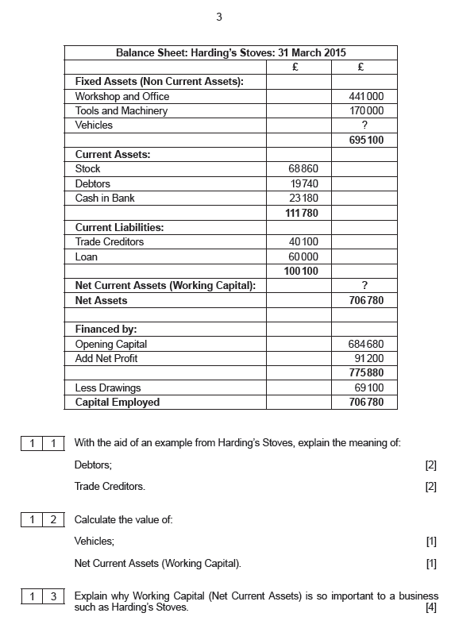

**Statement of Financial Position Kingfisher as at 30 January**

|  |  |  |
| --- | --- | --- |
|  | 2010  £ million | 2009  £ million |
|  |  |  |
| **Fixed (Non-Current) Assets** |  |  |
| Goodwill & other intangible assets | 2465 | ? |
| Property, plant and equipment | 3612 | 3699 |
| Other fixed assets | 388 | 466 |
|  | **?** | **6634** |
|  |  |  |
| **Current Assets** |  |  |
| Stocks (inventories) | 1545 | 1792 |
| Debtors (trade and other receivables) | 494 | ? |
| Cash and Bank | 1260 | 1157 |
| Other current assets | 82 | 140 |
|  | **?** | **3597** |
| **Total Assets** | **?** | **?** |
|  |  |  |
| **Current Liabilities** |  |  |
| Creditors (trade & other payables) | 2374 | 2362 |
| Overdraft (borrowings) | ? | ? |
| Other current liabilities | 409 | 313 |
|  | **3430** | **3064** |
|  |  |  |
| **Net Current Assets/Liabilities** (Working Capital) | **?** | **?** |
|  |  |  |
| **Long-Term (non-current) Liabilities** |  |  |
| Loans (borrowings) | ? | ? |
| Other long-term liabilities | 578 | 462 |
|  | **1461** | **2369** |
|  |  |  |
| **Total Liabilities** | **?** | **?** |
|  |  |  |
| **Net Assets** | **?** | **?** |
|  |  |  |
| **Shareholders’ Capital (Equity)** |  |  |
| Share Capital | 2518 | 2517 |
| Retained Profit (earnings) | 1921 | 1768 |
| Other reserves | 516 | 513 |
| **Total Shareholders’ Capital** | **?** | **?** |