Revenue Costs and Profit Questions

ACTIVITY 1

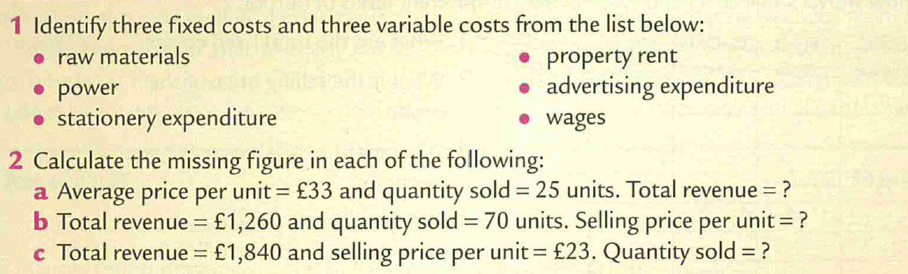

|  |
| --- |
|  |

ACTIVITY 2

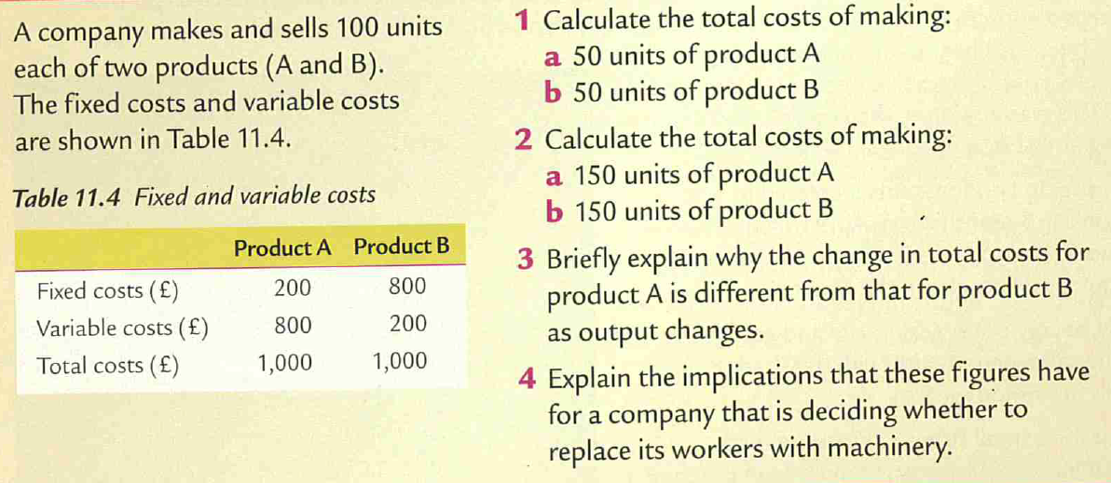

|  |
| --- |
|  |

ACTIVITY 3

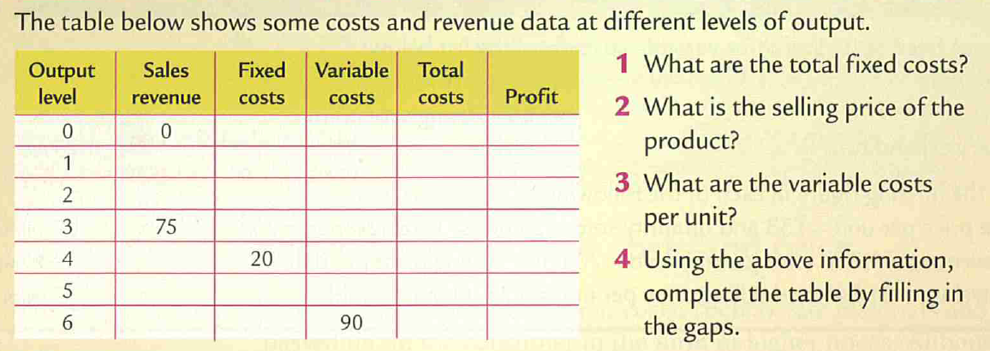

|  |
| --- |
|  |

Gnomes United case study



  
  
  