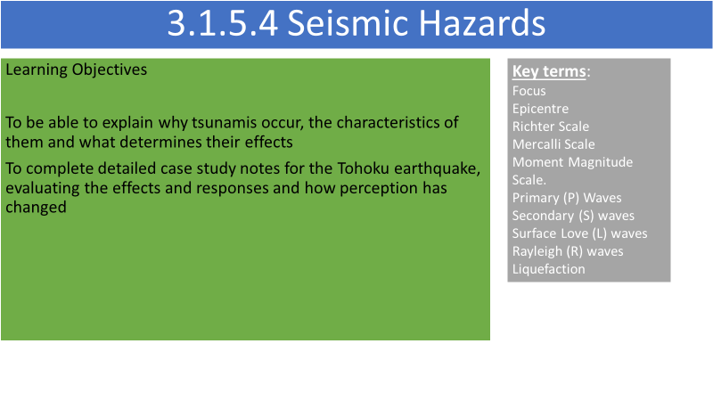

**What are tsunamis?**

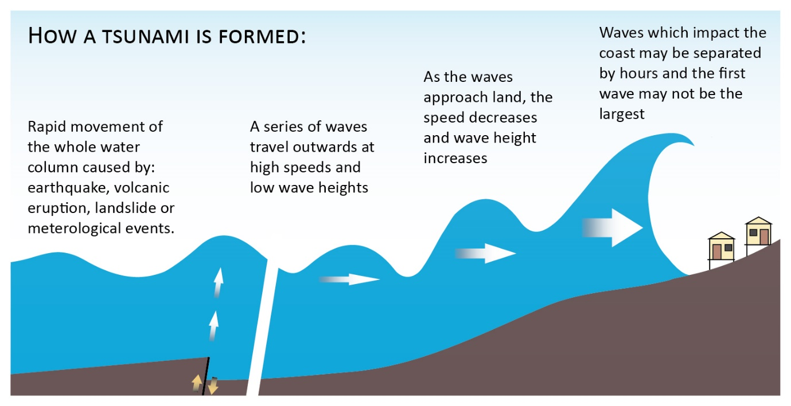

Tsunamis have a very ______________ wavelength (sometimes over 100km) and a ____________wave height (under one metre) in the open ocean and that travel at speeds of over 700km/hour but, when approaching land, ________________ rapidly in height.

Quite often, the first warning given to coastal populations is the wave trough in front of the tsunami which results in the reduction in sea level, known as a drawdown. Behind this comes the tsunami itself which unusually consists of a number of waves, the largest not necessarily being the first.

What do you think determines the effects of the tsunami?

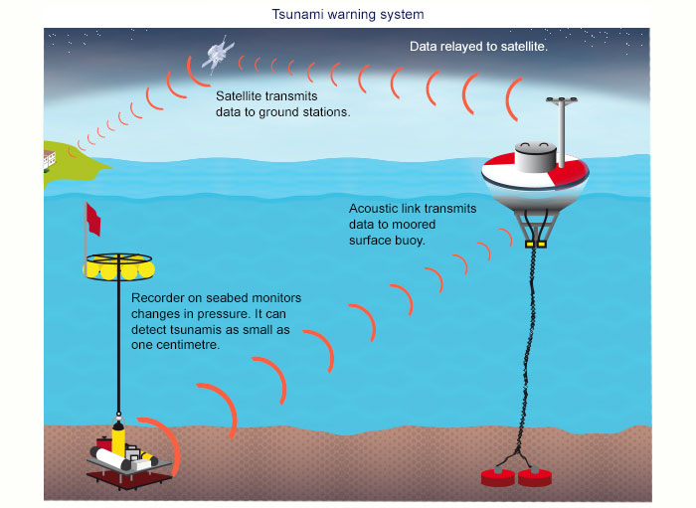

Following the Boxing Day Tsumani in Indonesia, many tsunami buoys have been installed in the Pacific Ocean. What do you think are the advantages and disadvantages of these buoys?

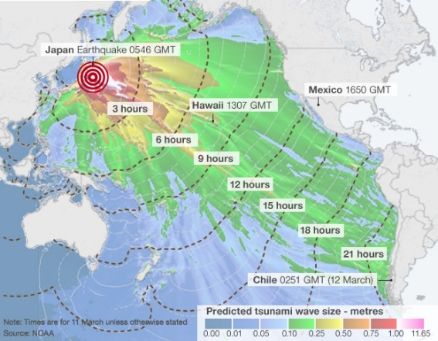

Analyse the map showing the Tohuku Tsunami

**Tohoku Earthquake and Tsunami case study**

<https://www.youtube.com/watch?v=oWzdgBNfhQU> Introduction

<https://www.youtube.com/watch?v=jFv5yY7pMgQ> Fukushima

Oxford textbook p 246-249

Geo factsheet 286

**Flip learning task - detailed case study Tohoku**

**To include:-**

* **The spatial and temporal setting of the event (maps)**
* **The association of the event to plate boundaries and plate movement**
* **The causes of the event**
* **The perception of the event, and the factors affecting those perceptions at a range of scales –e.g. magnitude, frequency, population characteristics**
* **The impacts and an assessment of the impacts**
* **Assessment and justification of the response to the event – including the factors affecting the response**