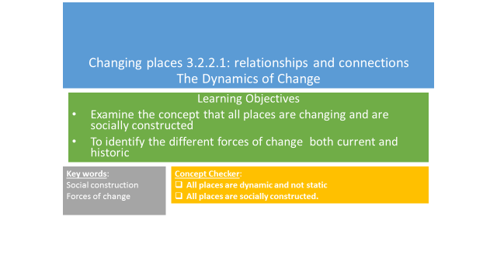

**A group of geographers dubbed the ‘social constructionists’ (that includes David Harvey and Doreen Massey) has suggested that all places must be understood as:**

* + **Dynamic and not static**
  + **Socially constructed**

**Example of this are Milton/Milton Abbas in Dorset and Poundbury in Dorset**

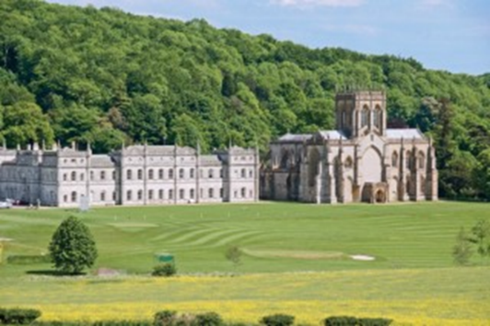 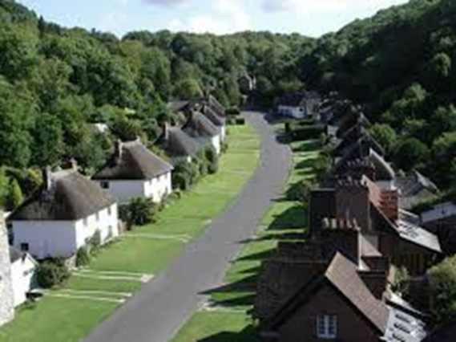

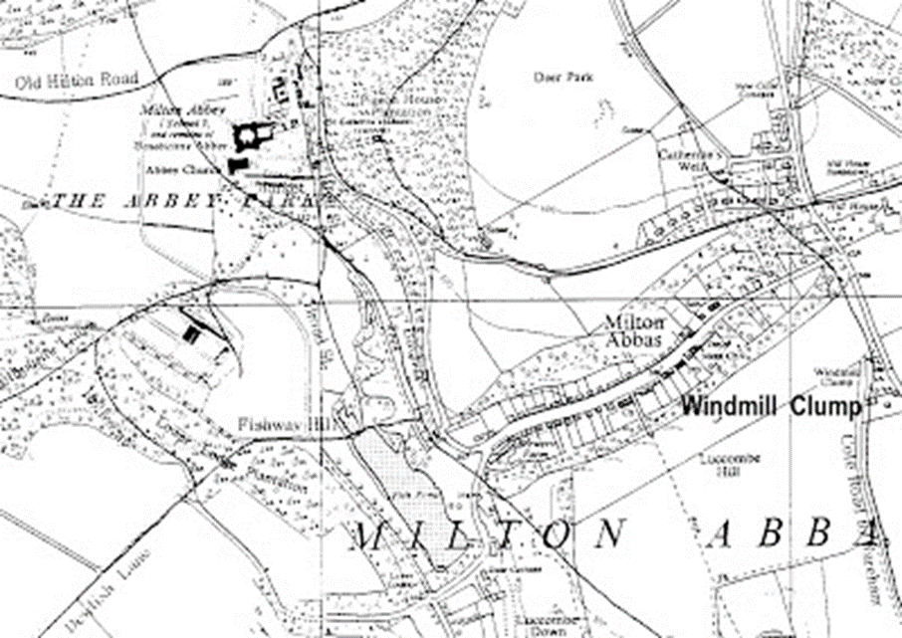

**Milton Abbas, Dorset**

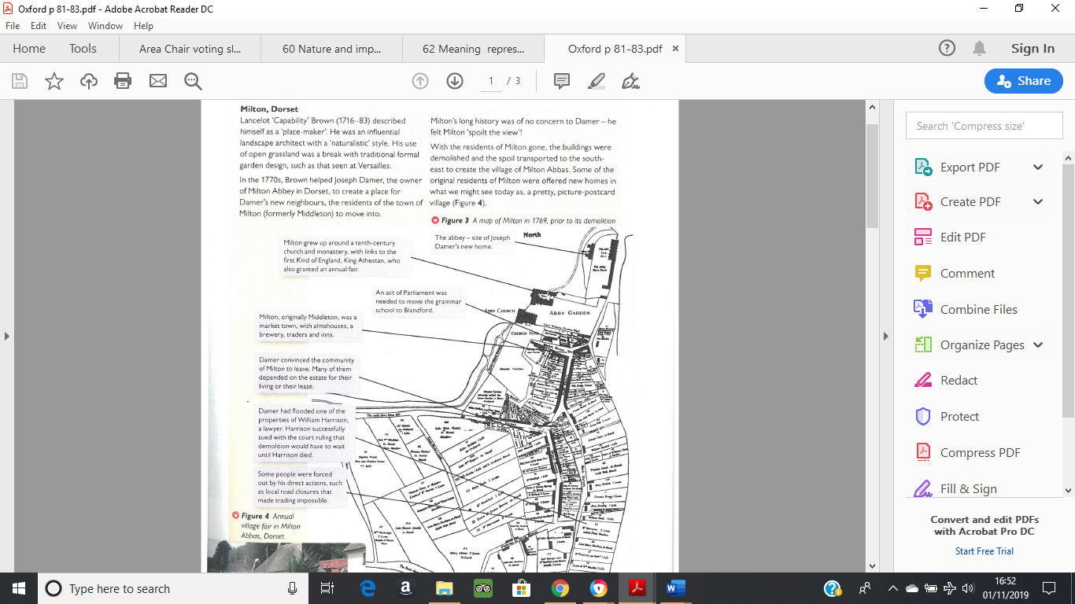

**In 1752 the estate of Milton was sold to Joseph Damer.**

**Read through p81 in the Oxford textbook.**

**Q Why did he want to destroy the village of Milton and build it elsewhere, renaming it Milton Abbas?**

**Q Do you think that it would be allowed to happen today?**

**Poundbury, Dorset**

* Many places/ land uses were created by the economic power of the aristocracy and Milton Abbas is an historical example
* In Poundbury (also in Dorset) another, more recent, aristocratic project has been created
* Watch the following clip showing the development of Poundbury

<http://estream.godalming.ac.uk/View.aspx?id=16045~5d~uPTFHGgELS> 26.15 mins to 33.15 mins

Why was Poundbury built?

|  |  |
| --- | --- |
| Positives of the development | Negatives of the development |
|  |  |

What is your sense of place of Poundbury? Would you like to live there?

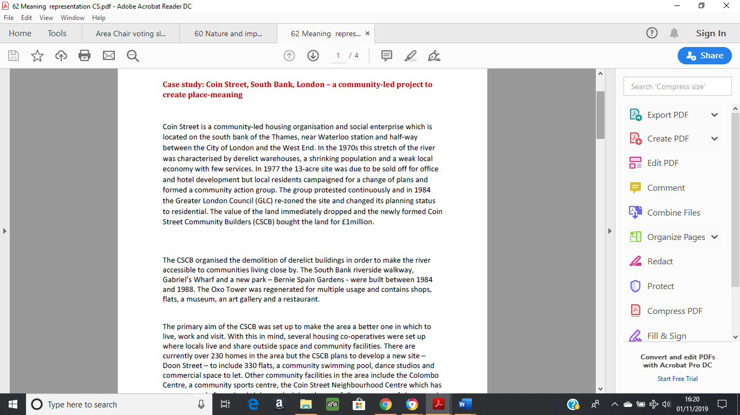

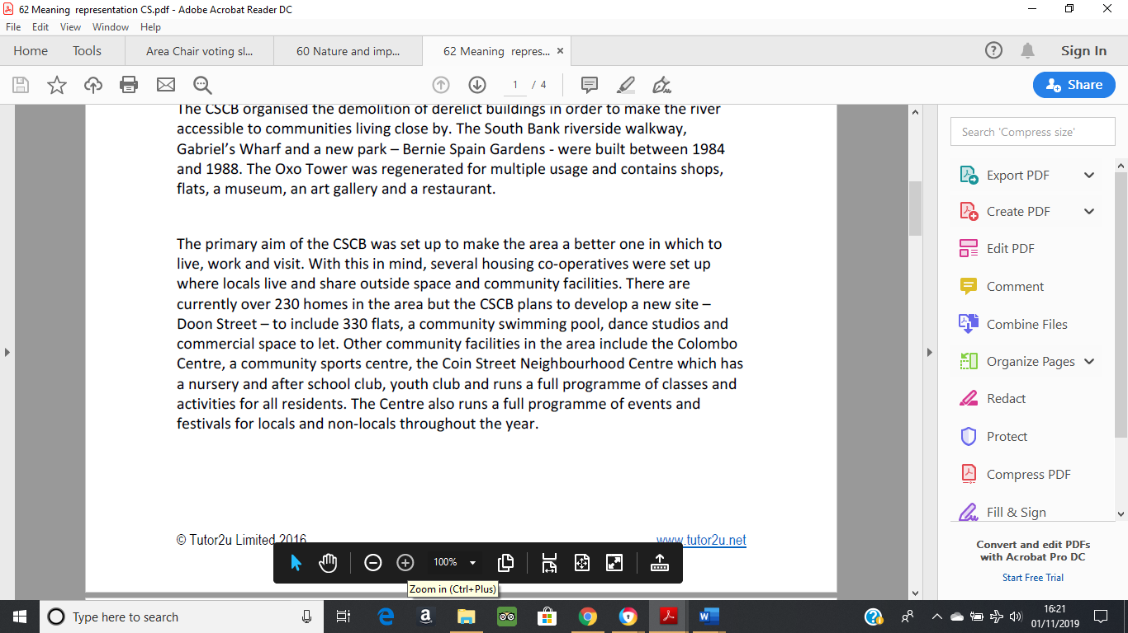

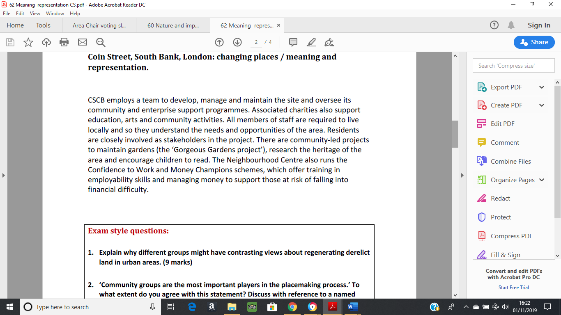

Read the information in the paragraph above and answer the questions in the space below.

1. Where is Coin Street?
2. What were the plans for the site in 1977?
3. Why did the plans not go ahead?
4. Who bought the land?
5. What did they do?
6. Evaluate the scheme – i.e. do you think that the project has been successful? Include at least 5 successes of the scheme and any disadvantages that you can think of.

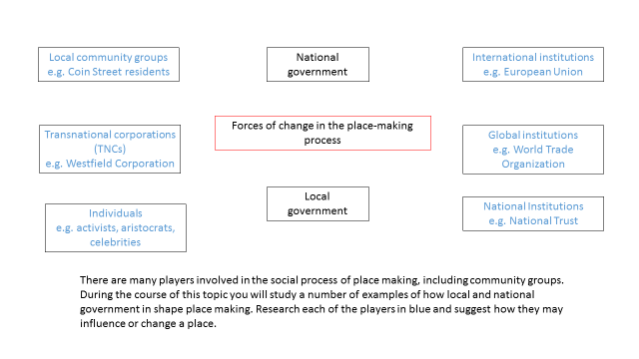

Definition of place making – The deliberate shaping of an environment to facilitate social interaction and improve a community’s quality of life.

Definition of stakeholder – individual, group or organisation that is affected by an issue.

Complete the table below by identifying the different place-makers and the different stakeholders for each of the schemes. The first two have been done for you. Identify and highlight the place-makers that you feel have had the greatest influence in shaping place for each of the schemes.

|  |  |  |
| --- | --- | --- |
| **Scheme** | **Who were/are the place-makers?** | **Who were/are the stakeholders?** |
| Milton Abbas | Joseph Damer | Joseph Damer  The residents of Milton Abbas |
| Stratford | National Government  Local Government  Olympic committee  Westfield Corporation  Private property developers | The placemakers + :-  Residents of the Carpenters Estate  Residents of East Village  Tourists  Local businesses |
| Detroit |  |  |
| Coin Street |  |  |
| Llandudno |  |  |
| Poundbury |  |  |

**Exam style question:**

**‘Community groups are the most important players in the place-making process’ to what extent do you agree with this statement? Discuss with reference named examples (20 marks)**

Hints

* It is asking for your opinion and the extent to which you agree with this statement. Before you start take a moment to think about it and whether you agree to a strong extent, partial extent or do not agree.
* What case study examples could you use to back up your opinion?

Possible essay structure

|  |  |
| --- | --- |
| Introduction  Define the key term – Place-maker. Introduce different community groups and schemes | |
| P - Coin Street | Explain – where is it and what did the community do?  Evidence – what success did they have?  Link to question - To what extent were they the most important player? |
| P - | Explain –  Evidence –  Link to question - |
| P - | Explain –  Evidence –  Link to question - |
| P - | Explain –  Evidence –  Link to question - |
| Conclusion  Overall, to what extent do you agree that community groups are the most important players in the place-making process? Explain why. | |