# **Sources of Finance for Start Ups and SME’s**

**Introduction**

Often the hardest part of starting a business is raising the money to get going. The entrepreneur might have a great idea and clear idea of how to turn it into a successful business. However, if sufficient finance can’t be raised, it is unlikely that the business will get off the ground.

Raising finance for start-up requires careful planning. The entrepreneur needs to decide:

* How much finance is required?
* When and how long the finance is needed for?
* What security (if any) can be provided?
* Whether the entrepreneur is prepared to give up some control (ownership) of the start-up in return for investment?

The finance needs of a start-up should take account of these key areas:

* Set-up costs (the costs that are incurred before the business starts to trade)
* Starting investment in capacity (the fixed assets that the business needs before it can begin to trade)
* Working capital (the stocks needed by the business –e.g. r raw materials + allowance for amounts that will be owed by customers once sales begin)
* Growth and development (e.g. extra investment in capacity)

One way of categorizing the sources of finance for a start-up is to divide them into sources which are from within the business (internal) and from outside providers (external).

**Internal sources**

The main internal sources of finance for a start-up are as follows:

***Personal sources***   
These are the most important sources of finance for a start-up, and we deal with them in more detail in a later section.

**Retained profits**   
This is the cash that is generated by the business when it trades profitably – another important source of finance for any business, large or small.   
**Note that retained profits can generate cash the moment trading has begun.** For example, a start-up sells the first batch of stock for £5,000 cash which it had bought for £2,000. That means that retained profits are £3,000 which can be used to finance further expansion or to pay for other trading costs and expenses.

**Share capital – invested by the founder** The founding entrepreneur may decide to invest in the share capital of a company, founded for the purpose of forming the start-up. This is a common method of financing a start-up. The founder provides all the share capital of the company, retaining 100% control over the business.

The advantages of investing in share capital are covered in the section on business structure. The key point to note here is that the entrepreneur may be using a variety of personal sources to invest in the shares. Once the investment has been made, it is the company that owns the money provided. The shareholder obtains a return on this investment through **dividends** (payments out of profits) and/or the value of the business when it is eventually sold.

A start-up company can also raise finance by selling shares to **external investors** – this is covered further below.

**External sources**

**Loan capital** this can take several forms, but the most common are a **bank loan** or **bank overdraft**.

**A bank loan** provides a **longer-term** kind of finance for a start-up, with the bank stating the fixed period over which the loan is provided (e.g. 5 years), the rate of interest and the timing and amount of repayments. The bank will usually require that the start-up provide some security for the loan, although this security normally comes in the form of personal guarantees provided by the entrepreneur. Bank loans are good for financing investment in fixed assets and are generally at a lower rate of interest that a bank overdraft. However, they don’t provide much flexibility.

**A bank overdraft** is a more short-term kind of finance which is also widely used by start-ups and small businesses. An overdraft is really a loan facility – the bank lets the business “owe it money” when the bank balance goes below zero, in return for charging a high rate of interest. As a result, an overdraft is a flexible source of finance, in the sense that it is only used when needed. Bank overdrafts are excellent for helping a business handle seasonal fluctuations in cash flow or when the business runs into short-term cash flow problems (e.g. a major customer fails to pay on time).  
Two further loan-related sources of finance are worth knowing about:

**Share capital – outside investors** For a start-up, the main source of outside (external) investor in the share capital of a company is **friends and family** of the entrepreneur. Opinions differ on whether friends and family should be encouraged to invest in a start-up company. They may be prepared to invest substantial amounts for a longer period of time; they may not want to get too involved in the day-to-day operation of the business. Both of these are positives for the entrepreneur. However, there are pitfalls. Almost inevitably, tensions develop with family and friends as fellow shareholders.

**Business angels** are the other main kind of external investor in a start-up company. Business angels are professional investors who typically invest £10k - £750k. They prefer to invest in businesses with high growth prospects. Angels tend to have made their money by setting up and selling their own business – in other words they have proven entrepreneurial expertise. In addition to their money, Angels often make their own skills, experience and contacts available to the company. Getting the backing of an Angel can be a significant advantage to a start-up, although the entrepreneur needs to accept a loss of control over the business.

You will also see **Venture Capital** mentioned as a source of finance for start-ups. You need to be careful here. Venture capital is a specific kind of share investment that is made by **funds managed by professional investors.** Venture capitalists rarely invest in genuine start-ups or small businesses (their minimum investment is usually over £1m, often much more). They prefer to invest in businesses which have established themselves. Another term you may here is “private equity” – this is just another term for venture capital.

A start-up is much more likely to receive investment from a business angel than a venture capitalist.

**Personal sources**

As mentioned earlier, most start-ups make use of the personal financial arrangements of the founder. This can be personal savings or other cash balances that have been accumulated. It can be personal debt facilities which are made available to the business. It can also simply be the found working for nothing! The following notes explain these in a little more detail.

***Savings and other “nest-eggs*** “An entrepreneur will often invest personal cash balances into a start-up. This is a cheap form of finance and it is readily available. Often the decision to start a business is prompted by a change in the personal circumstances of the entrepreneur – e.g. redundancy or an inheritance. Investing personal savings maximizes the control the entrepreneur keeps over the business. It is also a strong signal of commitment to outside investors or providers of finance.   
Re-mortgaging is the most popular way of raising loan-related capital for a start-up. The way this works is simple. The entrepreneur takes out a second or larger mortgage on a private property and then invests some or all of this money into the business. The use of mortgaging like this provides access to relatively low-cost finance, although the risk is that, if the business fails, then the property will be lost too. .

***Borrowing from friends and family*** this is also common. Friends and family who are supportive of the business idea provide money either directly to the entrepreneur or into the business. This can be quicker and cheaper to arrange (certainly compared with a standard bank loan) and the interest and repayment terms may be more flexible than a bank loan. However, borrowing in this way can add to the stress faced by an entrepreneur, particularly if the business gets into difficulties.

***Credit cards*** this is a surprisingly popular way of financing a start-up. In fact, the use of credit cards is the most common source of finance amongst small businesses. It works like this. Each month, the entrepreneur pays for various business-related expenses on a credit card. 15 days later the credit card statement is sent in the post and the balance is paid by the business within the credit-free period. The effect is that the business gets access to a free credit period of around 30-45 days!

# **Sources of Finance**

| Source | Definition / Description (include internal or external, short/medium/long term) | Advantages | Disadvantages | Suitable for? (e.g. Start Up, SME, LTD, PLC) |
| --- | --- | --- | --- | --- |
| Personal Sources |  |  |  |  |
| Retained profit |  |  |  |  |
| Bank Loan |  |  |  |  |
| Overdraft |  |  |  |  |
| Business Angels |  |  |  |  |
| Share capital (invested by the founder) |  |  |  |  |
| Share capital (invested by family and friends) |  |  |  |  |
| Government assistance |  |  |  |  |
| Sale of assets |  |  |  |  |
| Trade credit |  |  |  |  |
| Factoring |  |  |  |  |
| Leasing and hire purchase |  |  |  |  |
| Commercial mortgages |  |  |  |  |
| Sale and leaseback |  |  |  |  |
| Share capital (for Limited companies – ordinary / preference shares) |  |  |  |  |
| Venture capitalists |  |  |  |  |

**Plc and share capital explained – advantages and disadvantages**

A public limited company ('PLC') is a company that is **able to offer its shares to the public**. They don't have to offer those shares to the public, but they can.

Well over 95% of limited companies in the UK are "private" – it is by far the most common form of limited company.

However, you also need to know about **"public" limited companies.**

There are some specific requirements for a PLC which must be met:

* The minimum number of shareholders must be two (a private limited company only needs one shareholder)
* Accounts must be filed within 6 months of the year end (the limit is 9 months for a private company)
* The Company Secretary must be a qualified person (in a private company the secretary does not need to be qualified)
* The minimum number of Directors is two (just one needed for a private company)

The main advantages of a being public limited company are:

* **Better access to capital** – i.e. raising share capital from existing and new investors
* **Liquidity** – shareholders are able to buy and sell their shares (if they are quoted on a stock exchange
* **Value of shares** – the value of the firm is shown by the market capitalisation (based on the share price)
* The opportunity to more **easily make acquisitions** – e.g. by offering shares to the shareholders of the target firm
* To give a company a more **prestigious profile**

As always there are some disadvantages to being a PLC (as opposed to remaining as a private company). The main downsides are:

* Once listed on a stock exchange, the company is likely to have a much larger number of external shareholders, to whom company directors will be accountable
* Financial markets will govern the value of the company through the trading of the company's shares, and will represent the market's view of the company's performance over time
* Greater public scrutiny of the company's financial performance and actions

**Long term sources of finance – share capital for a plc**

**2 types of shares (Shareholders are part owners of a company)**

**Ordinary Shares (Equities):**

* Ordinary shareholders have voting rights
* Dividend can vary
* Last to be paid back in event of collapse
* Share price varies with trade on stock exchange

**Preference Shares:**

* Paid before ordinary shareholders
* Fixed rate of return
* Cumulative preference shareholders – have right to dividend carried over to next year in event of non-payment

**New Share Issues** – arranged by merchant or investment banks

**Rights Issue** – existing shareholders given right to buy new shares at discounted rate

**Bonus or Scrip Issue** – change to the share structure – increases number of shares and reduces value but market capitalisation stays the same

Identify the best sources of finance for each of the following situations **and** give your reasons (why):

|  |  |  |  |
| --- | --- | --- | --- |
|  | **Situation** | **Best Source(s)?** | **Why?** |
| 1 | Finance a new fleet of cars |  |  |
| 2 | Build a new factory |  |  |
| 3 | Purchase raw materials |  |  |
| 4 | Need to pay suppliers (Trade Credit) today but customers (Debtors) not required to pay for 60 days |  |  |
| 5 | A large “Plc” needs to finance new product development |  |  |
| 6 | Need to install a new computer system but realizes technology is changing rapidly |  |  |
| 7 | Has positive cash flow but little cash to spare & wants to have some extra cash as a precaution |  |  |
| 8 | Limited company with strong profits wants to invest heavily in new technology and factories |  |  |
| 9 | A sole trader with some great ideas wants to grow but cannot invest more and the banks will not help |  |  |
| 10 | Many short-term liabilities coming due in the next months, but with strong cash flow potential the next year |  |  |

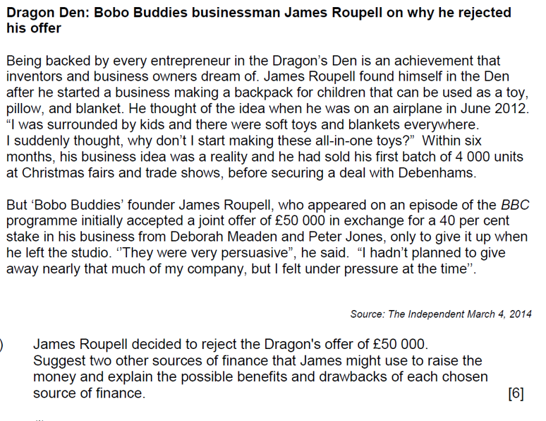**Past Paper Question**

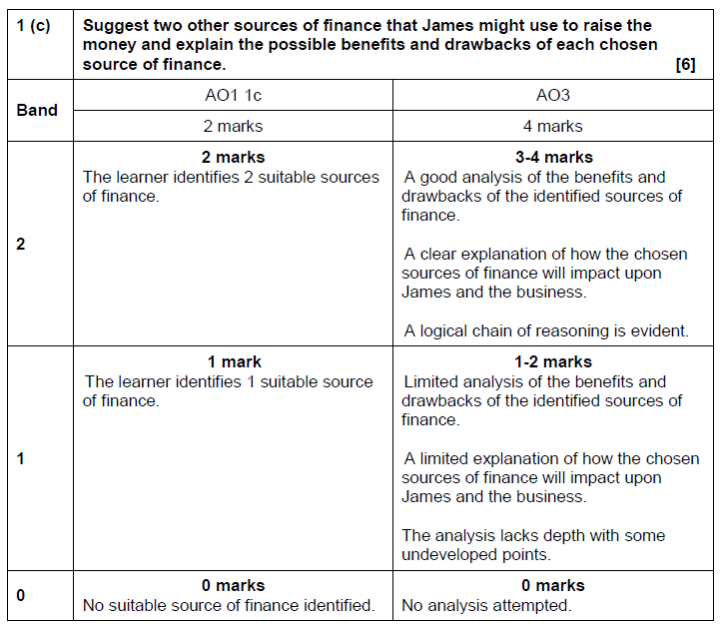

**Example to help with exam technique….**

*A suitable source would be a bank loan (AO1. This would be good for James because loans are widely available from a variety of financial institutions and large sums are normally quick and easy to arrange (AO3). James is able to provide evidence that he can pay back the loan as he has already made good level of sales and has secured a contract with Debenhams so his loan application is likely to be accepted (context for AO3). However, loans have interest attached (AO1), this may be a disadvantage to James because….. (AO3)*