|  |
| --- |
| **Item B**  Some sociologists explain levels of offending by girls and women in terms of their socialisation or their position in patriarchal society. For example, one feminist sociologist argues that the weakening of patriarchy has led to an increase in female offending.  However, other sociologists focus on the ways in which the police and courts treat females, as well as on the impact of media stereotypes of female offending. |
|  |

**Q4. Applying material from Item B and your knowledge, evaluate sociological explanations of levels of female offending. [30 marks] 2019 summer exam**

**The mark scheme for this question was:**

Indicative Content

Concepts and issues such as the following may appear: chivalry thesis; control theory; liberation thesis; patriarchy; sex role theory; feminism; functionalism; class and gender deals; intersectionality; different categories of offence (e.g. shoplifting, prostitution, violence); girl gangs; delinquent subcultures; per pressure; role models; moral panics; ‘defining deviance up’/net widening;; victim-precipitation; stereotyping in the criminal justice system; self-report studies.

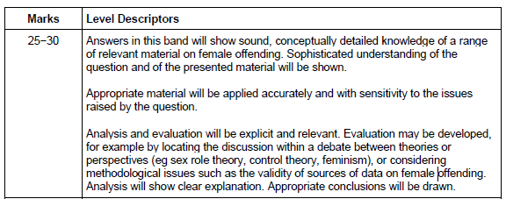

**Examiners report**

Question 04

This question produced responses at all levels of quality. Some weaker answers became side-tracked into explanations of male criminality, or of females as victims rather than as offenders. Other responses lacked knowledge of material, specifically on female offending, and attempted, often with only limited success, to apply other theories of crime and deviance, usually strain and subcultural theories.

However, in general at all levels of response, students made an effort to apply material from Item B. Weaker answers tended to offer somewhat commonsensical accounts of one or two theories that reflected points in the Item, or accounts that were light on conceptual detail. Most students struggled to develop the Item's reference to media stereotyping satisfactorily, though a few higher-level responses engaged successfully with the idea that a moral panic about young female offending had led to increased social control and criminalisation of females.

Good answers were able to discuss some or all of the following, using appropriate concepts and evidence: sex role theory and gender socialisation: Heidensohn and control theory; Adler's liberation thesis and the weakening of patriarchy; Carlen on class and gender deals; and the chivalry thesis.

The best answers made good analytical and evaluative points throughout their essay. For example, in discussing Heidensohn and control theory, some questioned the extent to which changing gender roles may have made the theory less relevant in today's society, often then going on to link this evaluation to the liberation thesis. Similarly, some better answers questioned the continuing relevance of the chivalry thesis in the context of greater gender equality and increased numbers of women working in the criminal justice system.

**Using this feedback, what have questions tended to leave out?**

**With the two examples, what are the 2 pieces of feedback/targets you would give them to help improve their essays?**

Example 1:

>

>

Example 2:

>

>

Using your essay plan and the two example essays construct the best introduction and conclusion to this essay that you can.

__________________________________________________________________________________________________________________________________________________________________________________________________________________________________________________________________________________________________________________________________________________________________________________________________________________________________________________________________________________________________________________________________________________________________________________________________________________________________________________________________________________________________________________________________________________________________________________________________________________________________________________________________________________________________________________________________________________________________________________________________________________________________________________________________________________________________________________________________________________________________________________________________________________________________________________________________________________________________________________________________________________________________________________________________________________________________________________________________________________________________________________________________________________________________________________________________________________________________________________________________________________________________________________________________________________________________________________________________________________________________________________________________________________________________________________________________________________________________________________________________________________________________________________________________________________________________________________________________________________________________________________________________________________________________________________________________________________________________________________________________________________________________________________________________________________________________________________________________________________________________________________________________________________________________________________________________________________________________________________________________________________________________________________________________________________________________________________________________________________