***1: What is direct realism? [3 Marks]***

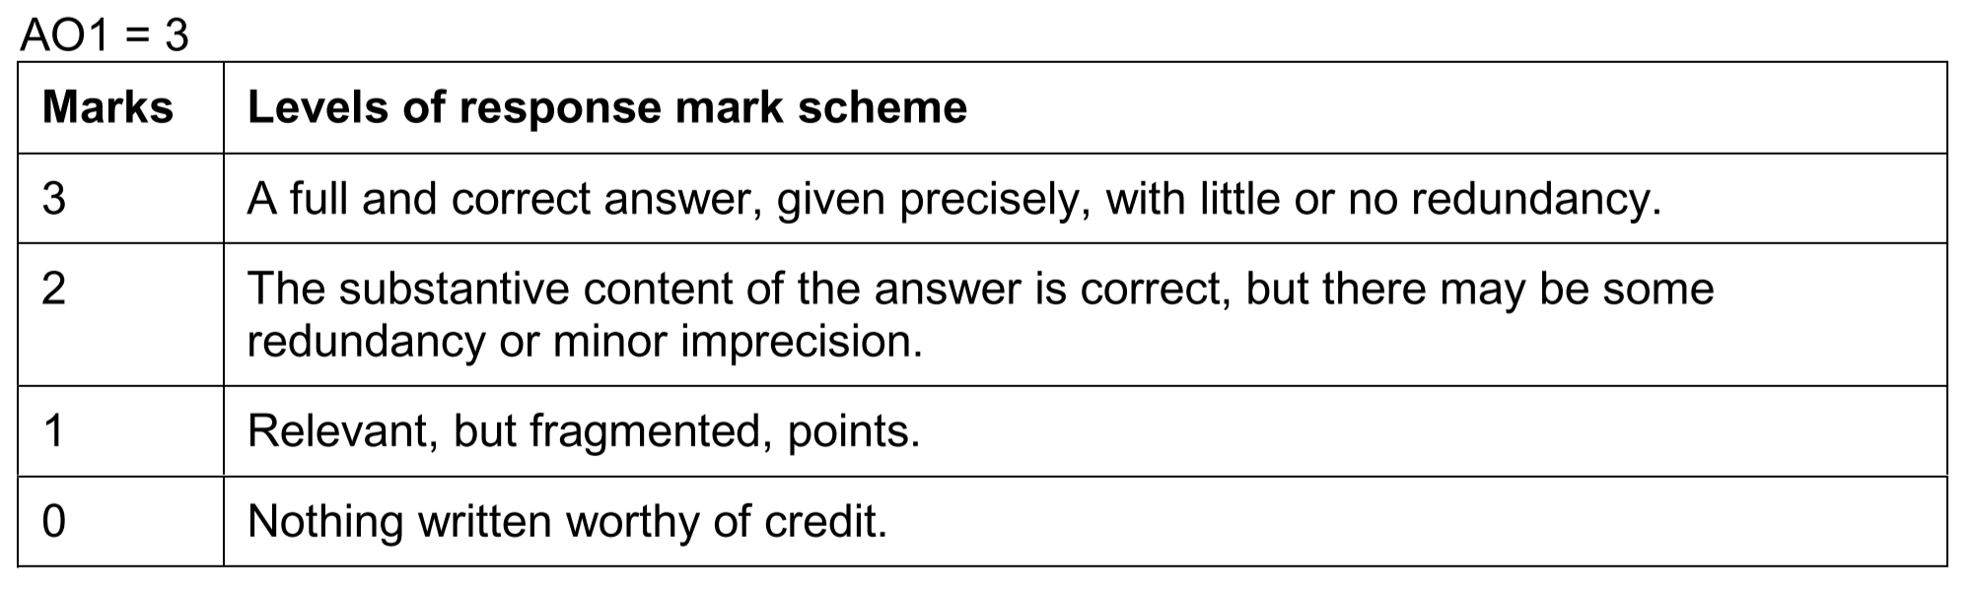

**Indicative content:**

* Direct realism is a theory of perception that makes two key claims: (a) an external world (of mind-independent material/physical objects and their properties) exists and (b) we perceive that world without any intermediaries (e.g. sense data). Students who write the aforementioned (or some suitable variation on it) will get full marks, but we can expect a variety of approaches:
  + a) Candidates may legitimately address the ‘realist’ part of the theory with reference to a ‘mind independent world (or objects)’; an ‘external world (or objects)’; or a ‘material/physical world (or objects)’.
  + b) Candidates may legitimately address the ‘direct’ part of the theory positively (e.g. ‘we perceive a mind independent world immediately’); or they may frame it negatively (e.g. ‘we perceive a mind independent world without mediation’). But we are looking for candidates to do more than reproduce the term ‘direct’ (or the adverbial form: ‘directly’).

***2: Explain* one *of Berkeley’s criticisms of indirect realism [5 Marks]***

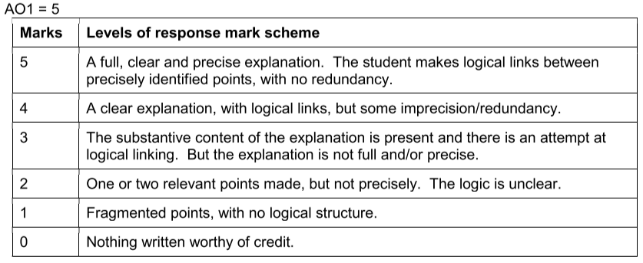

**Indicative content:**

Background: the distinction made by Locke (and others) between primary properties/qualities that are mind-independent (shape, size, motion, etc) and secondary properties/qualities that are, at least in some sense, mind-dependent (colour, taste, smell, etc).

* Berkeley wishes to establish that all properties/qualities are mind-dependent, so attacks the distinction between primary and secondary qualities.
* To do this, Berkeley argues that:
  + **Argument 1**
    - P1: Secondary qualities are subject to interpersonal and intrapersonal perceptual variation (eg objects can appear to have different colours, tastes, etc) and are therefore mind-dependent.
    - P2: Primary qualities are also subject to interpersonal and intrapersonal perceptual variation (objects can appear to have different sizes, shapes, speeds, etc).
    - C: Therefore primary qualities are also mind-dependent.
    - Students may discuss colours of clouds, Locke’s example of two hands in water feeling different heats - which Berkeley himself discusses - and/or examples of how size can appear different to differently-sized perceivers, but there are many other possible examples.
  + **Argument 2**
    - P1: The mind cannot form an idea of an object with primary qualities but without any secondary qualities.
    - P2: If an idea of X is impossible (“contradictory”), X is impossible.
    - C1: Therefore, objects with primary qualities but without any secondary qualities are impossible.
    - C2: Therefore, both primary and secondary qualities are essential properties of objects.
    - Students may discuss Berkeley’s claim that “you [can’t] even separate the ideas of extendedness and motion from the ideas of all the so-called secondary qualities”.
  + **Other possible arguments**
    - Berkeley’s argument that so-called primary qualities (reality) are as mind-dependent as so-called secondary qualities, and that therefore we cannot know by the qualities we perceive that a mind-dependent reality exists. Berkeley argues that, in the same way perceptual variation in terms of colour leads to the conclusion that secondary qualities such as colour are mind dependent, there is perceptual variation in terms of size (an ant's foot is a very different size to an ant compared to a human) - size is a primary quality so must also be mind-dependent.
    - Indirect Realism faces problems arising from the view that mind-dependent objects (particularly non-physical sense-data) represent mind-independent objects (there is not enough in common between these different types of objects to sustain this relationship of representation) Examples relating to this include:
      * Secondary qualities/mind dependent objects are temporary, constantly changing, primary qualities/material/mind independent objects are fixed and constant. How can something that changes represent something that is constant?
      * How can things that we directly perceive (sense data) be like primary qualities which are impossible to perceive? (eg how can a colour represent something that isn't colourful, how can a sound represent something that isn't audible?)

***3: Outline the issue of perceptual variation against direct realism. [5 marks]***



**Indicative content:**

* The issue of perceptual variation:
  + Perceptual variation is the phenomena that the qualities of the object seem to change depending on factors external to the object (ie conditions/context of perception, eg the position of the perceiver).
* The logic of the issue can be outlined as follows:
  + P1) The object I directly perceive changes (eg its colour, shape, or size)
  + P2) The physical object doesn’t change
  + C1) Therefore, the object I directly perceive cannot be the physical object
  + C2) It follows that direct realism as defined above is false.
* The logic of the issue can also be expressed using the phenomenal principle: ‘if it appears that there is an x which has the sensible quality f then there is an x which does possess that quality f’
  + P1) The object I directly perceive appears to change (eg its colour, shape, size)
  + P2) If the object I directly perceive appears to change, then the object I directly perceive must change
  + P3) The physical object doesn’t change
  + C1) Therefore, the object I directly perceive isn’t the physical object
  + C2) It follows that direct realism as defined above is false.
* Students may draw on Bertrand Russell’s argument from perceptual variation which is found in Problems of Philosophy chapter 1. He uses the example of different people having different perceptions of the same table to show that there is a gap between ‘reality’ (the physical object which exists independent of us) and ‘appearance’ (what we perceive) so that we do not immediately perceive the physical object but must infer its existence and reality. Russell’s arguments show how the colour, the texture, and the shape of the table are all perceptually variable.
* Students need to be careful not to conflate the argument from perceptual variation with the argument from illusion (in particular) and hallucination.

***4: Explain how indirect realism leads to scepticism about the existence of mind-independent objects* and *Locke’s response based on the involuntary nature of our experience [12 marks]***

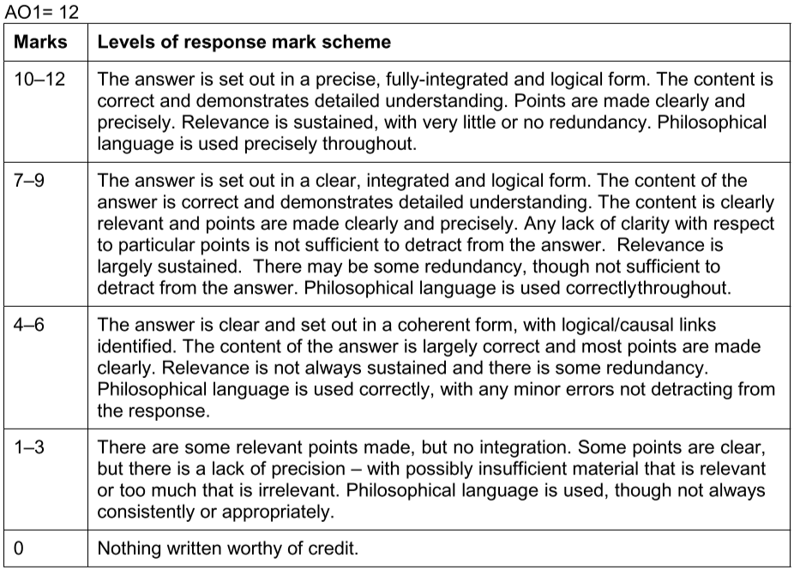

**Indicative content**

Outline how indirect realism leads to scepticism about the existence of mind-independent objects…

* Indirect realism is the claim that:
  + mind-independent/physical objects exist in the external world
  + but we never directly perceive them
  + instead we only ever perceive them indirectly by directly perceiving or being aware of mind-dependent entities (such as sense-data, ideas, impressions).
* The issue of scepticism facing indirect realism:
  + If we never directly perceive mind-independent/physical objects, our perceptual experiences can never give us direct evidence that such objects exist
  + Any claim that mind-independent objects exist would therefore have to be inferred from claims about our sense-data (ideas, impressions)
  + Such an inference cannot be justified
    - Neither experience (a posteriori argument) nor reason (a priori argument) can justify such an inference. (Some students will focus mainly or solely on experience being unable to justify such an inference, without mentioning ‘reason’ and this is fine)
  + **Therefore, the indirect realist cannot know that there is any mind-independent/external reality beyond what is directly perceived (i.e. mind-dependent sense data)**
* In addition to explaining the issue for indirect realism relating to scepticism about the existence of mind- independent objects, students might go on to refer to sceptical argument more generally. Examples include but are not limited to:
  + Berkeley’s argument that so-called primary qualities (reality) are as mind-dependent as so-called secondary qualities, and that therefore we cannot know by the qualities we perceive that a mind- dependent reality exists
  + Arguments that support the claim that we are only ever directly aware of mind-dependent objects (sense-data): e.g. the argument from perceptual variation, the argument from illusion, the argument from hallucination, and the time-lag argument
  + Students may refer to sceptical scenarios in popular culture to explain the issue of scepticism which faces indirect realism, e.g. films such as ‘The Matrix’ or ‘Inception’
  + None of these additional developments are required, but they should not be classed as redundant / penalised so long as they do not detract from the quality of the response. However, it is important that the specific problem for indirect realism is explained (see previous page), and that students do not simply provide an explanation of scepticism / sceptical arguments more generally.

…and explain Locke's response based on the involuntary nature of our experience.

* + Locke argues that our sensations must be caused by something outside of ourselves:
  + “I find that I can’t avoid having those ideas produced in mymind.”
  + The fact that our experiences are involuntary suggests that they must come from outside of ourselves, and are most likely caused by mind-independent physical objects, since the ideas that are mind-dependent and stem from our own imagination are under our control and voluntary
  + Locke gives the example that he can shut his eyes and choose to recall the idea of light but if he turns his eyes to the sky at noon he cannot ‘avoid’ the idea of light being produced in him
  + Some students might identify this argument as being an inductive argument.