***1: Briefly outline Bentham’s utilitarianism [3 Marks]***

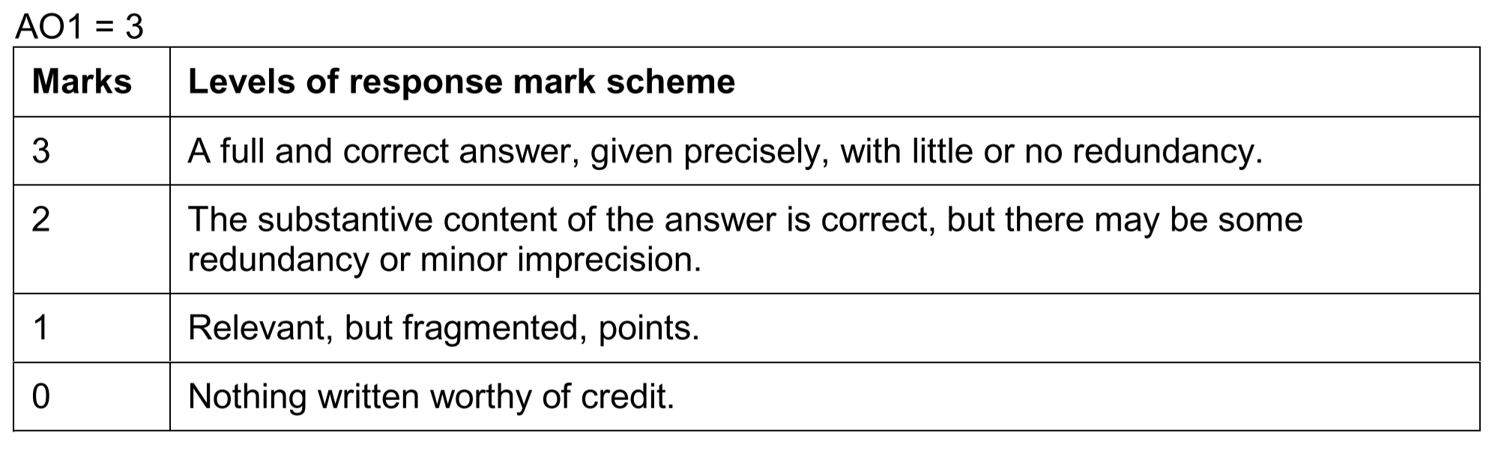

**Indicative content:**

**Indicative content for 3 marks**

* Bentham is a quantitative hedonistic utilitarian (one mark for each)
  + [**Utilitarian**] He argues that actions are morally right/good to the extent that they maximise utility
  + [**Hedonistic**] By “utility” he means happiness which he understands as the balance of pleasure over pain (maximising pleasure, minimising pain). He claims that only pleasure is intrinsically/ultimately valuable: “Nature has placed mankind under the governance of two sovereign masters, pain and pleasure.” (The Principles of Morals and Legislation (1789), Chapter 1).
  + [**Quantitative**]. For Bentham it is the quantity of pleasure that matters. He does not (as Mill does) see there being any morally important difference between types of pleasure. He does not make any qualitative distinctions between pleasure based on its type, its origin or indeed what the pleasure is being taken in.

It is possible students write more than usual for this 3 marker, only count as redundancy anything which does not serve the definition (eg mentions of preference, rule utilitarianism, comparisons with Mill etc).

***2: Explain how Nozick’s experience machine challenges hedonism [5 Marks]***

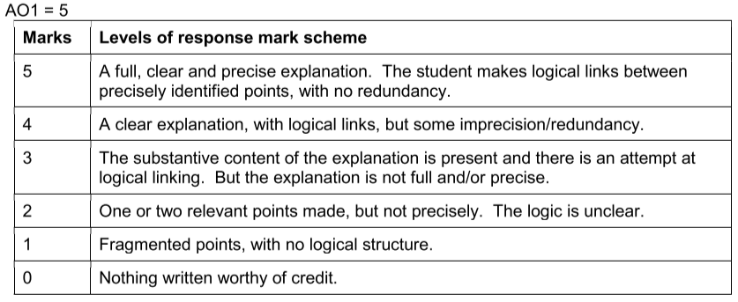

**Indicative content:**

* Students could refer to either Psychological hedonism (the view that as a matter of fact all we desire is happiness/pleasure) or ethical hedonism (the view that we ought to desire happiness/pleasure).
* Nozick’s experience machine challenges psychological hedonism and thereby undermines ethical hedonism.
* In order to explain how Nozick’s thought experiment challenges hedonism, the student will need to outline the thought experiment, and what it shows, and then successfully connect this back to the hedonist claim
* Nozick says: “Imagine a machine that could give you any experience (or sequence of experiences) you might desire. When connected to this experience machine, you can have the experience of writing a great poem or bringing about world peace or loving someone and being loved in return. You can experience the felt pleasures of these things, how they feel “from the inside.” You can program your experiences for tomorrow, or this week, or this year, or even for the rest of your life.” Anarchy, State, and Utopia (1974)
* There are some important things to note about this imagined scenario:
* “The question is not whether to try the machine temporarily, but whether to enter it for the rest of your life.”
* “Upon entering, you will not remember having done this; so no pleasures will get ruined by realizing they are machine produced.”
* NB: Students must not confuse the machine Nozick describes with a simpler pleasure machine in which they are kept in a permanent drug-induced high.
* Here’s Nozick’s objection in standard form:
* P1: Hedonism claims that as a matter of fact all we desire is happiness/pleasure
* P2: If as a matter of fact all we desire is happiness/pleasure, then we would have no good reason not to plug into the experience machine (assuming it increased the quantity of pleasure experienced)
* P3: However, we do have good reasons not to plug into the experience machine, such as that
  + we care about what actually is the case, not just how things seem
  + we want to be connected to reality
  + we want to be able to change reality, and
  + we want to share reality with other people and to affect them
* C: Therefore, the hedonist claim that as a matter of fact all we desire is happiness/pleasure is not true.

***3: Outline Mill’s ‘proof’ of the greatest happiness principle. [5 marks]***



**Indicative content:**

They may (but do not have to) begin with Mill’s analogy: ‘The only proof capable of being given that an object is visible is that people actually see it … In like manner … the sole evidence … that something is desirable is that people do actually desire it ….’

* P1: Each person desires his own happiness.
* P2: What each person desires is a good to that person.
* C1: Therefore, each person’s happiness is a good to that person.
* P3: If each person’s happiness is a good to that person, then the happiness of all people is a good to the aggregate of people.
* C2: Therefore, the happiness of all people is a good to the aggregate of people.
* P4: Some things are desired apart from happiness.
* P5: However, anything desired apart from happiness is desired as a part of happiness.
* C3: Therefore, what is desired is desired as a part of happiness.
* C4: Therefore, the sole good is the happiness of all people.

***4: Explain how a utilitarian could approach the issue of eating animals. [12 marks]***

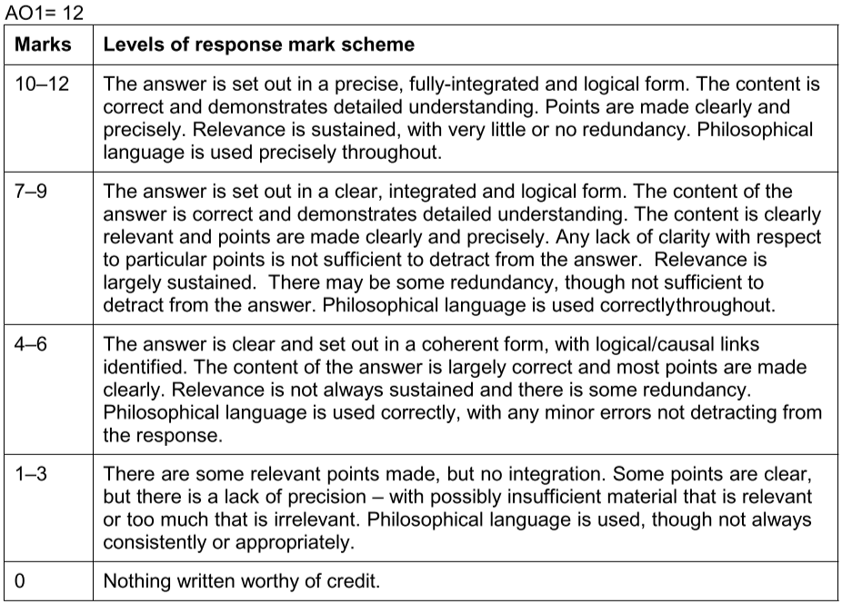

**Indicative content**

* Students may discuss (a) utilitarianism in general, (b) focus on one particular version of utilitarianism, or (c) consider two or more versions.
* Students may explain what utilitarianism is in general:
  + Utilitarians (as consequentialists) decide whether actions are morally right or wrong based on their effects.
  + The best decision is the decision that maximises utility (creates the greatest net utility).
  + NB: what utility is understood to be and what maximisation amounts to vary across the many different species of utilitarianism.
  + A utilitarian would consider the effects on happiness of all those affected; no-one would be ignored during the calculating process (impartiality: “every man to count for one, nobody for more than one” (Bentham)).
* Students may choose to discuss one or more versions of utilitarianism (made complicated by the fact that utilitarians differ in their answers to various questions, forming a complicated matrix of possible positions):
  + Which consequences matter? / What is meant by ‘utility’?
    - the quantity of pleasurable sensations (Bentham’s hedonic calculus);
    - the quality of pleasure (Mill’s distinction between higher and lower pleasure);
    - the satisfaction of preferences (preference utilitarianism – Hare and Singer)…
    - various ‘ideals’/values (ideal utilitarianism - Moore)
  + The consequences of what?:
    - particular acts (act utilitarianism);
    - rules (rule utilitarianism)…
  + The consequences for whom?:
    - do animals count?;
    - do all human beings count, and if not, what are the criteria?
  + For all of these possibilities, students may explain details of these views and it is not possible to give all of those details here.
* They may do one or more of the following:
  + Explain that (or consider how) one or more such view would/could support the eating of animals
    - eg, the utility caused to humans from eating animals outweighs the disutility (for the animals and for vegetarians/vegans) – perhaps assuming certain things about the way in which the animals are kept and killed
  + Explain that (or consider how) one or more such view would/could oppose the eating of animals
    - eg, the disutility (for the animals and for vegetarians/vegans) outweighs the utility caused to humans from eating animals – perhaps, again, assuming certain things about the way in which the animals are kept and killed
  + Explain/consider the utilitarian decision-making process, perhaps by considering it in terms of various hypothetical scenarios, eg, “If p, then it would be right to do A”. Eg:
    - if certain animals do not feel pain (e.g. insects), then…
    - if non-meat alternatives are rare then…
    - if non-meat alternatives are plenty then…