# Transfer the data on to the Profit and Loss account for 2007 and calculate Net Profit

Joanna looked back on the year with some pride and satisfaction. Sales turnover had increased to £130,000. During the year she had bought £65,000 of stock, to add to the £25,000 carried forward from last year. At the end of the year she was left with stock valued at £30,000.

There had been a number of expenses which she had tried her best to minimise. For example, motor expenses of £2,500 plus depreciation of the vehicle added a further £2,000 to her costs. Her telephone costs were £800 and advertising etc. cost £2,500. The location expenses were broken down into, rent and rates (£8,000), electricity (£1,300) and insurance (£400). Bank charges and interest were a net figure of £2,500. Finally, she was advised to ‘write down’ the value of her fixtures and fittings; that is depreciate them by £900. Due to the extra sales she had employed casual labour that had cost £1,000.

|  |  |  |
| --- | --- | --- |
|  | £ | £ |
| Turnover |  |  |
| Cost of sales |  |  |
| Opening stock |  |  |
| Purchases |  |  |
| Closing stock |  |  |
|  |  |  |
| Gross Profit |  |  |
|  |  |  |
| Expenses |  |  |
| Casual Labour |  |  |
| Motor expenses |  |  |
| Telephone |  |  |
| Advertising etc. |  |  |
| Electricity |  |  |
| Rent and rates |  |  |
| Insurance |  |  |
| Bank charges |  |  |
| Depreciation – car |  |  |
| Depreciation - fixtures |  |  |
| Total expenses |  |  |
|  |  |  |
| Net profit |  |  |

# Statement of comprehensive income for Frying Tonight

Use the information below to complete the blank figures

|  |  |
| --- | --- |
| Sales are up by 30% on the 2013 year | |
| Purchases are up by 30% on the 2013 year | |
| The wage bill has increased to £21 000 | |
| Electricity has increased by 75% | |
| Rent has increased by £1000 |  |

|  |  |  |
| --- | --- | --- |
|  | 2014 | 2013 |
| Sales | ? | 56 500 |
| Less Cost of Sales |  |  |
| Opening Stock | 4 100 | 3 900 |
| Purchases | ? | 18 600 |
| Closing Stock | 5 300 | 4 700 |
|  | ? | 17 800 |
|  |  |  |
| GROSS PROFIT | ? | 38 700 |
|  |  |  |
| Less Expenses |  |  |
| Wages | ? | 17 880 |
| Rent | ? | 4 600 |
| Rates | 2 350 | 2 350 |
| Travel | 2 600 | 2 600 |
| Sundries | 860 | 860 |
| Electricity | ? | 300 |
| Total Expenses | ? | 29 590 |
|  |  |  |
| NET PROFIT | ? | 9 110 |

# Calculate the missing figures where there are grey spaces, and complete the Profit and Loss accounts:

**Example 1**

|  |  |  |
| --- | --- | --- |
|  | £ | £ |
| Turnover |  | 780,400 |
| Cost of sale |  |  |
| Purchases | 489,300 |  |
| Opening stock |  |  |
|  | 554,600 |  |
| Closing stock | 71,300 |  |
|  |  |  |
|  |  |  |
| Gross Profit |  |  |

**Example 2**

|  |  |  |
| --- | --- | --- |
|  | 2008 | 2007 |
|  | £ | £ |
| Turnover | 785,600 |  |
|  |  |  |
| Opening stock | 37,300 | 36,900 |
| Purchases | 498,400 |  |
| Closing stock |  | 37,300 |
| Cost of sales | 497,600 | 368,700 |
|  |  |  |
| Gross Profit |  | 161,000 |
|  |  |  |
| Expenses |  |  |
| Wages | 45,300 | 44,100 |
| Motor expenses | 10,600 | 15,900 |
| Telephone | 900 | 800 |
| Electricity | 2,300 | 2,100 |
| Rent and rates | 12,000 |  |
| Advertising | 10,800 | 400 |
| Insurance | 2,300 | 2,100 |
| Accountancy fees | 1,600 | 1,500 |
| Depreciation | 6,500 | 6,500 |
| Total expenses |  | 85,400 |
|  |  |  |
| Net profit |  |  |

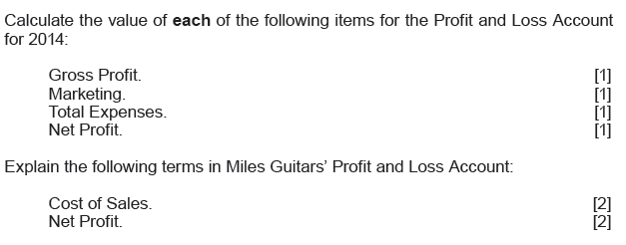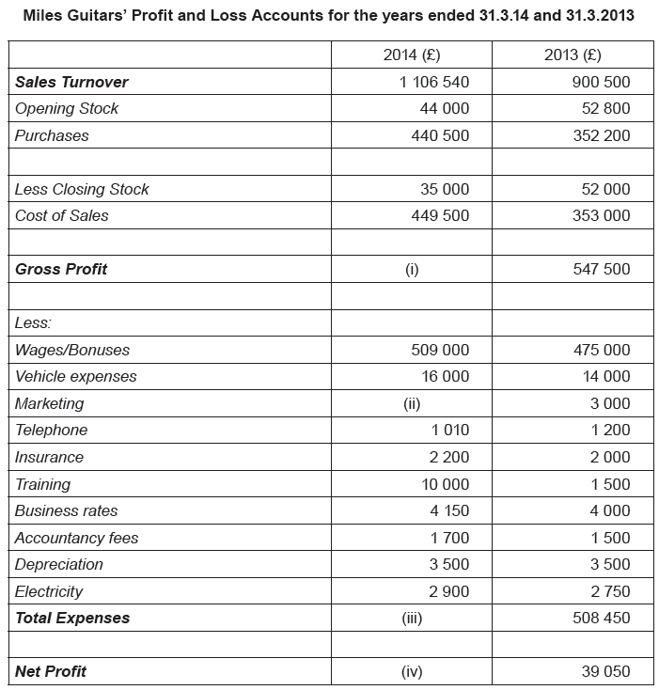

*Marketing spend has increased by 75%*

