**Budgeting**

**1. Missing words**

Budgeting means making an estimate of the appropriate level of income or ____________________over a future period of time. At the end of each month, budgeted figures are compared with ______________ ones to identify any ___________________. These can then be analysed to help understand the reasons for the firm’s financial success or failure. It may also be necessary to change the ________________ during the year, perhaps when the firm’s overall profit level looks likely to be lower than expected.

(words from: budgets, actual, variances, expenditure)

**2. Which terms are defined by the following statements?**

2.1 The difference between budgeted and actual figures

2.2 Money received. *Synonyms: Sales, receipts, revenue.*

2.3 A budget prepared using a previous period's budget

2.4 Setting budgets at £0, to force managers to justify every £ they say they need.

2.5 Money spent on direct and indirect items.

**3. Doing well or badly?**



3.1 Calculate the total income budget for the period Jan – June.

3.2 Calculate the actual profit for the period Jan – March.

3.3 Calculate the actual, and budgeted profit for the period Jan - June

3.4 If a manager was looking at this information in July, and thinking ahead to the rest of the year, should s/he?

a) Close the business down? b) Demand to know why the budgeting was done so poorly?

c) Look into the causes of the income shortfall and, especially, the reasons why costs weren’t lower

3.5 Justify your answer for 3.4

**Advantage (A) or Disadvantage (D) of Historical Budgeting**

4.1 No incentive for developing new ideas.

4.2 The impact of change can be seen quickly.

4.3 Conflicts should be avoided if departments can be seen to be treated similarly.

4.4 Encourages spending up to the budget

4.5 The budget may become out of date

4.6 The system is relatively simple to operate and easy to understand.

**Budgets**

* **What is a budget?**

|  |
| --- |
|  |

* **Process of setting a budget**

|  |  |
| --- | --- |
| Stage 1 |  |
| Stage 2 |  |
| Stage 3 |  |
| Stage 4 |  |
| Stage 5 |  |
| Stage 6 |  |
| Stage 7 |  |
| Stage 8 |  |

* **Types of Budget – match the term with the correct definition!**

**Income budgets**

**Expenditure budgets**

**Profit budgets**

Shows the agreed, planned money flowing out of a business (…………………………………..) over a period of time

Shows the overall expectation of the success of the business (……………………………………………………..)

Shows the agreed, planned money flowing into a business (………………………..) over a period of time

* **Methods of setting budgets – match the method the left with the correct explanation on the right!**

|  |  |
| --- | --- |
| **1. Budgeting according to company objectives** | A) This method allocates the budget on the strength of the case presented by the product manager. It is ideal for budgets such as marketing and R&D, as the dynamic nature of these activities means that a budget can be quickly agreed to suit a sudden event. Also used for one-off events such as the London Olympics 2012 which had a budget of £3.1 bn.  Encourages budget holders to plan carefully  Helps to identify changes in needs of an organisation (so that declining areas of business do not get high budgets)  Saves money by enabling the business to cut costs where managers are unable to justify their spending  Time consuming (detailed planning is needed)  Leads to a higher allocation to managers who are skilled at presenting the case. |
| **2. Budgeting according to competitors spending** | B) Common practice in industries that experience little change from budgets in the previous year, plus an allowance for inflation. Used widely in public services.  If the budget was suitable last year, it will be suitable this year.  However, the business may be able to beat competition through making changes in their budget. |
| **3. Setting the budget as a percentage of sales revenue** | C) In order to stay competitive, a business may look to match the spending of its rivals. For example, in 2007, Tesco mounted its price comparison campaign. This caused other supermarkets to introduce their own responses, leading to changes in income and expenditure budgets.  Popular with start-ups who may be unaware of typical levels of spending.  However, there are potential benefits for businesses who don’t follow the trend. |
| **4. Zero budgeting** | D) Ambitions objectives lead to bigger budgets. Before Uber offered taxi journeys, its expenditure budget was very large due to paying for lots of R&D.  Big budgets can lead to high profits (Uber).  Big budgets are risky – the business may fail (Phones4U). |
| **5. Budgeting according to last year’s budget allocation** | E) Common in a business with a variety of different products with their own budgets e.g. banks, supermarkets. In the UK’s liqueur market, advertising budgets such as Baileys and Tia Maria equate to 3% of sales revenue, whilst for Unilever, marketing costs are over 13% of sales revenue.  Seen to be fair.  May not suit the future needs of the business. |

* **Budgetary Control – Explain “Variance”**

|  |
| --- |
|  |

The difference between the budgeted and actual performance (the variance) can be either:

Favourable: (explain this)

Adverse: (explain this)

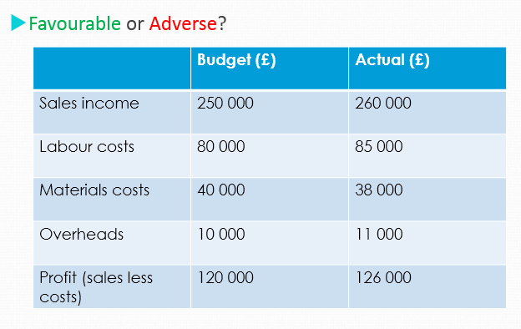

* Budgeting: Overall Benefits and Drawbacks of setting budgets

|  |  |
| --- | --- |
| Benefits | Drawbacks |
|  |  |

1. **Setting your budgets:**

The data below shows your sale targets of decorations for your business for the coming year:

|  |  |
| --- | --- |
| **Christmas line** | **60000 Units at a price of £1.50 each** |
| **Easter line** | **8000 Units at a price of £2.30 each** |
| **Halloween line** | **25000 Units at a price of £1.75 each** |
| **Bonfire night line** | **12000 Units at a price of £1.50 each** |

**Draw up a sales budget for these product lines:**

|  |  |
| --- | --- |
| **Source of Income** | **Income (£) *(Quantity sold x price per unit)*** |
| Christmas line |  |
| Easter line |  |
| Halloween line |  |
| Bonfire night line |  |
| **Total Income** |  |

Here are the predicted costs for the next year:

* **Raw materials are budgeted at 50% of the selling price for each product.**
* **Labour costs 20 pence per product – regardless of which product line is involved.**
* **Marketing costs are £6500**
* **Administration will cost £3600**
* **Rent is £10500 per year**

**Now draw up an expenditure budget for the next year:**

|  |  |
| --- | --- |
| **Item Of expenditure** | **Expenditure (£)** |
| **Raw materials** |  |
| Labour |  |
| Marketing |  |
| Administration |  |
| Rent |  |
| **Total Expenditure** |  |

**Now draw up a Profit budget using the figures form your income and expenditure budgets:**

|  |  |
| --- | --- |
| **Item of income/ Expenditure** | **£** |
| Total Income |  |
| Total Expenditure |  |
| **Budgeted profit**  **(Revenue – Total Costs/Expenditure)** |  |

**EXTENSION ACTIVITY – CHALLENGE YOURSELF**

1. **Amending Budgets**

Recent market research suggests that given the current economic climate your original sales predictions are somewhat optimistic. You have decided to alter these and also to undertake a cost cutting exercise.

Here are the changes:

* Halloween and Bonfire night sales both decrease by 25%
* Christmas sales decrease by 10%
* New premises lead a decrease in rent to £9000 per year
* Marketing budgets are slashed by 25%

**Use these new figures to draw up three new budgets for Income, Expenditure and Profit.**