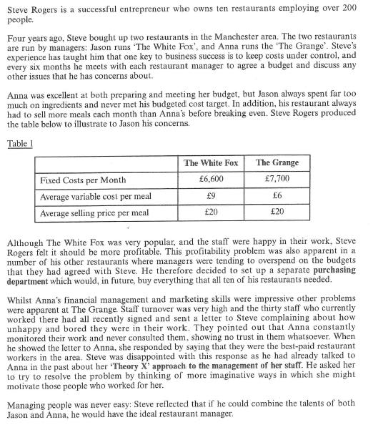

1. Consider both the benefits and the drawbacks of budgeting to Steve Rogers’ business

Calculation practice:

2. Using the figures in table 1, calculate by how **many more meals per month** The White Fox has to sell to break-even when compared with the Grange (show your workings)