Reflect on the Recruitment and Selection Process and your individual Performance

Copy the following templates into your work and complete them fully.

For this one, please ask at least one other person from your group to complete it for you.

|  |  |
| --- | --- |
| Name of person being reviewed:  Name of person carrying out the review: | |
| How well did they listen? |  |
| What was their body language like during the role play? |  |
| How professional was their language? |  |
| What was their dress like? |  |
| How did they ask their questions? |  |
| How did they answer questions? |  |
| What was their attitude like during the role play? |  |
| Any other relevant information. |  |

Review of Communication Skills

|  |  |  |
| --- | --- | --- |
| Communication Skill | Rating 1-4 (4 is the highest) | Why do I think this?  What evidence do I have? |
| Did I communicate clearly when speaking? |  |  |
| Was my handwriting legible when I was making notes? |  |  |
| Did I communicate everything that was needed? |  |  |
| Was I accurate in my communication? |  |  |
| Was I certain about what I was communicating? |  |  |
| Did I remember to include everything I needed to? |  |  |
| Did others understand me when I was communicating? |  |  |
| Was I polite and professional when communicating? |  |  |
| Did I use my business terms and professional language throughout my performance? |  |  |
| Did I make sure that I was thinking about legal and ethical considerations when I was communicating? |  |  |

Review of Organisational Ability

|  |  |  |
| --- | --- | --- |
| Organisational Skill | Rating 1-4 (4 is the highest) | Why do I think this?  What evidence do I have? |
| Did I always plan what I was going to do in advance of the activity? |  |  |
| Did I keep to the agreed deadlines for producing my documents? |  |  |
| Did I ensure that all the activities were detailed to the right level? |  |  |
| As interviewer, did I publish a schedule in advance of starting the interview with all the necessary information? |  |  |
| As interviewer, did I ensure the interview(s) started and finished on time? |  |  |
| As interviewer, did I prepare my questions in advance? |  |  |
| Did I make sure that other panel members (where appropriate) were aware of what they were doing? |  |  |
| As interviewer, did I make sure that I had all the required paperwork ready and materials such as pens/pencils? |  |  |
| As interviewee, did I arrive on time? |  |  |
| As interviewee, did I have all the materials I needed? |  |  |
| As interviewee, did I prepare answers to questions that might come up in the interview in advance? |  |  |

SWOT

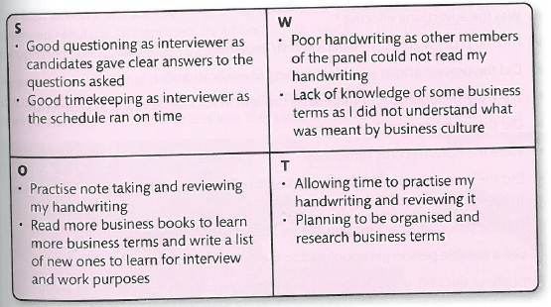

* Strengths = what are you really good at?
* Weaknesses = which areas do you not perform so well at?
* Opportunities = what could you do to improve your performance, especially in areas where you did not do so well.
* Threats = what is stopping you getting better?

You have to complete a SWOT analysis of your role as an interviewer and an interviewee.

Please copy the following two tables and complete.

SWOT of your role of the Interviewee

|  |  |
| --- | --- |
| **Strengths** | **Weaknesses** |
| **Opportunities** | **Threats** |

SWOT of your role of the Interviewer

|  |  |
| --- | --- |
| **Strengths** | **Weaknesses** |
| **Opportunities** | **Threats** |