**Composition**

* Crowded, scene depicting an old women stood on a balcony, looking down on the city being built, he included multiple perspective’s and angular lines (influenced by Picasso & Braque) – the street actually seems the enter the house as the perspective seems as though it is reaching toward the old women stood on a balcony
* Faceted finish
* Horse appears on the woman's bottom, Manifesto - ***"How often have we seen upon the cheek of the person with whom we are talking the horse which passes at the end of the street. – avante garde, innovative***

**Boccioni – Street Enters the House (1912)**

Oil on canvas (100x100cm)

Futurism – Modern urban life – non - French artists

Marinetti – Futurist manifesto

Artistic and social movement, It emphasized **speed, technology, youth, violence, and objects such as the car, the airplane, and the industrial city.**

* Do what the camera cannot do – removed realism

Moved to Paris 1911 – see cubism & cubism (later futurism Marinetti subject atter, cubist technique)

* The more cubist style made after 1911

**Marinetti** –Italian poet/philosophy/ wrote a manifesto

**‘Manifesto for the art of noises’ (1908)**

literature including all arts (movement)

how to do futurist painting/ writing

- Energy of mob to change society ‘for the people’ not the nobles

- wanted Milan to be the centre of modern art

*‘Simultaneous dynamism’* – harnessed collective energy to change

**Clear influences**

* Braque’s & Picasso – capture more than two viewpoints
* Cubism – strong angularity, , broken into cubes harsh orthogonal of the construction pols – leads eye to back of painting
* Women appears almost see-through – influence of the Roentgen - X-ray (1895) – multi faceted view – see other figures through her – like an x-ray (you can see through these) – referencing the new innovations being discovered, rapid change in society and science
* Bergson – ‘***constant state of flux’*** – the new city is constantly changing, making way for new ideas

**Colour/ Light / texture**

* Chaotic hues of primary colours – bustle of the new developing city
* His mother on the balcony? (often employed women from family to model for him) the old looking down on the new Italy
* Light illuminates the background of the image – creating depth & draws the viewers eye backwards
* Bold simple colours, old technique used for new designs
* 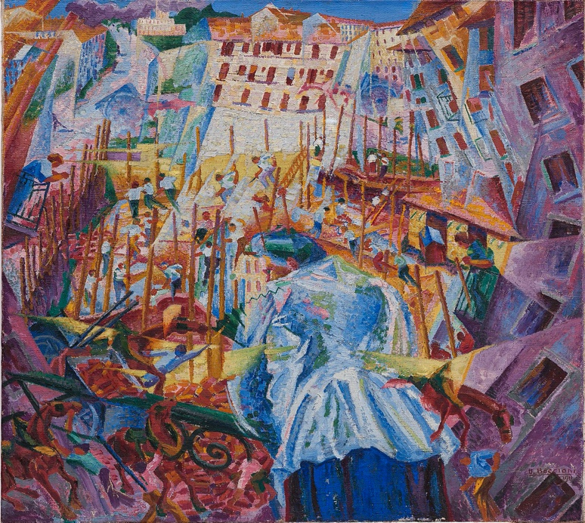

***“We want to represent not the optical or analytical impression, but the psychical and total experience.” (Boccioni, 1911)***

**Typical of futurism**

* ***‘Universal dynamism’*** – street closing in on both sides, claustrophobic – no escape of the future events
* Focus on the physical and external as supposed to emotional internal values – before he focused on neo-impressionist styles and incorporated his emotions using colour
* Movement through space
* Radical new/ play on perspective – all approach in slightly different ways
* Painting technique isn’t as new & radical – pointillism (first movement in Milan – first movement earlier was pointillism)
* Primary bold colours (contrast)– modern twist (taken away from literal meaning & for symbolic use) (less vibrant – cubist influence

Clear focus on - Machinery

Movement

Modernity

Power of the mob – surge of energy