|  |  |
| --- | --- |
| Artist | Brancusi |
| Title | Mlle Pogany |
| Date | 1913 |
| Medium | Bronze |
| Scale | 44x22x32cm |
| Scope/s | Specified sculptor |
| Style | Modernism |
| Patron | Margit Pogany |
| Location | Paris (now at MOMA New York) |
| Function | Departing from traditional portraiture, representing a stylised subject rather than likeness |

|  |  |
| --- | --- |
| Formal features/How ‘Modernist’? | |
| Composition | Unusual composition for portraiture as she has no shoulders, making the viewer focus more on the features depicted. Her large almond shaped eyes take up most of the face with a stylised beak nose eliminating detail and rejecting the temporary element of identity. Her hands are tucked to the side of her face, an intimate gesture that is self-contained unlike traditional sculptures that attempted to make an impressive impact. |
| Colour or texture | The bronze has a shine to it that catches the eye of viewers and represents the glow of skin. Patina is used at the top of the head to give a weathered look of hair and is a painterly method of handling bronze. This adds texture as it juxtaposes the smooth bronze. |
| Light & tone | The bronze has a shine, reflecting light and tone is made with the Patina technique. This can also be seen in the stylised moulding in the face, sharp feature create areas of shadow such as the brow bones. |
| Space & depth or relief | Space and depth is created through proportions in the work, the eyes and hands are large against a smaller mouth and neck. Again stylised moulding of the bronze creates a simplified depiction of space as the shadows of features suggest depth in the face. |
| Line or brushwork | Simplified, sharp lines are employed throughout the face to evoke Brancusi’s stylised aesthetic. This is prominent in the brow bones and nose. These lines add depth to the face and defy expectations of working with bronze. |

Stylistic comment and artistic influence:

Brancusi was apprenticed to Rodin and carries on an avant-garde way of sculpting but in a more stylised, less detailed manner. It could be said Brancusi’s walk from Romania to Paris influenced this.

Use or development of materials, techniques & processes:

The expectations of working in bronze are defied through simplification. Bronze usually symbolises wealth but is made to look weathered with the Patina technique, a painterly way of handling bronze. Brancusi believed in direct carving as he said it was fundamental to reaching the essential truth of a work. Applied black patina on hair is highly unusual and defies the convention of detail. Golden colour and shine are associated with halo/femininity rather than typical use ofbronze as serious/important material

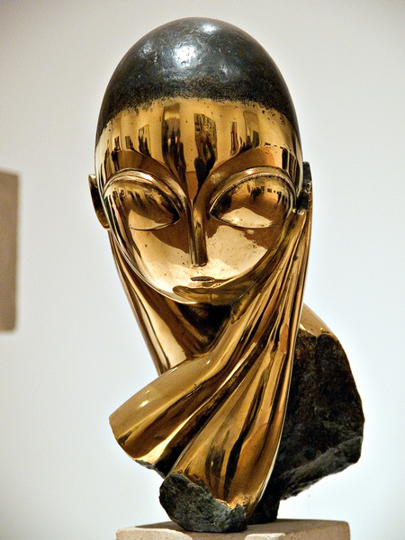

Influence from political factors:

The primitive influences Brancusi as the almond eyes and beaked nose mirrors African masks. The artist wanted to defy traditional conventions of portraiture through simplification. Brancusi depicts an essential truth and inner essence of a person rather than their belongings, rejecting the temporary nature of identity. He juxtaposed the rushing of other movements at the time, such as Italian futurism, advancing in a different manner as a different kind of artist.

Critical text quote:

“It broke with academic tradition, and helped shape the principles of radically reduced and non-representational modernism” (Malcholz journalist)