|  |  |
| --- | --- |
| Artist | Robert Delaunay |
| Title | ‘The Cardiff Team’ |
| Date | 1913 |
| Medium | Oil on canvas |
| Scale | 198.8 x 135.2 |
| Scope/s | Modern urban life |
| Style | Salon/Orphic cubism |
| Patron |  |
| Location | Paris, France |
| Function | Celebrating new technologies and societal changes |

|  |  |
| --- | --- |
| Formal features/How ‘Modernist’? | |
| Composition | The composition is busy in the lower part especially as people are crowded with rugby and billboards, all directing their gaze upwards leading the viewere to look up aswell – to the new technological changes. |
| Colour or texture | Bright colours unlike cubism, complementary colours throughout. Fauvist influences.e |
| Light & tone | Slight tonal range as the figures are very flat. Light is very fragmented especially in the sky as its split in squares. |
| Space & depth or relief | Little depth in the forground as the rugby players merge into the foregrounds, however the Eiffel tower in the background is small suggesting depth and space. |
| Line or brushwork | Flat facets of colour, visible brushstrokes especially in the sky. No bare canvas showing or markmaking as its mostly block colours. |

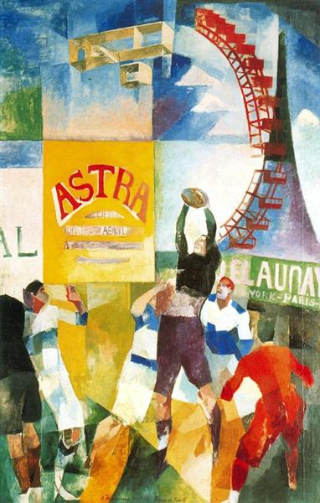

Influence from technological factors:

* It depicts Bleriot flying the first biplane across the top half of the painting, Bleriot was an engineer and inventor. He made the first airplane fly in 1909, first to fly across channel in 1909.
* Eiffel tower also shown, it was the tallest building at the time.
* A ferris wheel curves off the Eiffel tower, the repetition of wheels imply the new technology/inventions like the spinning of propellers.
* Billboards are seen being held up, showing the new advertisement developments.

Influence from cultural/social factors:

* Salon cubism was made for salons meaning to be exhibited and sold. So it was colourful, eyecatching and not random. Unlike cubists who were experimenting.
* Orphists saw art as bringing together sensations of colour and fragmented abstraction.

Critical text quote:

"if there is a perceptible difference in dark-light value between the two colours, then the darker will appear to be even darker"

Eugene Chevreul (chemist who influenced Delauney)

Use or development of materials, techniques & processes:

* Oil on canvas
* Salon cubism was a mix between cubism and abstraction, abstracting and fragmenting shapes with colour.
* The painting is cropped as photography was becoming more popular, shows there is more to the scene.

Stylistic comment and artistic influence:

* Influenced by Fauvism with use of bright colours.
* Fragmented scene influenced by Cubism.
* Synthetic Cubism (1912-14) influences in lettering on billboards.
* Futurism: emphasis on movement and dynamism

IG