|  |  |
| --- | --- |
| Artist | Andre Derain |
| Title | The Dance |
| Date | 1906 |
| Medium | Oil on canvas |
| Scale | 175 x 225 cm |
| Scope/s |  |
| Style | Fauvism |
| Patron | Ambroise Vollard |
| Location | Private collection |
| Function |  |

|  |  |
| --- | --- |
| Formal features/How ‘Modernist’? | |
| Composition | There are four figures within a jungle with wild animals around e.g. snake and parrot. There are three centre figures that are dancing one is cropped showing movement and how the scene continues |
| Colour or texture | The colours are very bold and full with highly saturated palette of the primary colours, with the addition of green |
| Light & tone | The sun looks like it is setting behind them with the background fading into the distance. There are some white highlights to add light |
| Space & depth or relief | There isn’t much shadow shown in the piece but I hard line is shown to add detail in the figures this in most obvious in the centre figure. |
| Line or brushwork | The colours used create a dense surface like the yellow in the background that which is a flat colour. Detail is also some with rough brushstrokes  Use or development of materials, techniques & processes:  The Dance testifies to the multi-layered, hybrid approach modern artists adopted as they attempted to create art works imbued with so-called primitive qualities. Also using the synthetic style from Gauguin were emotions are conveyed through colours |

Your ES initials

Critical text quote: “Fauvism was our ordeal by fire… colors became charges of dynamite. They were expected to charge light… The great merit of this method was to free the picture from all imitative and conventional contact” Andre Derain

Influence from technological factors:

By this time the camera had been invented and artist wanted to create artworks that couldn’t be captured in daily or real life instead creates a pictorial style associated with wild and unrestrained expression. Derain is also distorting reality making a sense of fantasy

Influence from political factors:

Derain wants to show off his skill and how he has mastered the Fauvism movement with the large scale of the painting trying to make an impact with the scale to impose the viewer.

The dancers link to a well-established tradition of imagined primitivism scenes in European art that feature sexualized images of non-European women. It is also specifically of its time in its focus on dance. At the turn of the 20th century there was widespread interest in non-western dance forms.

Influence from cultural/social factors:

Influence from the primitive with the position of the figures and landscape as its set in a jungle with wild animals surrounding them. The figures have been abstracted in response to the African sculptures and masks that was a popular influence to Fauvism.

Image: 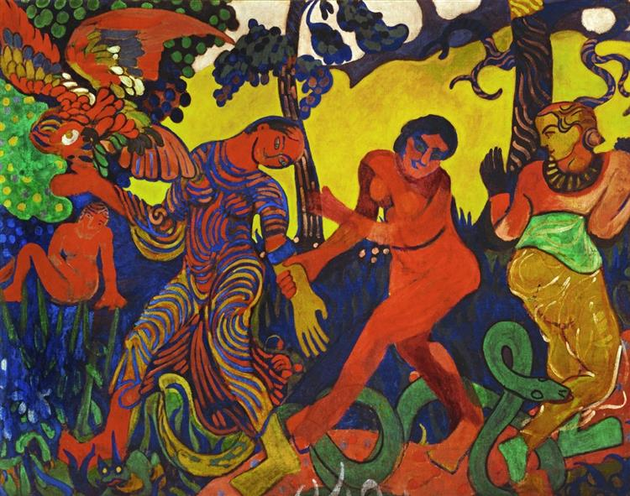

Stylistic comment and artistic influence:

Gauguin’s influence is one of the most dominate. With the exotic elements and landscape. Also with the use of simplified forms and unmodulated areas of bright colour to create a flat and decorative quality to the piece.