|  |  |
| --- | --- |
| Artist | Marcel Duchamp |
| Title | Fountain |
| Date | 1917 |
| Medium | Porcelain |
| Scale | 36cm x 48cm x 61cm |
| Scope/s |  |
| Style | Dada |
| Patron | Duchamp |
| Location | Tate Modern (replica 1964 only) |
| Function | Challenges the hypocrisy and complacency of the gallery going elite. It makes people think about materials and meanings about the boundaries between art and life. |

|  |  |
| --- | --- |
| Formal features/How ‘Modernist’? | |
| Composition | Curved and symmetrical – plays with Classical conventions in a radical way. Duchamp challenges existing definitions of art (anti-art).  “The upside-down urinal's gently flowing curves the veiled head of a classic Renaissance Madonna or a seated Buddha or, perhaps more to the point, one of Brancusi’s polished erotic forms." - Tomkins |
| Colour or texture | Smooth, white – again references purity and idealism from classical/academic art but portrays it with a violent message.  The white colouring makes the black text stand out against it, guiding viewers to read it and understand the work further. |
| Space & depth or relief | The work is small and is displayed on a short plinth, meaning viewers look down into it. It stands on its own, with no pipe connections etc, implying that it has its own individual importance, rather than linking to anything else. |
| Line or brushwork |  |

Stylistic comment and artistic influence:

This piece triggered a new perspective on art, straying away from paintings and carved sculpture, instead removing everyday objects, and giving them ironic or symbolic meaning (e.g., Andy Warhol).

Critical text quote:

‘a piece of mischief at the expense of the art world’ – John Passmore, philosopher

Influence from cultural/social factors:

* Duchamp’s intention was to shock the public and critic by going against conventions of art at the time.
* ‘R. Mutt’ was an unknown artist – Duchamp could observe society’s openness to art that did not conform to conventional standards without compromising the outcome

Use or development of materials, techniques & processes:

He purchased a urinal from a sanitaryware supplier.

It was presented on its back for exhibition purposes rather than upright and was signed and dated ‘R. Mutt 1917’.

In 2004, *Fountain*topped a poll of 500 British art experts as the single most influential artwork of the twentieth century, ahead of Picasso’s *Les Demoiselles d’Avignon*1907 and Andy Warhol’s *Marilyn Diptych*1962.

Image: 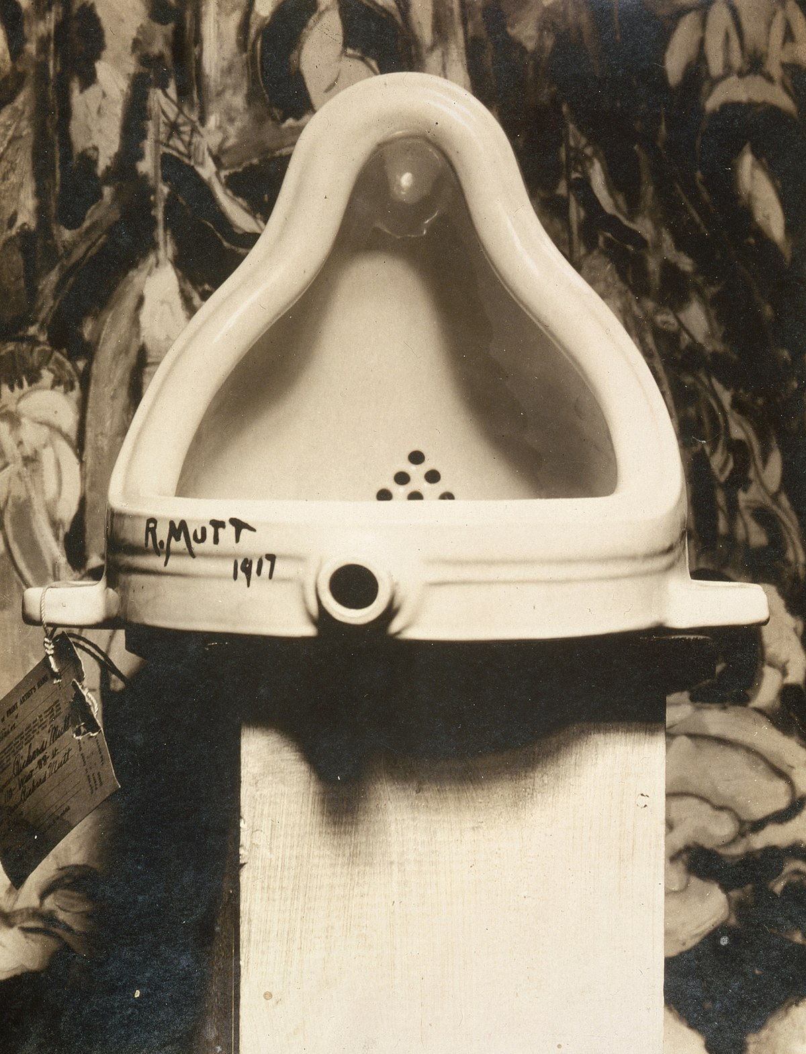

Influence from political factors:

* It is a declaration of war on traditional art and its value systems – links to America’s declaration of war on Germany in April 1917.
* 'R. Mutt' is a pun on the German word Armut meaning poverty.
* “I added Richard [French slang for money-bags] … Get it? The opposite of poverty. But not even that much, just R. MUTT.” - Duchamp