|  |  |
| --- | --- |
| Artist | Henri Matisse |
| Title | Joy of Life |
| Date | 1906 |
| Medium | Oil Paint |
| Scale | 176x240cm: huge scale |
| Scope | The female figure (painting or sculpture) by a French artist  Landscape painting by a French artist |
| Style | Fauvism: late stage of style |
| Location | Salon des Indépendants, Paris, March 1906 |
| Function | Reject traditional academic art and explore emotional expression |

|  |  |
| --- | --- |
| Formal features | |
| Composition | A complicated composition, multiple groups of figures in fore, middle and background. Trees on far left and far right sides of composition which reach overhead. |
| Colour or texture | Use of bright and vibrant colour that adds warmth. Use of reds, yellows and soft pinks (flesh like tones) |
| Light & tone | A lack of realistic light and tone do not create depth in traditional, academic sense. Use of light and tone on the bodies of the central figures to show mood rather than 3D. |
| Space & depth or relief | Groups of figures get smaller further into the background, creating iconsistency of depth. Lack of aerial perspective at horizon line, Trees and bodies share similar lyrical lines to emphasise harmony and joy rather than any attempt at realism |
| Line or brushwork | Use of heavy outline on the figures of missed colours. Brushwork is smooth and leaves areas of bare canvas. Not used to create texture, a flat surface but instead to celebrate the use of colour. |

Influence from cultural/social factors:

Middle and upper class were living comfortable life’s during this time, he is mirroring this future of society as the figures are seen relaxed and content.

M studied under Bougereau and Moreau at the Academie Julian. Influenced by exhibition of Van Gogh’s art at Berthe Weil’s gallery in 1903. Also saw Gauguin’s work sent back to Paris from Tahiti, takes idea of pastoral idyllic scene.

Not interested in subject matter in traditional sense but in ability of colour to create meaning in own right. Influenced by large bathers/nudes of both Ingres and Cezanne but here reworked in modernist language

Influence from political factors:

Matisse’s art was not affected by politics. Instead he was influenced by other artists, social factors (as mentioned above) and following his own inspiration.

Influence from technological factors:

Tubed paint was a new invention that he was using.

Wanting to turn the art away from the modern age where technological factors had such a huge influence on everyday life and art, and instead relating art that celebrated a simpler life based on happiness and love.

Image: 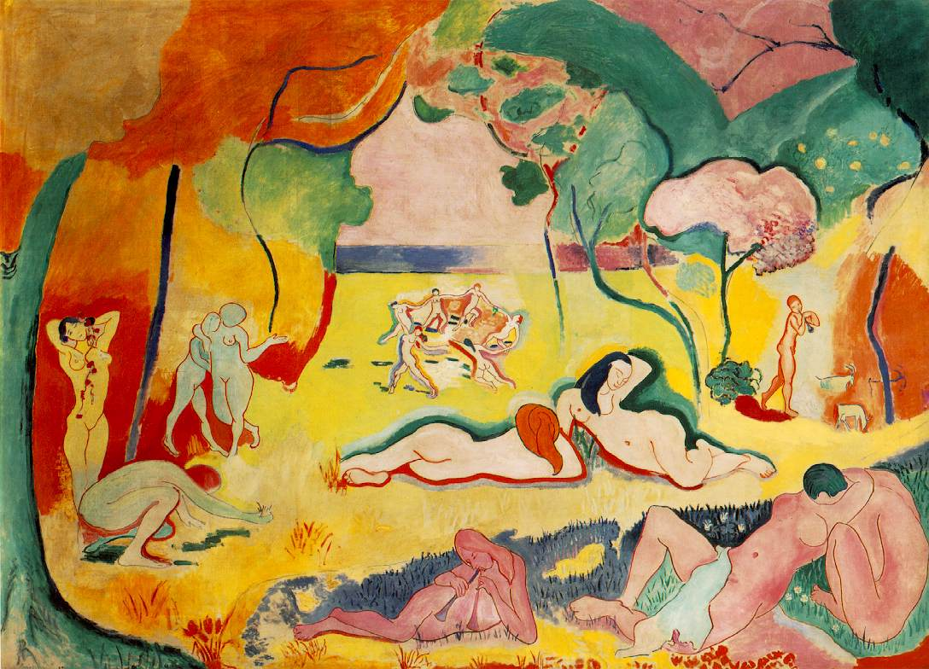

Use or development of materials, techniques & processes:

Develops on from early Fauvist work. Earlier Fauvist work used brighter and more vibrant colours, figures were more simplified and brushwork was thick and textured. This later fauvist work has developed stylistically. Use of colour is more balanced and figures have painted more stylistically.

Stylistic comment and artistic influence:

Other Artist were attracted to Matisse’s want to reject traditional academic art and to find ways to make art that shows the modern age. He has also been influenced by earlier fauvist art.

Critical text quote:

What I dream of is an art of balance, of purity and serenity-Matisse, 1908