|  |  |
| --- | --- |
| Artist | Henri Matisse |
| Title | Woman in a Hat |
| Date | 1905 |
| Medium | Oil on canvas |
| Scale | 80.65cm by 59.69cm |
| Scope/s | Portrait by a French artist |
| Style | Fauvist |
| Patron | Gertrude Stein |
| Location | San Francisco Museum of modern art |
| Function | To find a new style of art fit for the new modern world |

|  |  |
| --- | --- |
| Formal features/How ‘Modernist’? | |
| Composition | Simple, asymmetric composition. Half figure portrait, with body in three-quarters pose and face turned towards the viewer. |
| Colour or texture | Unrealistic colours, bright, vibrant. Use of colour for its own sake. M said his wife was “actually wearing black of course” |
| Light & tone | Inconsistent outline, thick on shoulders, top of fan and hat. Tone not used conventionally at all, but light is shown as colour instead: green line on nose and yellow highlight on cheek |
| Space & depth or relief | Very 2D, no background no depth created. Flatness emphasises canvas and idea that painting itself is the actual subject matter here. |
| Line or brushwork | Rough brushwork, haphazardly applied: Intense impasto paint on hat, but dry open atches of rough colour behind the figure – emphasises effect and power of complementary colour rather than any sense of reality. |

Influence from cultural/social factors:

Traditional painting was still admired and unrealistic colours and proportions were just being explored and Matisse was a key artist who explores the different colours and different style of art.

This work was shown in the Salon of 1905 and was the largest of the Fauve works on display. Thus it generated the most publicity and controversy, which ironically made Matisse’ s reputation. It was bough by Gertrude and Leo Stein despite Leo claiming it was “the ugliest smear of paint he had seen”. This as important as it introduced M to the Stein’sweekly soirees and fuelled the rivalry between Picasso and Matisse.

Amelie Matisse was a milliner but work unlikely to promote her business.

Influence from technological factors:

This is a response to the raft of new inventions at the end of the 19th century: X ray, light bulb, electricity, car, radio etc. Feeling that world was changing so rapidly (Puguy “the world has hanged more in the last thirty years than at any time since the life of Jesus Christ” and Bergson “the world is in a constant state of flux”. Aim was to find new method and style of painting that was fit for new century rather than a portrait aiming to convey likeness or status.

Use or development of materials, techniques & processes:

Oil paint used for years before and is still used, unrealistic colours and brushwork challenged traditional art and changed the way critics looked at artwork.

Stylistic comment and artistic influence:

Influenced by both Van Gogh and Gauguin who had recent solo exhibitions in Paris, but takes their colour experimentation to a whole new level

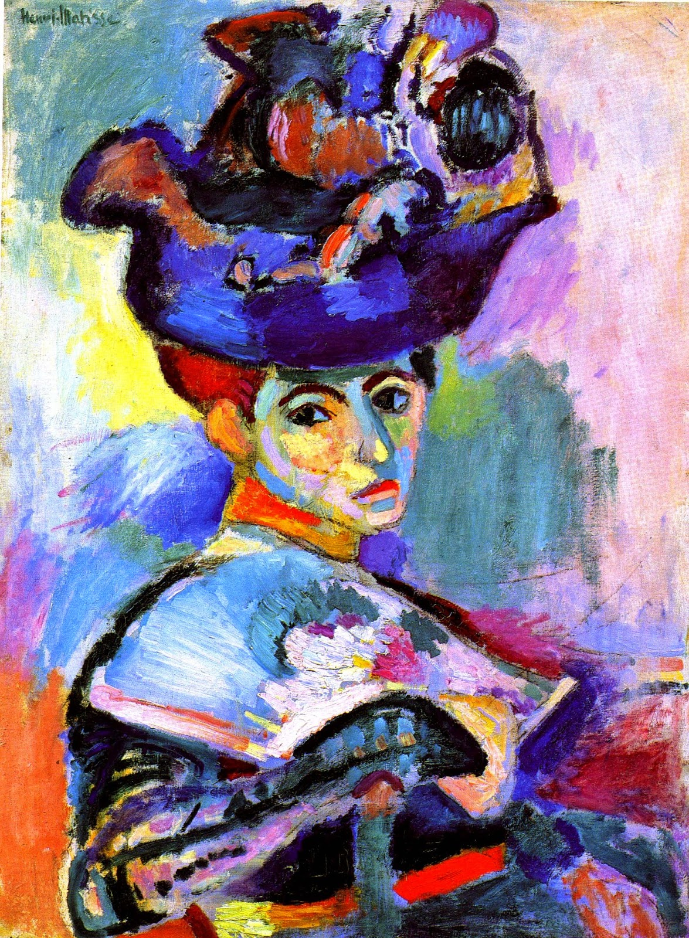

AS

Critical text quote:

A pot of paint has been flung at the face of the public” Camille Mauclair