|  |  |
| --- | --- |
| Artist | Picasso |
| Title | Still Life with Chair Caning |
| Date | 1912 |
| Medium | Oil on cloth with ready-made elements: rope and preprinted oil cloth |
| Scale | 29 x 37 cm |
| Scope/s | Still life by a non-French artist |
| Style | Synthetic Cubism |
| Patron | P&Braque in exclusive arragenement with Daniel Kahnweiler (and so often known as Gallery Cubists) |
| Function | To get closer to the truth of the subject, by relayering the fragments to build a experience of the subject |

|  |  |
| --- | --- |
| Formal features/How ‘Modernist’? | |
| Composition | The work is a circular shape rather than the traditional square or rectangular canvas, suggesting that it is representing a Café’ table top.  The composition is busy with no clear focal point. |
| Colour or texture | The work consists of very dull/muted colours. There is a lack of bright colour.  Picasso includes new and fascinating textures (chair caning and rope) in order to achieve the modernist style. |
| Light & tone | Picasso uses the contrasting tones of black and white in order to draw attention to the lettering and shapes. The bold, black lettering placed on the white background means that we can clearly identify the ‘J O U’ (a common first 3 letters in the French vocabulary).  There is lots of shadowing used in the work, creating a 3D illusion with some of the shapes. |
| Space & depth or relief | The work is a bird’s eye view of the chain caning and all the objects situated on top of it.  There is some special depth created with the cubist shapes and lines overlapping one another, but overall, the work appears very flat as we are looking down onto it. |
| Line or brushwork | The brush strokes are visible. The shapes and lettering appear block-like and heavily outlined, a feature of modernist art. |

Influence from cultural/social factors:

* The work challenges the expectations of fine art – a typical still life painting wouldn’t be painted from a bird’s eye view.
* The painting conveys a sense of anger and confusion due to the random grouping of objects.
* He uses geometric shape and form to show his style as a Cubist
* **Synthetic cubism** was about flattening out the image and sweeping away the last traces of allusion to three-dimensional space (a 2D feel)
* not typical of still life because still life is all about 3D depth
* Saussure’s ideas of signs and symbols and Einstein’s Theory of Relativity all important here in search for new modern language of art.

Influence from political factors:

The work deliberately uses fake chair caning in order to discuss the quality of ‘art’. Picasso is showing that even something considered ugly or invaluable can be considered art.

The overall manic and cluttered appearance of the painting links to the changing attitudes towards society at the time.

Influence from technological factors:

The use of found/readymade materials (tablecloth and rope) links to industrial and technological advancements.

It recognises a need for change in art. The increasing popularity of photography also meant that art needed to depict more than what could be captured through a lens in a single frame shot.

Stylistic comment and artistic influence:

Uses found objects – table cloth chair caning and a rope (beginning of the readymade). Picasso borrowed **Braque’s** collage technique - taking a manufactured piece of chair caning as his backdrop and then painting onto that. He also framed the painting using a rope.

Use or development of materials, techniques & processes:

Picasso’s use of manufactured/readymade materials in his work was considered radical at the time. However, this technique was later seen much more frequently in the Dada movement (1914). He wanted to address the need for modernising art and adding in new (avant-garde) features.

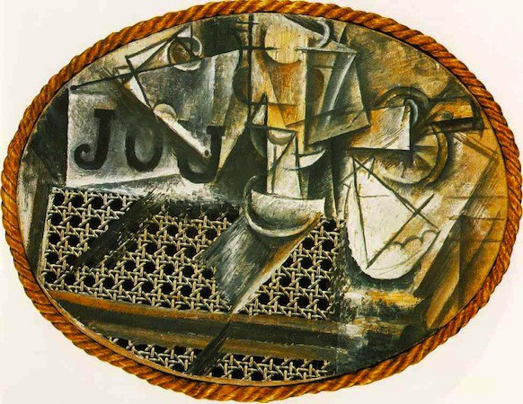

Critical text quote:

Bergson – ‘The world is in a constant state of flux’

E.S