**Name:**

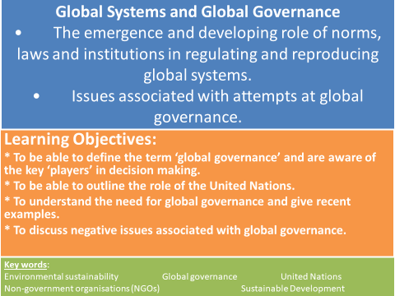

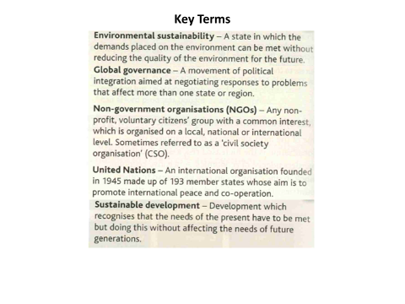

**Global Governance**

* Global governance refers to the ways in which global affairs affecting the whole world are managed.
* In international relations generally decisions are made by individual state governments.
* Co-operation is usually negotiated between countries which agree to abide by similar rules given in signed treaties or international laws.
* As the world becomes more independent, global economic governance is increasingly important across all nations.
* This is especially true for governance of the **global commons** where **environmental sustainability** is a concern.

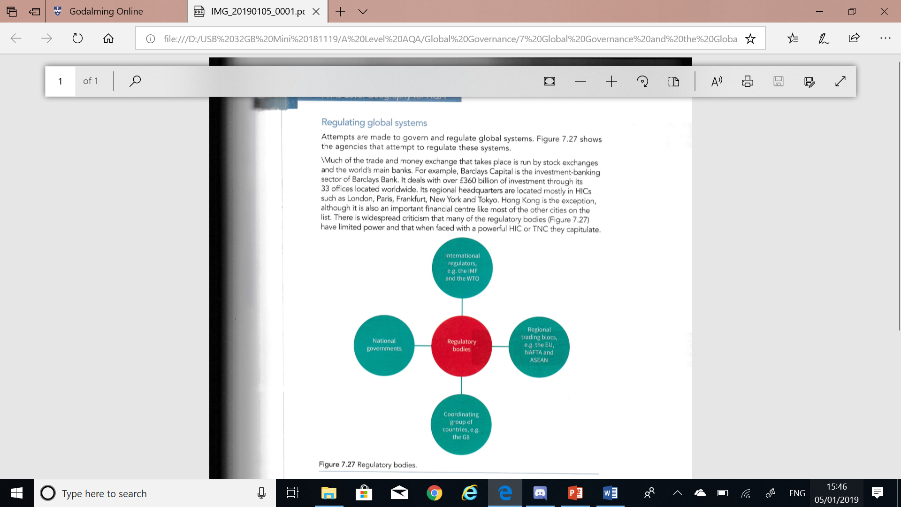Management of global affairs is done by: nation states, profit-making companies, international and regional organisations (such as the EU).

Their participation in this process may be reactive or proactive.

**Regulating Global Systems**

**TASK:** Identify economic, social and environmental challenges that may be termed ‘global’.

For each challenge, suggest who could have a role in helping to address it and action they could take.

|  |  |
| --- | --- |
| **Economic, social and environmental challenges** | **Who could have a role in helping address challenges?** |
|  |  |

**International development agencies**

* There is no ‘world government’ with the political authority to exercise jurisdiction over executive, judicial, legislative or military affairs for the whole planet.
* A number of organisations take responsibility for promoting growth, stability and the development of all regions sustainable both economically and environmentally.
* Many operating internationally are connected to the United Nations (UN) e.g. the United Nations Development Programme (UNDP).
* International organisations such as the World Trade Organisation (WTO) and the World Health Organisation (WHO) exist to take responsibility for managing specific aspects of an increasingly interrelated world.

**TASK: Watch the clip and animation to make notes on why the United Nations was set up and what it does around the world.**

<https://youtu.be/bHmXZXsABm0>

<https://www.theguardian.com/world/video/2015/sep/08/how-did-the-un-get-so-big-rachel-weisz-video>

**UN Sustainable Development Goals**

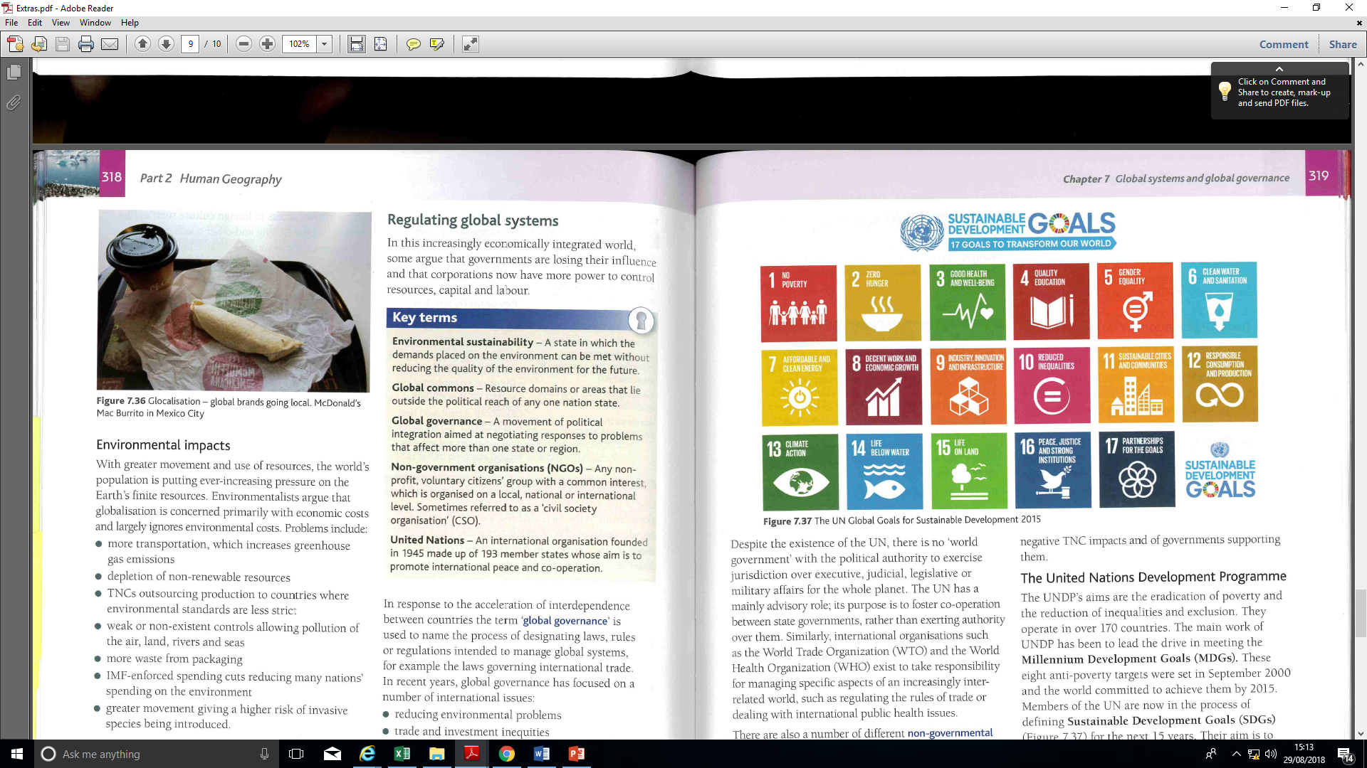

**TASK: Watch the clips about the Sustainable Development Goals.**

<https://www.youtube.com/watch?v=5G0ndS3uRdo>

<https://www.un.org/sustainabledevelopment/blog/2017/12/>[sustainable-development-goals-new-social-contract/](https://www.un.org/sustainabledevelopment/blog/2017/12/sustainable-development-goals-new-social-contract/)

**Agenda 21**

* Agenda 21 is a non-binding action plan of the United Nations with regard to sustainable development.
* It is a product of the Earth Summit (UN Conference on
* Environment and Development) held in Rio de Janeiro, Brazil, in 1992.
* It is an action agenda for the UN, other multilateral organizations, and individual governments around the world that can be executed at local, national, and global levels.

A framework for local authorities: **TASK: How could local agenda 21 affect you?**

* Promote energy efficiency
* Greening the city landscape
* Effective recycling
* Quality alternative transport
* Create employment
* Monitor pollution

**TASK: Use p319-321 in Hodder text book, previous work on WTO and the extract below on CO2 emissions to complete the table.**

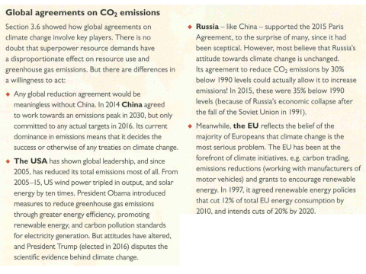

|  |  |  |  |
| --- | --- | --- | --- |
| **International Institution** | **What does it do?** | **Suggest how they promote growth & stability** | **Suggest how they exacerbate inequalities and injustices** |
| **(UNDP) UN Development Programme** |  |  |  |
| **World Trade Organisation (WTO)** |  |  |  |
| **World Summit on Sustainable Development and Agenda 21** |  |  |  |
| **UN Environment Programme (UNEP) and world summits on climate change** |  |  |  |

**TASK: Using the table on the previous page and handout ‘Global Governance Case Study: United Nations’ to complete the grid and answer the following question. Evaluate the UN as a system of global governance.**

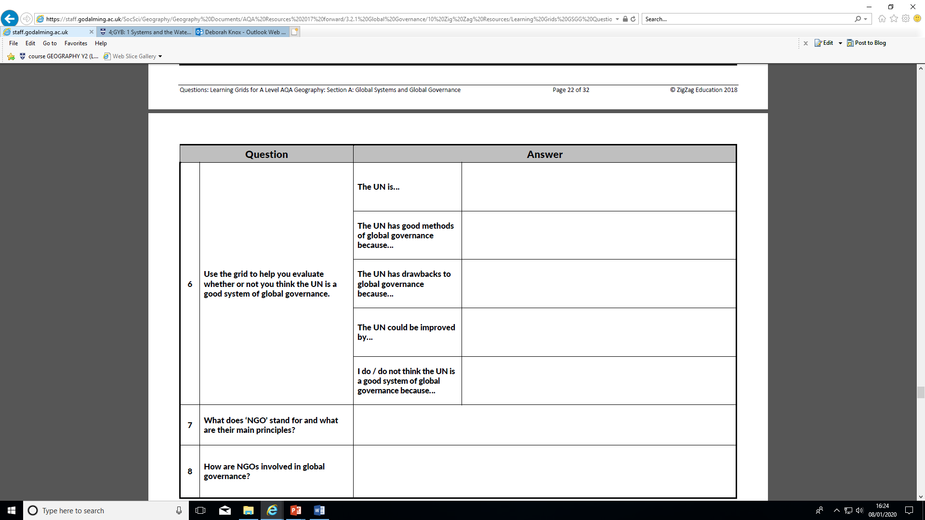

* **To what extent has the United Nations succeeded at global governance? Give evidence to support your view.**

**Interactions at all scales  
Non-governmental organisations (NGOs)**

There are also a number of different non-governmental organisations (NGOs) with varying objectives but generally either to ensure justice and equality for people across the world or to campaign for environmental sustainability.

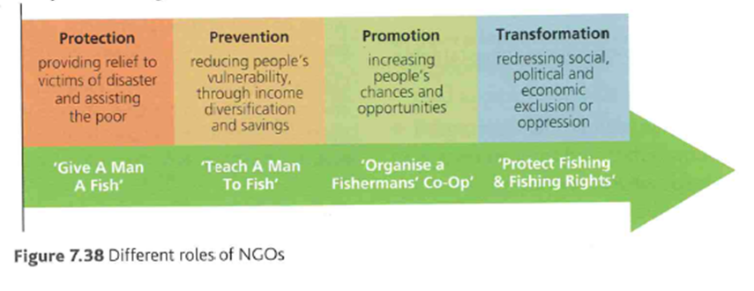

**TASK: Can you name any NGO’s?**

**Use Hodder text book p321-322 to answer the following.**

* **What are the main principles of NGOs?**
* **How are NGOs involved in global governance? Include examples in your answer.**

**Interactions between different scales of governance**

* Global institutions may make decisions which alienate governments at other scales; for example, the IMF and Greece or the EU and the UK over migration. *How might these decisions alienate governments?*
* Within nations, there may be conflict between or calls for independence.

**TASK: Can you name any recent examples of calls for independence?**

**Example of conflict – the Canadian First Nation People.**



* **TASK: Read the extract and answer the following questions.**
  + **Who is involved in the conflict?**
  + **What is the conflict about?**
  + **Why might conflicts like this increase in the future?**

**Interactions at all scales**

**TASK: Complete the table to show how different scales of governing bodies are relevant to you.**

|  |  |  |  |
| --- | --- | --- | --- |
| **Scale** | **Example:** | **Name of the governing body relevant to me on this scale** | **How this governing body is relevant to me.** |
| **Local** | **Town or city council** |  |  |
| **Regional** | **County council** |  |  |
| **National** | **National government, Parliament** |  |  |
| **International** | **Trade blocs, continental bodies** |  |  |
| **Global** | **NGO’s, global bodies** |  |  |

**To what extent are these governing bodies being related important to global systems as a whole?**

**Exam Style Questions**

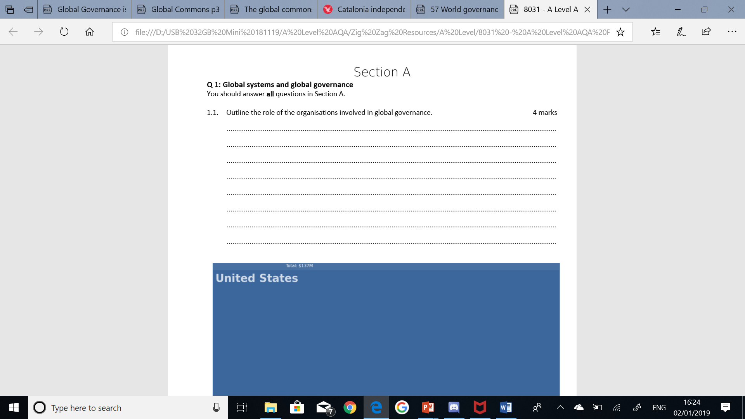

**‘The peace and economic development provided by global governance outweighs any negative effects.’ Assess the extent to which you agree with this statement. (20 marks)**