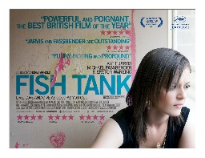**Film Studies yr1**

Component 2 - European Film (Section A)

*Fish Tank* (Andrea Arnold, 2009) screening note sheet

*During the screening, try to jot down your initial observations on- cinematography, editing, sound, mise en scene, narrative and representation.*

Type notes here…

Completing this sheet will help contribute to post screening tasks